Mango
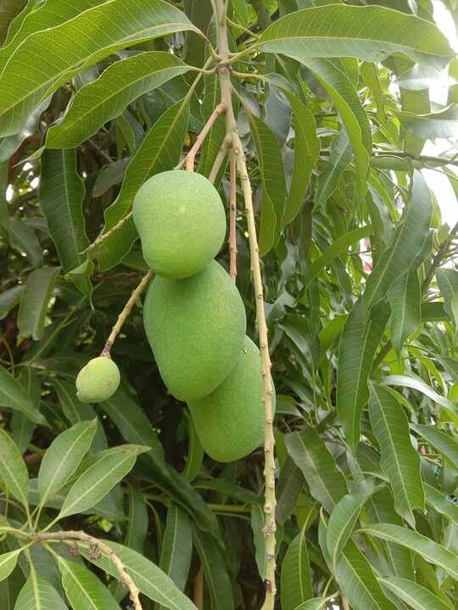
Source: Wikipedia — Mangifera indica
Scientific name | Local name | Interesting fact
Mangifera indica | aam | A mango tree can live and fruit for well over a century; many cultivars also grow true-to-type from polyembryonic seeds.

Neem
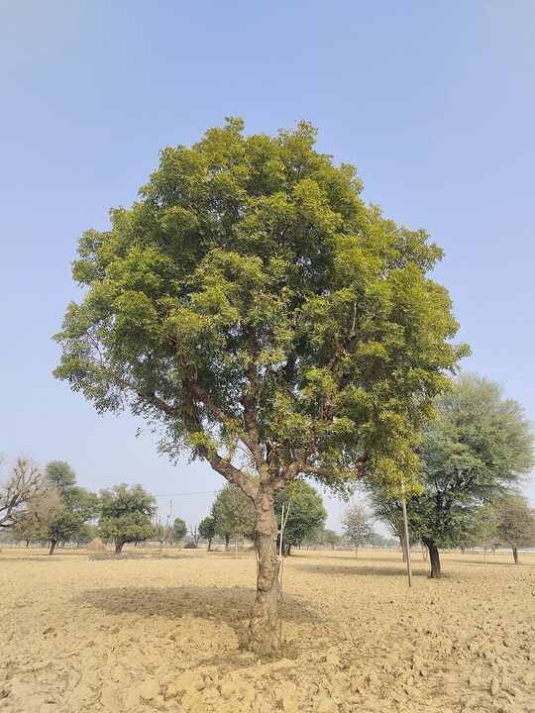
Source: Wikipedia — Azadirachta indica
Scientific name | Local name | Interesting fact
Azadirachta indica | neem | Neem seeds yield azadirachtin, a natural insect antifeedant used in many botanical pest-control products.

Banyan
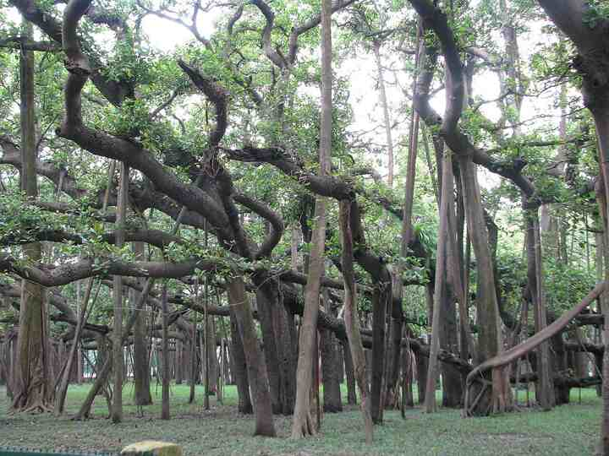
Source: Wikipedia — Ficus benghalensis
Scientific name | Local name | Interesting fact
Ficus benghalensis | bargad | Its aerial roots can grow down from branches and become new trunks, allowing one tree to spread over a very large area.

Peepal
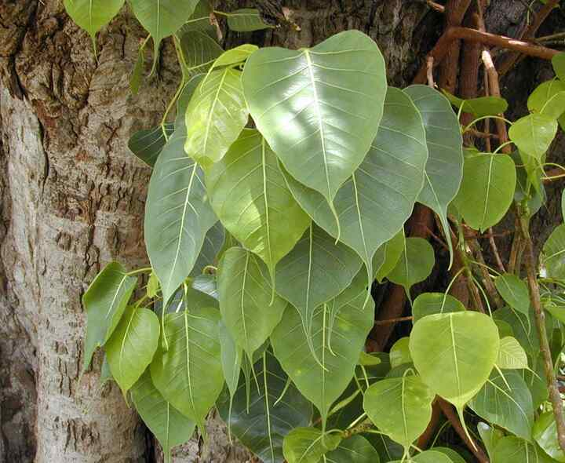
Source: Wikipedia — Ficus religiosa
Scientific name | Local name | Interesting fact
Ficus religiosa | peepal | This fig tree supports wildlife: birds eat its figs and disperse the seeds, helping new trees establish.

Tulsi (Holy basil)
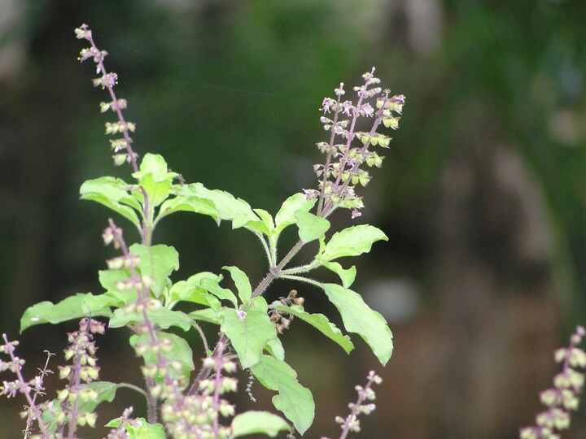
Source: Wikipedia — Ocimum tenuiflorum
Scientific name | Local name | Interesting fact
Ocimum tenuiflorum | tulsi | Its aromatic leaves are important in household worship and are also used in traditional herbal preparations.

Aloe vera
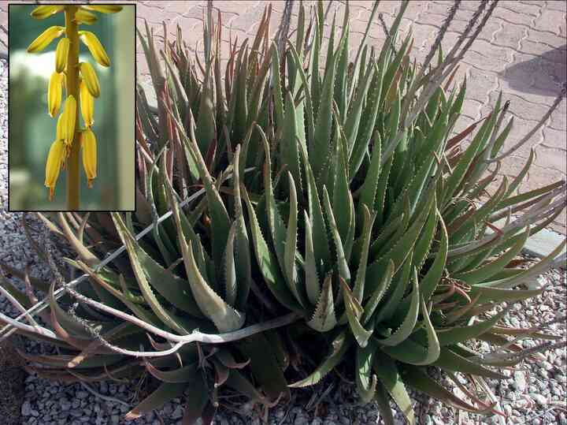
Source: Wikipedia — Aloe vera
Scientific name | Local name | Interesting fact
Aloe vera | ghritkumari | The leaf stores water in its gel; the yellow latex just beneath the skin is chemically different from the gel.

Hibiscus
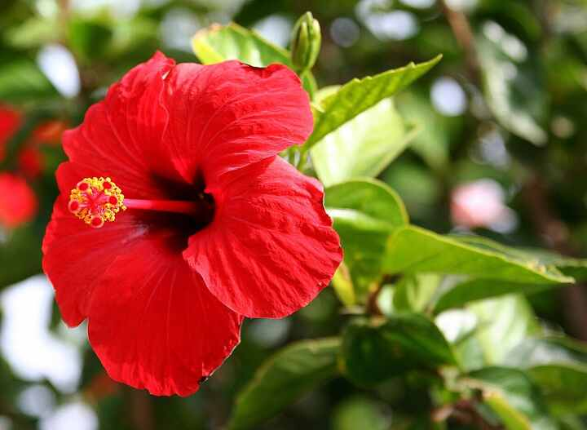
Source: Wikipedia — Hibiscus × rosa-sinensis
Scientific name | Local name | Interesting fact
Hibiscus × rosa-sinensis | gudhal | Ornamental hibiscus flowers are often sterile hybrids, so many garden plants are propagated from cuttings instead of seeds.

Rose
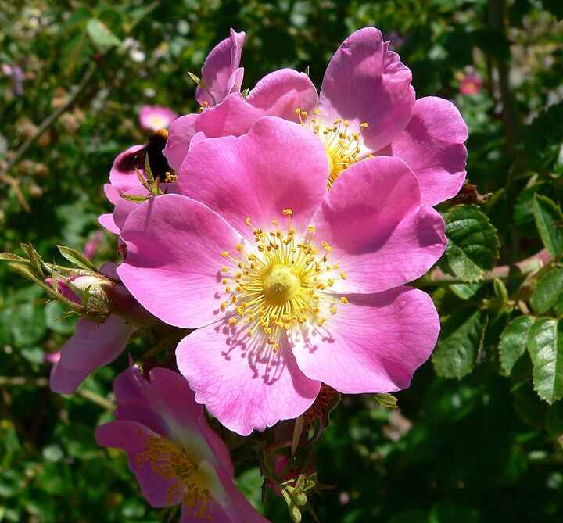
Source: Wikipedia — Rose
Scientific name | Local name | Interesting fact
Rosa spp. | gulab | The rose's fruit, called a rose hip, is rich in vitamin C and is used in teas, preserves and syrups.

Jasmine
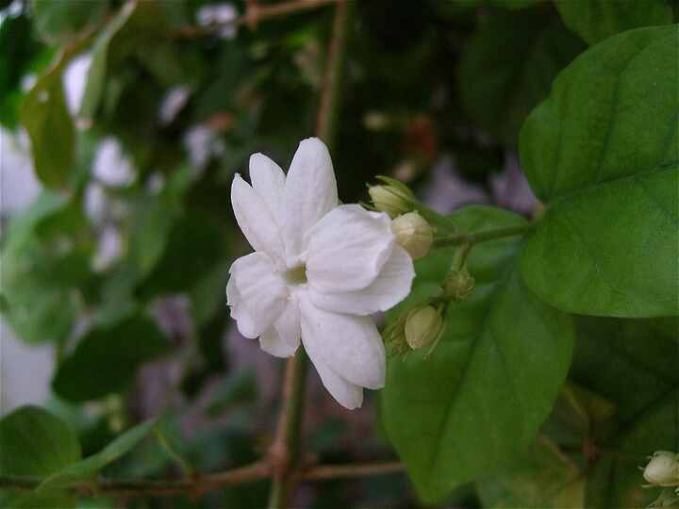
Source: Wikipedia — Jasminum sambac
Scientific name | Local name | Interesting fact
Jasminum sambac | mogra | Mogra flowers release much of their fragrance in the evening and are widely used in garlands and perfumes.

Marigold
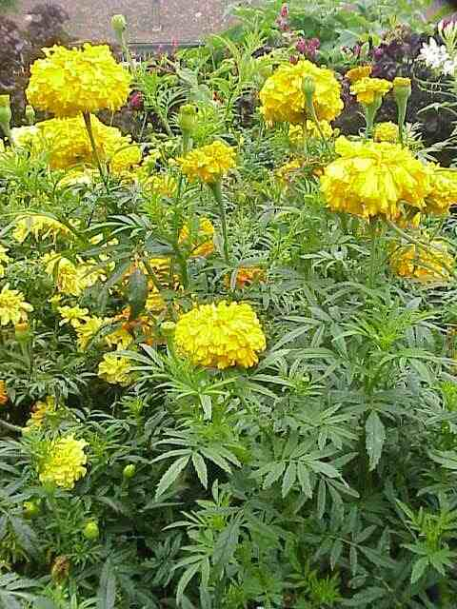
Source: Wikipedia — Tagetes erecta
Scientific name | Local name | Interesting fact
Tagetes erecta | genda | Marigold petals contain yellow-orange pigments and are used as a natural dye and food colour; the plants can also suppress some soil nematodes.

Sunflower
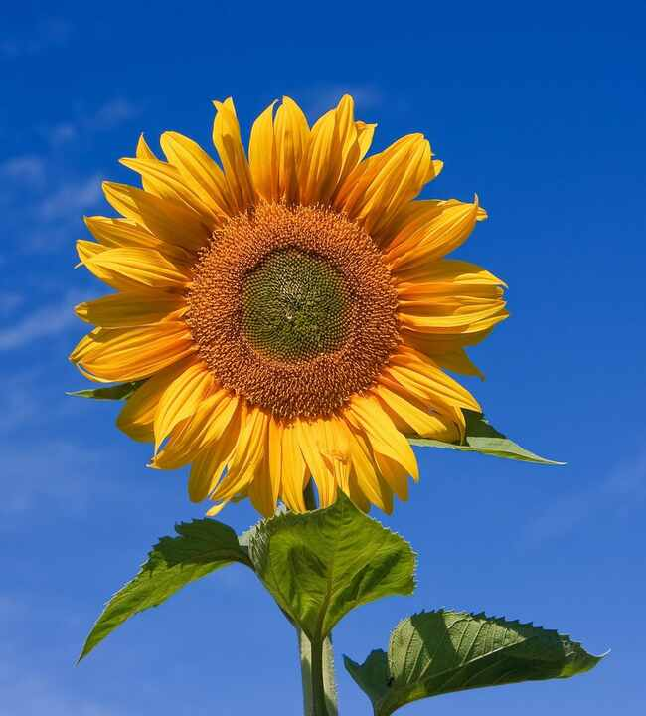
Source: Wikipedia — Common sunflower
Scientific name | Local name | Interesting fact
Helianthus annuus | surajmukhi | A sunflower head is a disc packed with hundreds of tiny flowers; young heads can track the sun before settling eastward.

Lotus
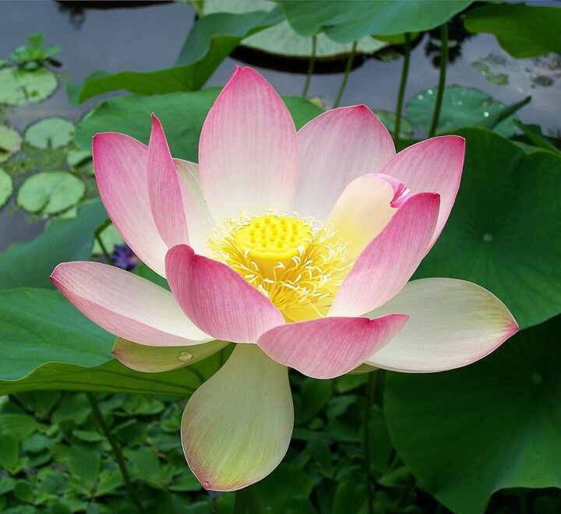
Source: Wikipedia — Nelumbo nucifera
Scientific name | Local name | Interesting fact
Nelumbo nucifera | kamal | Lotus leaves repel water through a microscopic waxy surface, an effect known as the lotus effect.

Water lily
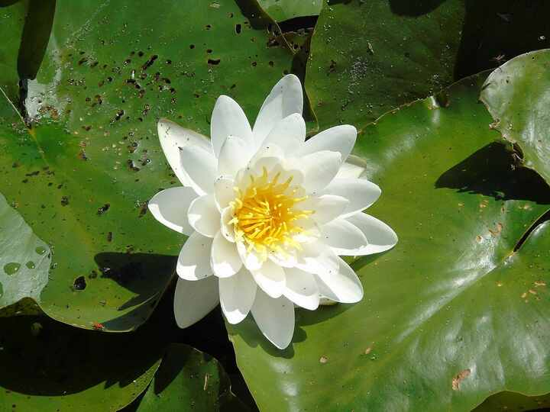
Source: Wikipedia — Nymphaea
Scientific name | Local name | Interesting fact
Nymphaea spp. | kumudini | Unlike lotus leaves, water-lily leaves generally float directly on the water; many flowers open and close with the light.

Bougainvillea
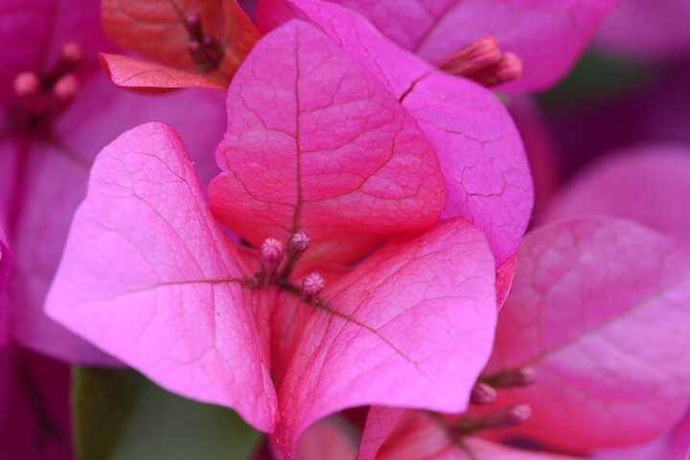
Source: Wikipedia — Bougainvillea
Scientific name | Local name | Interesting fact
Bougainvillea spp. | kagazi phool | The vivid pink, purple or orange parts are bracts; the actual flowers are the small, pale structures in their centres.

Ixora
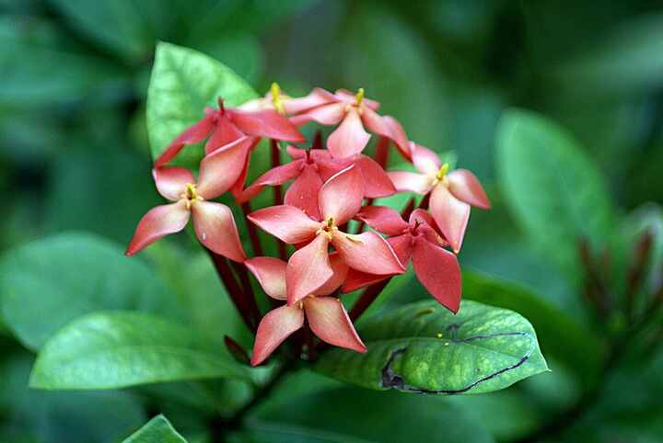
Source: Wikipedia — Ixora coccinea
Scientific name | Local name | Interesting fact
Ixora coccinea | rangan | Its tight clusters are made of many small tubular flowers that attract butterflies and other nectar-seeking insects.

Frangipani
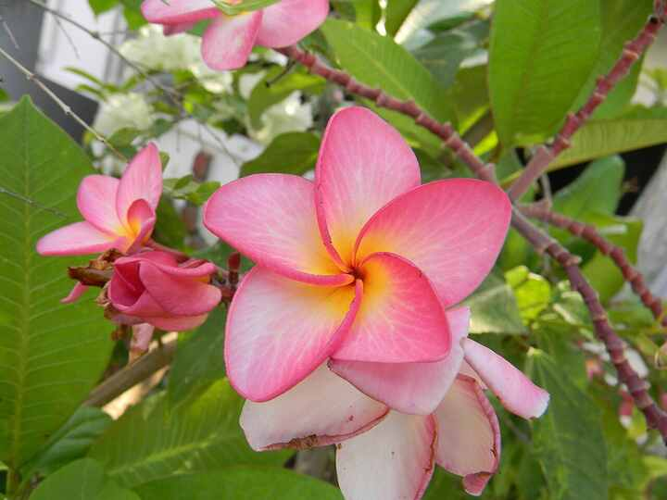
Source: Wikipedia — Plumeria
Scientific name | Local name | Interesting fact
Plumeria spp. | champa | Frangipani branches contain a milky latex, while its waxy, fragrant flowers are commonly used in tropical leis and temple offerings.

Gulmohar
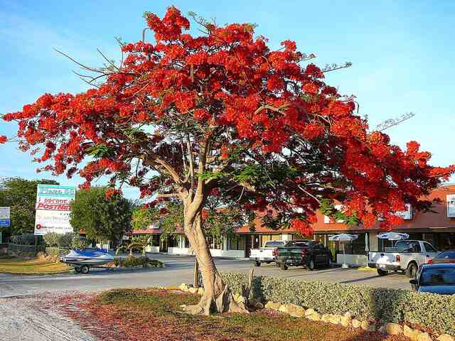
Source: Wikipedia — Delonix regia
Scientific name | Local name | Interesting fact
Delonix regia | gulmohar | Its broad crown produces spectacular red-orange flowers, followed by long, woody seed pods that can remain on the tree for months.

Ashoka tree
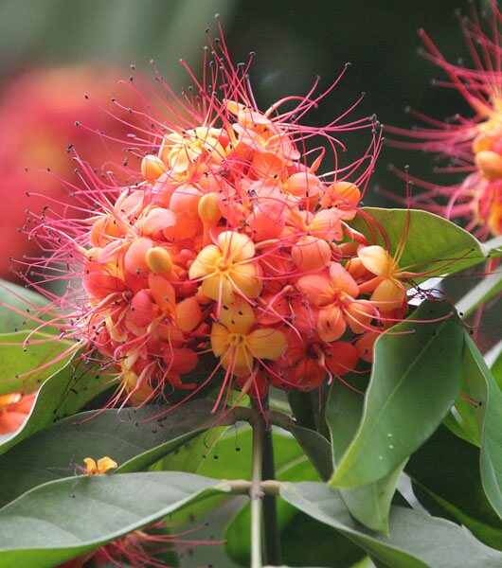
Source: Wikipedia — Saraca asoca
Scientific name | Local name | Interesting fact
Saraca asoca | ashok | The fragrant flowers change from yellow to orange-red as they age; the tree is culturally important across South Asia.

Curry tree
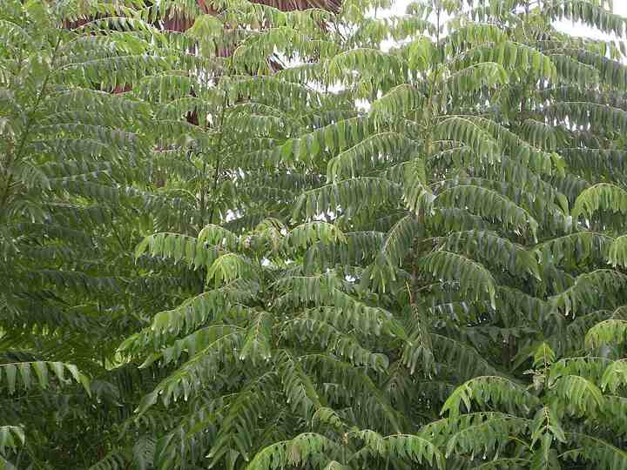
Source: Wikipedia — Curry tree
Scientific name | Local name | Interesting fact
Murraya koenigii | kadi patta | Curry leaves are aromatic because of their essential oils; the small black fruits are not the same thing as the culinary leaves.

Coconut palm
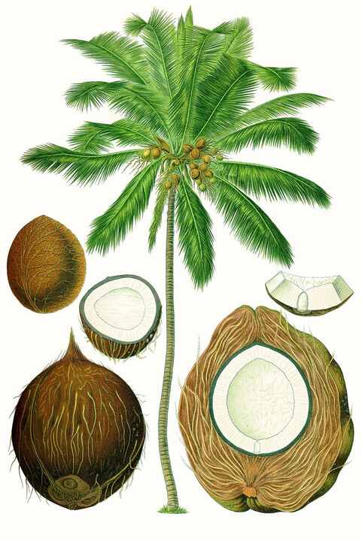
Source: Wikipedia — Coconut
Scientific name | Local name | Interesting fact
Cocos nucifera | nariyal | A coconut is botanically a fibrous one-seeded fruit, not a true nut; its husk, shell, water and flesh all have uses.

Banana
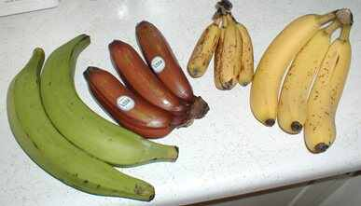
Source: Wikipedia — Banana
Scientific name | Local name | Interesting fact
Musa spp. | kela | The banana plant is a giant herb, not a tree: its apparent trunk is a tightly packed pseudostem of leaf bases.

Papaya
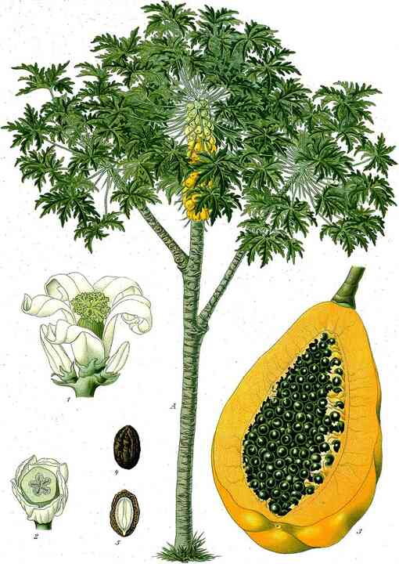
Source: Wikipedia — Papaya
Scientific name | Local name | Interesting fact
Carica papaya | papita | Papaya latex contains papain, an enzyme used as a meat tenderiser and in some food-processing applications.

Guava
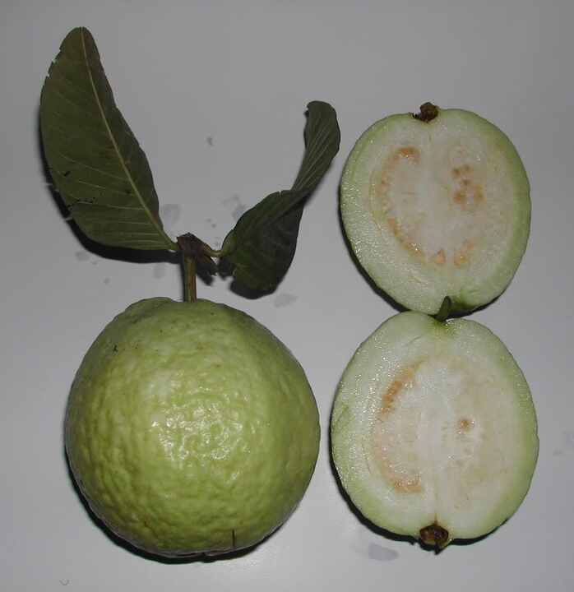
Source: Wikipedia — Psidium guajava
Scientific name | Local name | Interesting fact
Psidium guajava | amrood | Guava is exceptionally rich in vitamin C, and its flowers are pollinated by bees and other insects.

Pomegranate
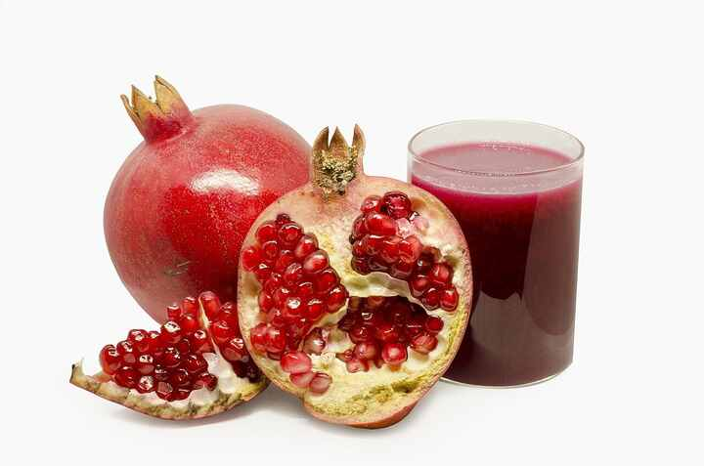
Source: Wikipedia — Pomegranate
Scientific name | Local name | Interesting fact
Punica granatum | anar | The juicy edible parts are arils: fleshy seed coverings, rather than the fruit's outer flesh.

Lemon
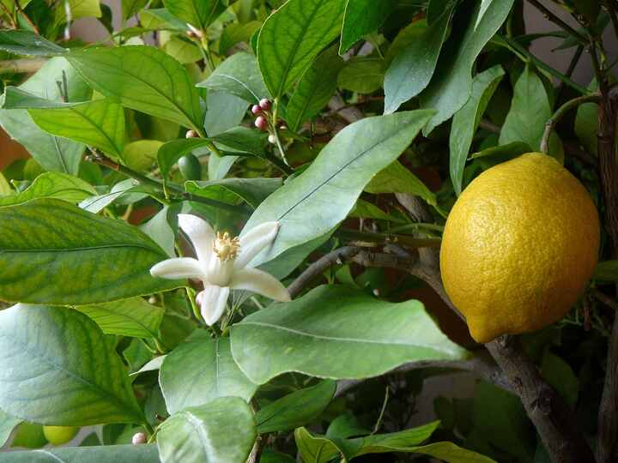
Source: Wikipedia — Lemon
Scientific name | Local name | Interesting fact
Citrus limon | nimbu | A lemon tree can carry flowers and ripe fruit at the same time, so several stages of the crop may appear together.

Sweet orange
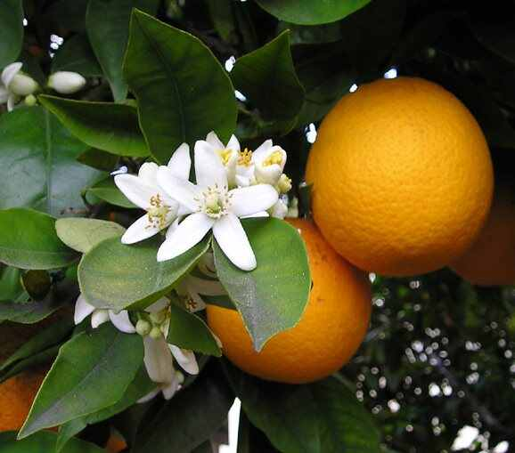
Source: Wikipedia — Citrus × sinensis
Scientific name | Local name | Interesting fact
Citrus × sinensis | santra | Sweet orange is a cultivated hybrid descended from mandarin and pomelo; many commercial trees are grafted.

Apple
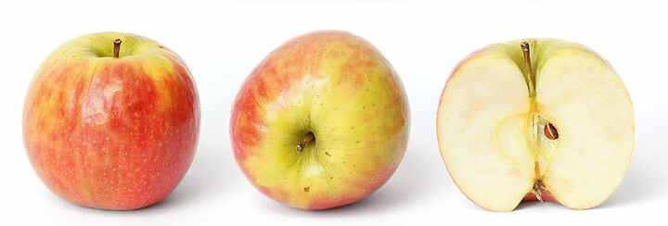
Source: Wikipedia — Apple
Scientific name | Local name | Interesting fact
Malus domestica | seb | An apple is a pome: much of the edible part develops from flower tissues around the ovary, not from the ovary alone.

Grapevine
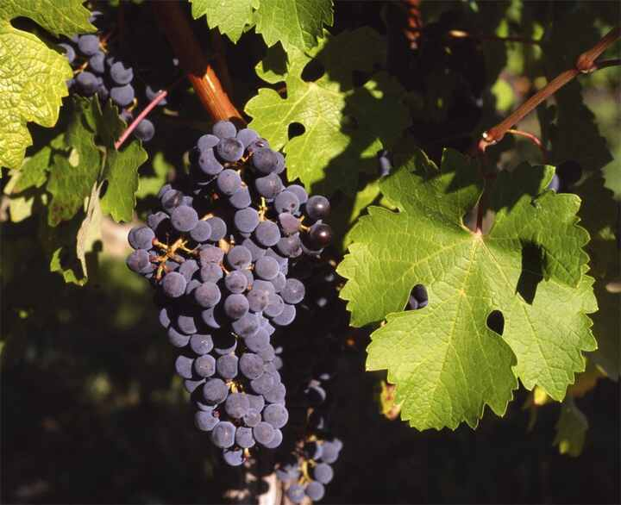
Source: Wikipedia — Vitis vinifera
Scientific name | Local name | Interesting fact
Vitis vinifera | angur | Grape tendrils are modified inflorescences or their branches, helping the vine climb toward light.

Strawberry
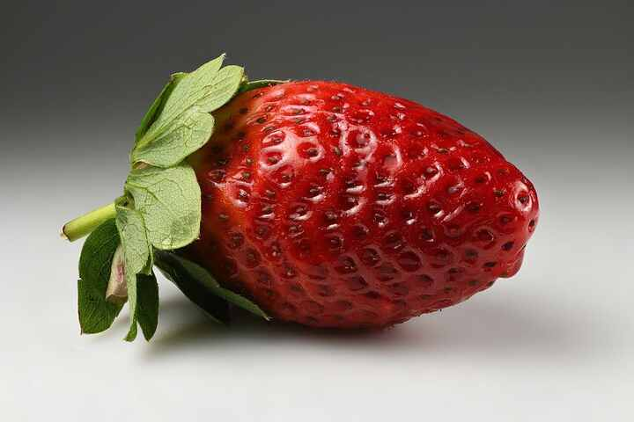
Source: Wikipedia — Strawberry
Scientific name | Local name | Interesting fact
Fragaria × ananassa | strawberry | The red fleshy part is a swollen flower receptacle; the tiny structures on its surface are the true fruits.

Pineapple
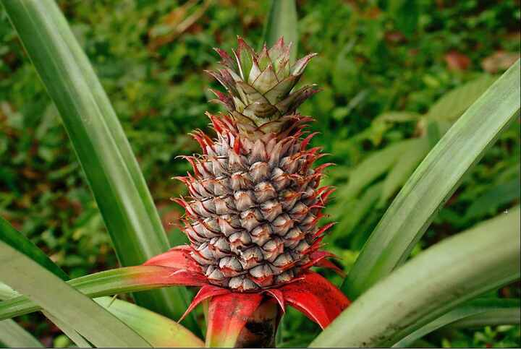
Source: Wikipedia — Pineapple
Scientific name | Local name | Interesting fact
Ananas comosus | ananas | A pineapple is a multiple fruit formed when many small flowers fuse together; its leafy crown can be rooted to grow a new plant.

Watermelon
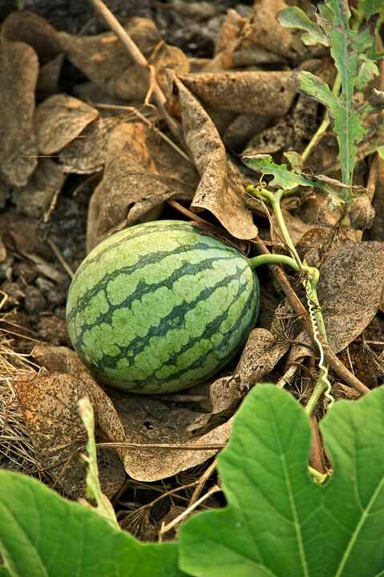
Source: Wikipedia — Watermelon
Scientific name | Local name | Interesting fact
Citrullus lanatus | tarbooz | Botanically, a watermelon is a type of berry called a pepo, with a firm rind and fleshy interior.

Tomato
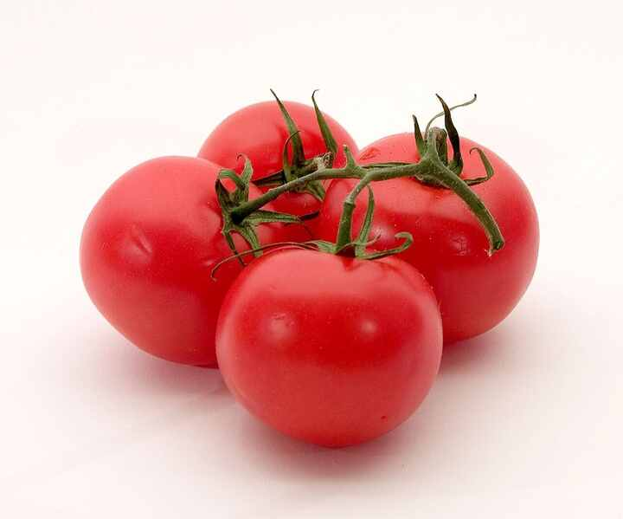
Source: Wikipedia — Tomato
Scientific name | Local name | Interesting fact
Solanum lycopersicum | tamatar | The tomato is botanically a berry; its wild relatives originated in the Andes and were domesticated in the Americas.

Eggplant (Brinjal)
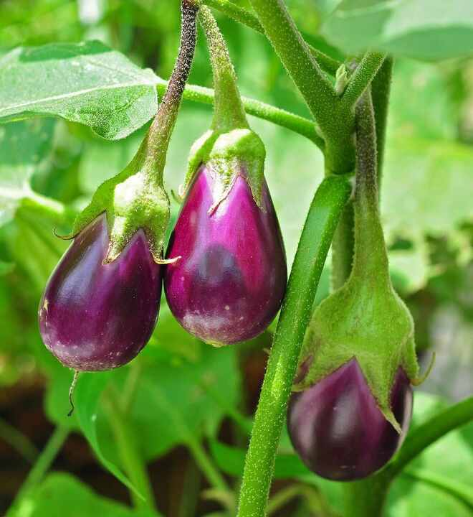
Source: Wikipedia — Eggplant
Scientific name | Local name | Interesting fact
Solanum melongena | baingan | Eggplant is also a botanical berry, and its flowers usually pollinate themselves with help from vibrating anthers.

Chili pepper
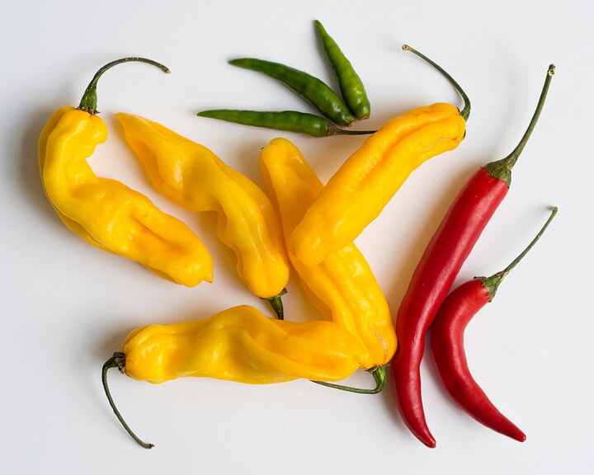
Source: Wikipedia — Chili pepper
Scientific name | Local name | Interesting fact
Capsicum annuum | mirch | Capsaicin is concentrated mainly in the white inner placenta, not in the seeds themselves.

Okra
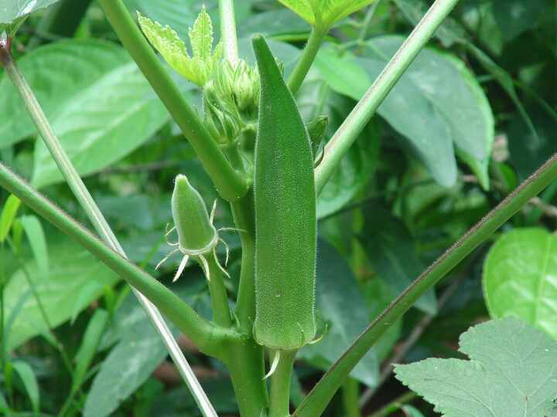
Source: Wikipedia — Okra
Scientific name | Local name | Interesting fact
Abelmoschus esculentus | bhindi | Young okra pods contain mucilage, which naturally thickens soups and stews when the pods are cut or cooked.

Cucumber
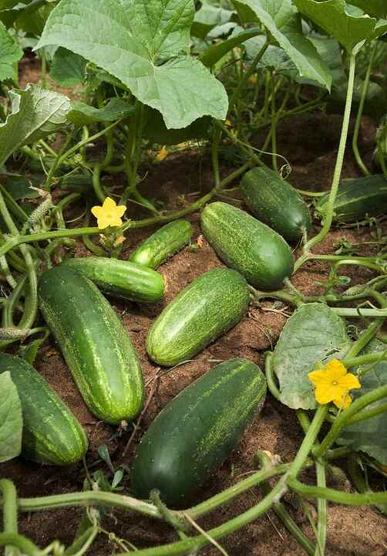
Source: Wikipedia — Cucumber
Scientific name | Local name | Interesting fact
Cucumis sativus | kheera | Cucumber is a pepo, a berry-like fruit with a firm rind; its fresh fruit is roughly 95 percent water.

Pumpkin
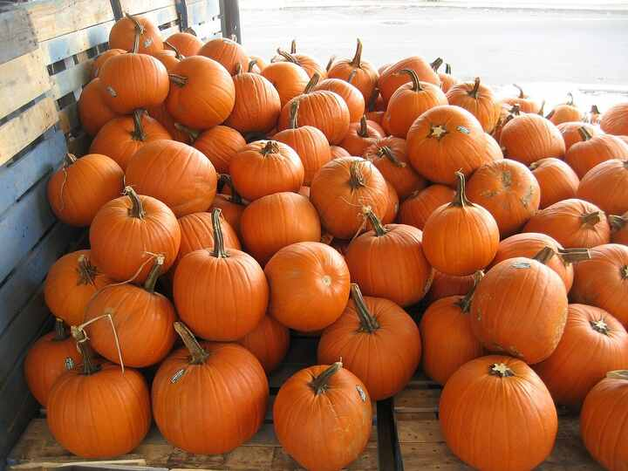
Source: Wikipedia — Pumpkin
Scientific name | Local name | Interesting fact
Cucurbita spp. | kaddu | Pumpkin vines produce separate male and female flowers, and the flowers themselves are edible in many cuisines.

Bottle gourd
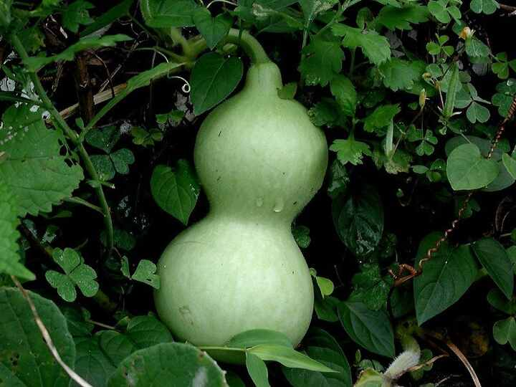
Source: Wikipedia — Calabash
Scientific name | Local name | Interesting fact
Lagenaria siceraria | lauki | When fully mature and dried, the hard shell can be turned into bottles, bowls, musical instruments and other containers.

Bitter melon
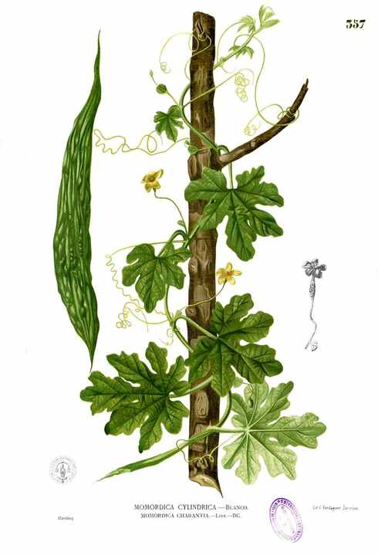
Source: Wikipedia — Momordica charantia
Scientific name | Local name | Interesting fact
Momordica charantia | karela | The ripe fruit splits open to reveal bright red arils around its seeds, contrasting with the fruit's strongly bitter taste.

Spinach
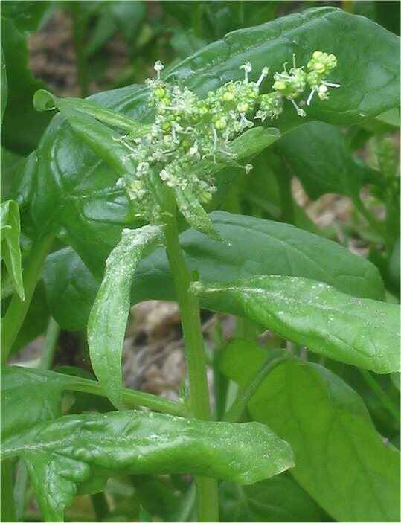
Source: Wikipedia — Spinach
Scientific name | Local name | Interesting fact
Spinacia oleracea | palak | Spinach leaves contain oxalates; blanching or cooking reduces their volume and can lower soluble oxalate.

Coriander
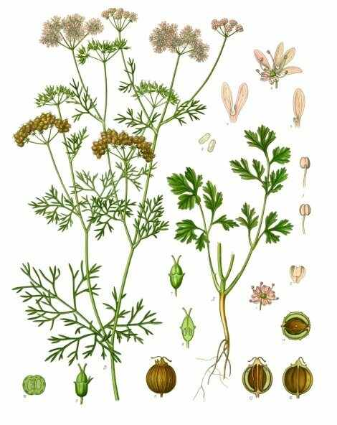
Source: Wikipedia — Coriander
Scientific name | Local name | Interesting fact
Coriandrum sativum | dhaniya | Its leaves and seeds have noticeably different aromas because the plant's oils change as the fruit matures.

Mint
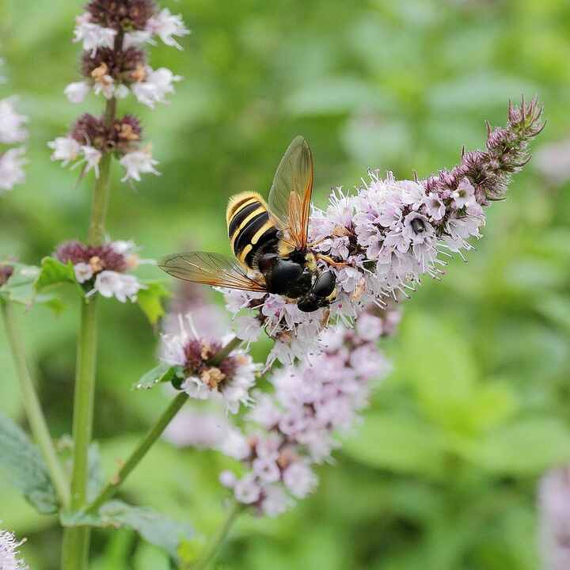
Source: Wikipedia — Mentha
Scientific name | Local name | Interesting fact
Mentha spp. | pudina | Mint spreads vigorously through underground stems and can take over a garden bed unless its roots are contained.

Fenugreek
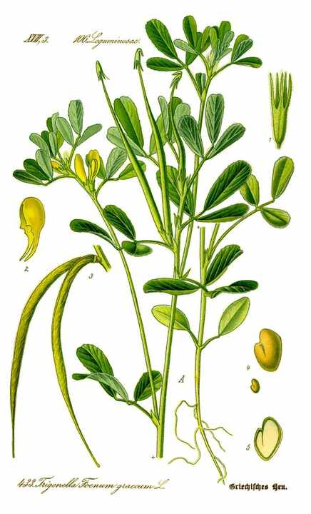
Source: Wikipedia — Fenugreek
Scientific name | Local name | Interesting fact
Trigonella foenum-graecum | methi | Both the fresh leaves and the dried seeds are used; the seeds have a distinctive maple-like aroma.

Mustard plant
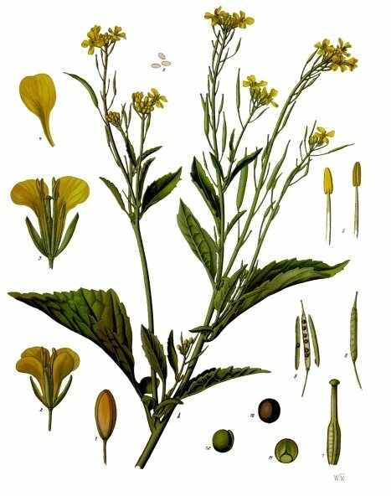
Source: Wikipedia — Brassica juncea
Scientific name | Local name | Interesting fact
Brassica juncea | sarson | Mustard's pungency develops when crushed tissues meet water, allowing enzymes to form sharp mustard oils.

Ginger
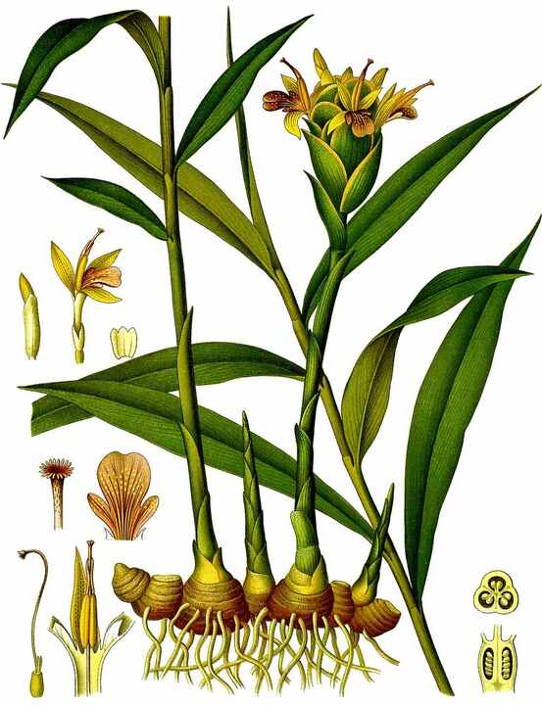
Source: Wikipedia — Ginger
Scientific name | Local name | Interesting fact
Zingiber officinale | adrak | The familiar ginger is a rhizome, a horizontal underground stem, rather than a true root.

Turmeric
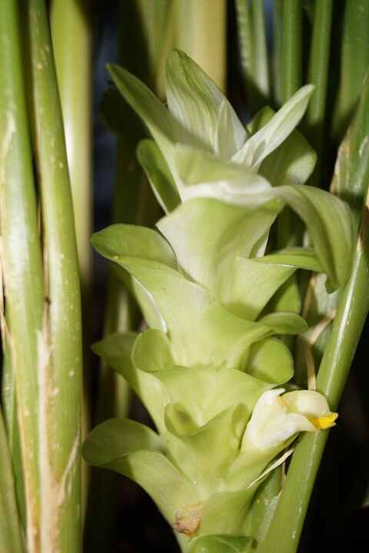
Source: Wikipedia — Turmeric
Scientific name | Local name | Interesting fact
Curcuma longa | haldi | Turmeric's golden colour comes largely from curcuminoids stored in its rhizome.

Garlic
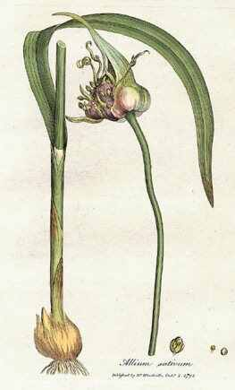
Source: Wikipedia — Garlic
Scientific name | Local name | Interesting fact
Allium sativum | lahsun | A garlic bulb is made of separate cloves; chopping damages cells and lets them form the pungent compound allicin.

Onion
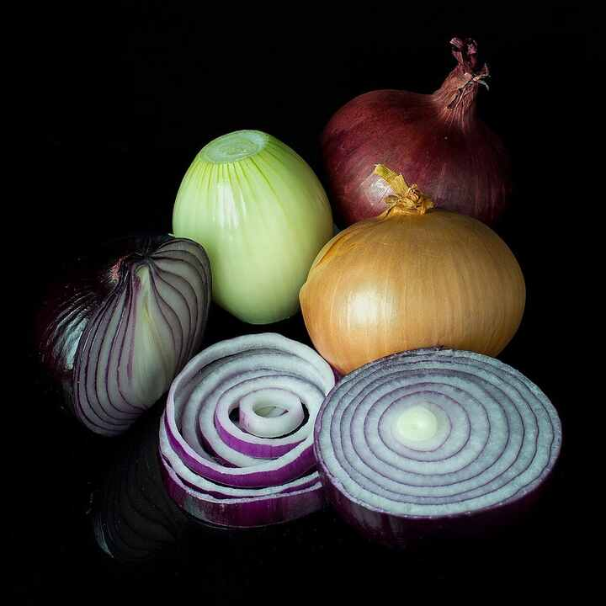
Source: Wikipedia — Onion
Scientific name | Local name | Interesting fact
Allium cepa | pyaz | Cutting onions releases a volatile compound that reacts with the eye's moisture and triggers tears.

Potato
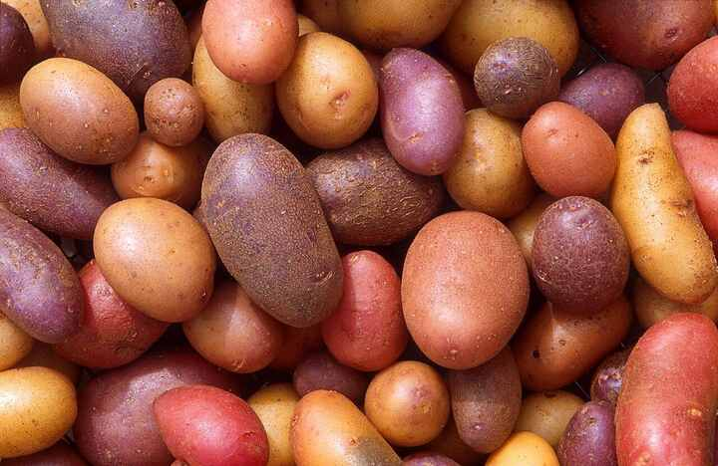
Source: Wikipedia — Potato
Scientific name | Local name | Interesting fact
Solanum tuberosum | aloo | A potato is a stem tuber; green or bitter parts can contain elevated glycoalkaloids such as solanine.

Sweet potato
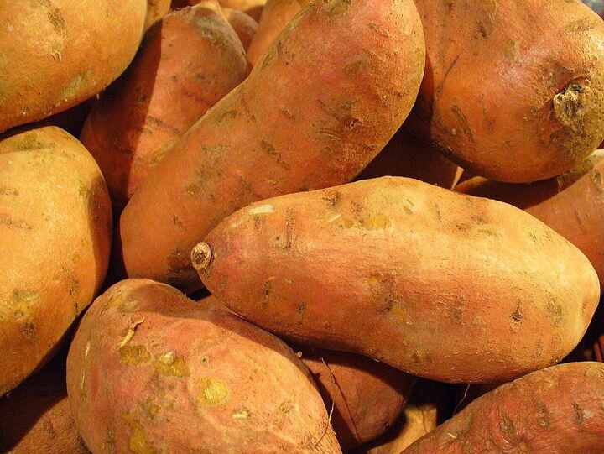
Source: Wikipedia — Sweet potato
Scientific name | Local name | Interesting fact
Ipomoea batatas | shakarkand | Unlike potato, sweet potato is a swollen storage root and belongs to the morning-glory family.

Carrot
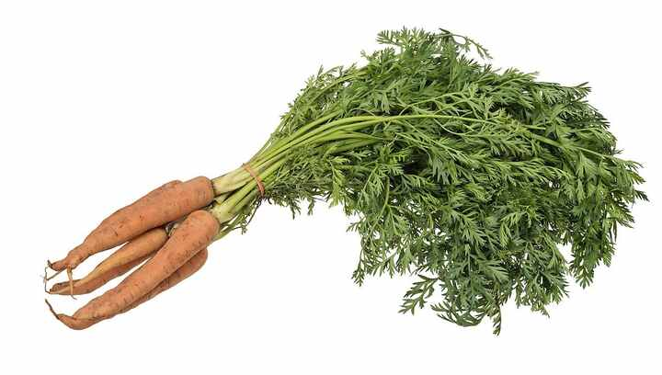
Source: Wikipedia — Carrot
Scientific name | Local name | Interesting fact
Daucus carota subsp. sativus | gajar | The orange colour of many carrots comes from beta-carotene, which the body can convert to vitamin A.

Radish
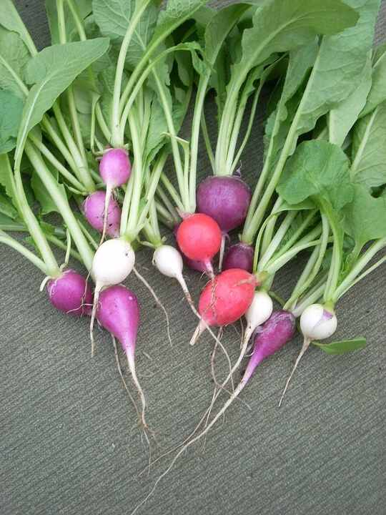
Source: Wikipedia — Radish
Scientific name | Local name | Interesting fact
Raphanus sativus | mooli | Radish is a fast-growing crop whose swollen taproot stores energy below ground.

Beetroot
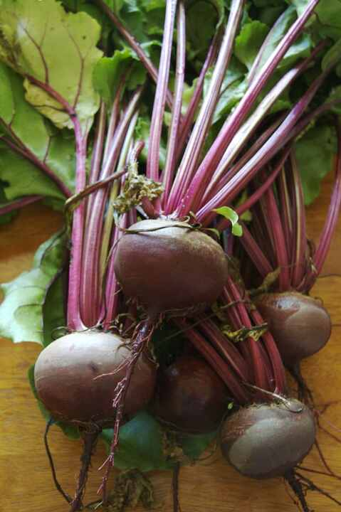
Source: Wikipedia — Beetroot
Scientific name | Local name | Interesting fact
Beta vulgaris | chukandar | Its red-purple colour comes mainly from betalain pigments, which are chemically different from the anthocyanins in many red fruits.

Cabbage
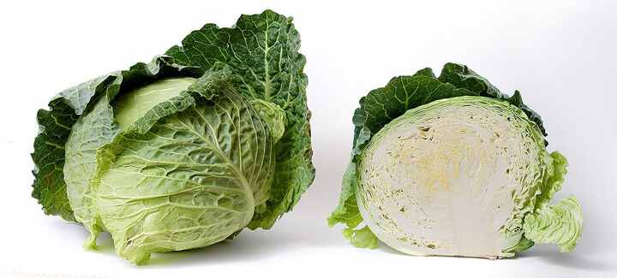
Source: Wikipedia — Cabbage
Scientific name | Local name | Interesting fact
Brassica oleracea var. capitata | patta gobhi | The familiar head is a tightly packed cluster of leaves; cabbage is closely related to kale, broccoli and cauliflower.

Cauliflower
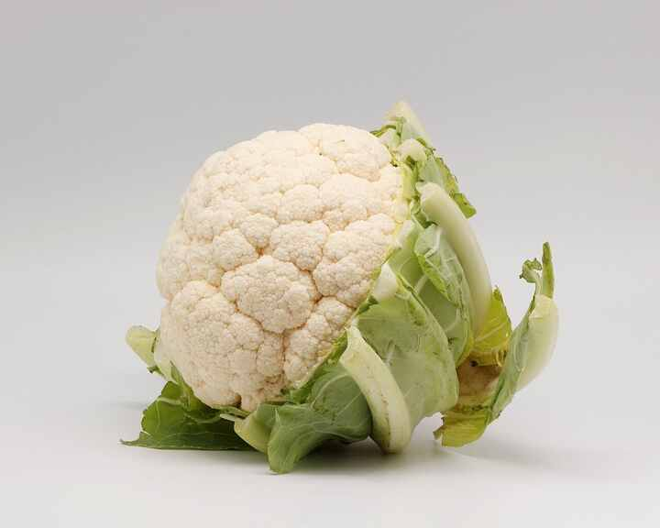
Source: Wikipedia — Cauliflower
Scientific name | Local name | Interesting fact
Brassica oleracea var. botrytis | phool gobhi | The white 'curd' is an immature, tightly branched flowering structure harvested before the flowers open.

Broccoli
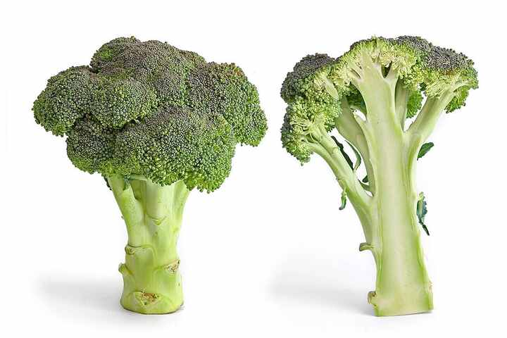
Source: Wikipedia — Broccoli
Scientific name | Local name | Interesting fact
Brassica oleracea var. italica | broccoli | Broccoli is harvested for immature flower clusters; if left to mature, it produces small yellow flowers.

Pea
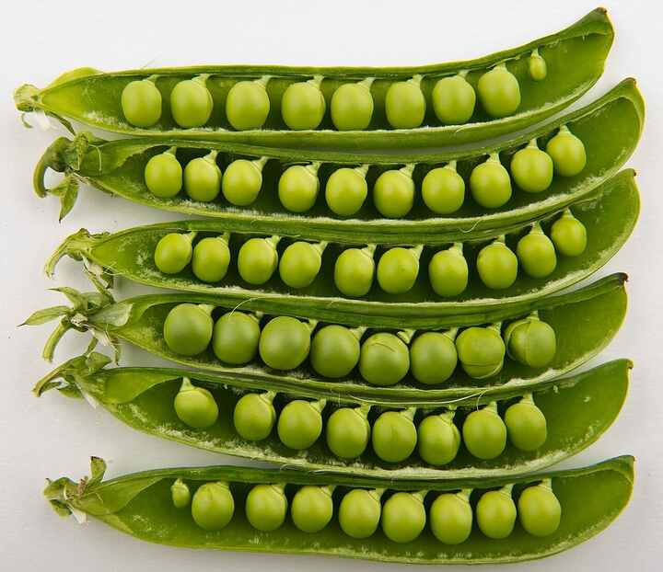
Source: Wikipedia — Pea
Scientific name | Local name | Interesting fact
Pisum sativum | matar | Pea plants host nitrogen-fixing bacteria in root nodules, converting atmospheric nitrogen into forms the plant can use.

Chickpea
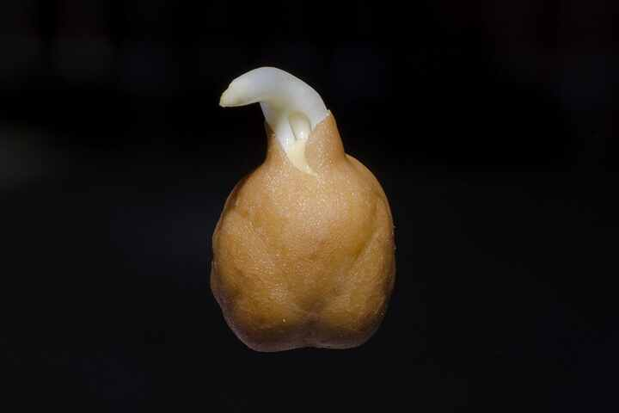
Source: Wikipedia — Chickpea
Scientific name | Local name | Interesting fact
Cicer arietinum | chana | The two familiar market types, desi and kabuli, differ in seed size, colour and coat texture.

Lentil
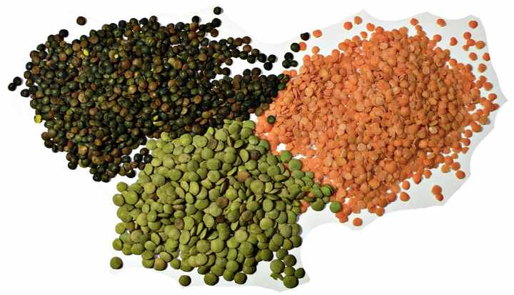
Source: Wikipedia — Lentil
Scientific name | Local name | Interesting fact
Lens culinaris | masoor | Lentil seeds are lens-shaped and come in several colours, including brown, green, red and black.

Soybean
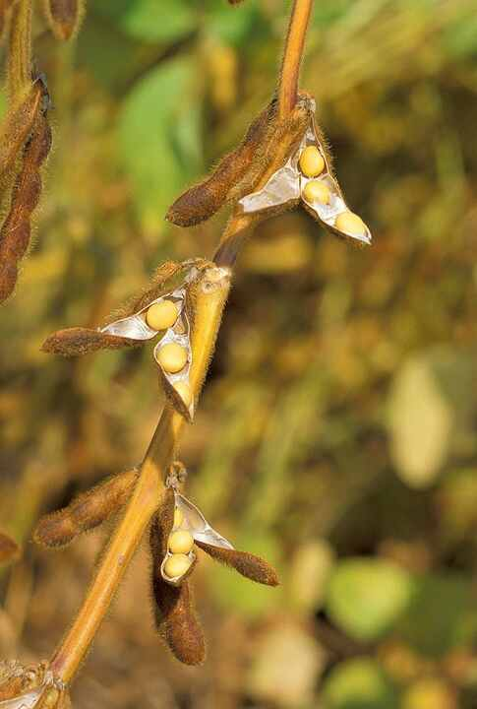
Source: Wikipedia — Soybean
Scientific name | Local name | Interesting fact
Glycine max | soyabean | Soybean is both a nitrogen-fixing legume and an important source of plant protein and edible oil.

Rice
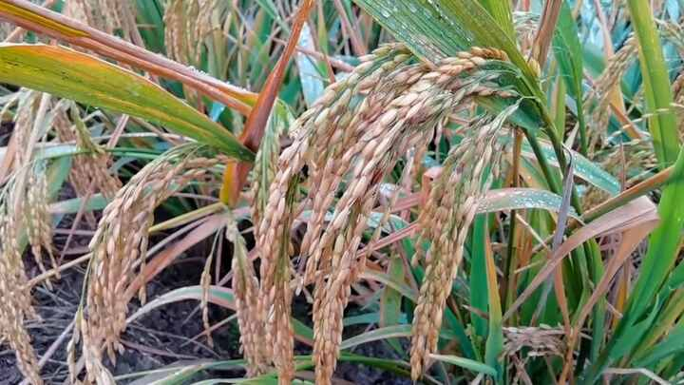
Source: Wikipedia — Rice
Scientific name | Local name | Interesting fact
Oryza sativa | dhaan | Rice is a grass; its aromatic varieties can owe their characteristic scent to the compound 2-acetyl-1-pyrroline.

Wheat
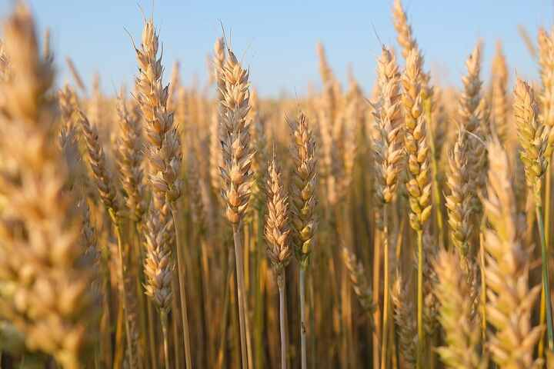
Source: Wikipedia — Wheat
Scientific name | Local name | Interesting fact
Triticum aestivum | gehun | Bread wheat forms an elastic dough because its storage proteins combine with water to create gluten networks.

Maize (Corn)
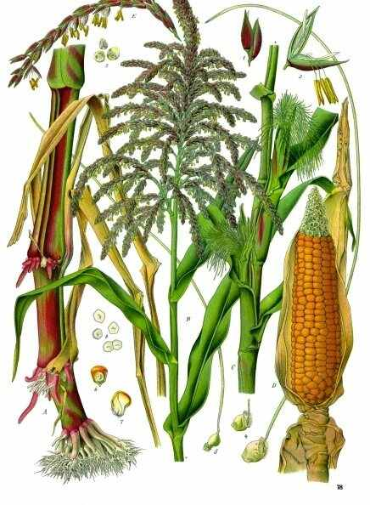
Source: Wikipedia — Maize
Scientific name | Local name | Interesting fact
Zea mays | makka | The tassel is the male flower cluster, while the silks on each ear are styles connected to individual kernels.

Sugarcane
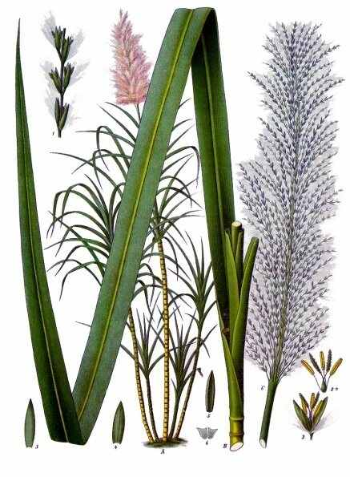
Source: Wikipedia — Sugarcane
Scientific name | Local name | Interesting fact
Saccharum officinarum | ganna | Commercial sugar is extracted from the juice stored in sugarcane's thickened stem, which is itself a grass stem.

Cotton
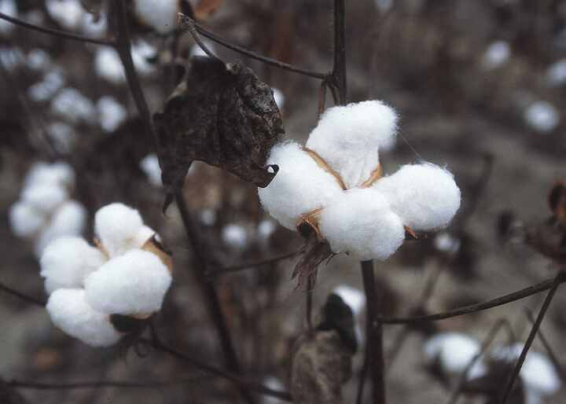
Source: Wikipedia — Cotton
Scientific name | Local name | Interesting fact
Gossypium spp. | kapas | Cotton fibre is made of elongated seed hairs; the fluffy boll is the plant's way of dispersing those seeds.

Tea plant
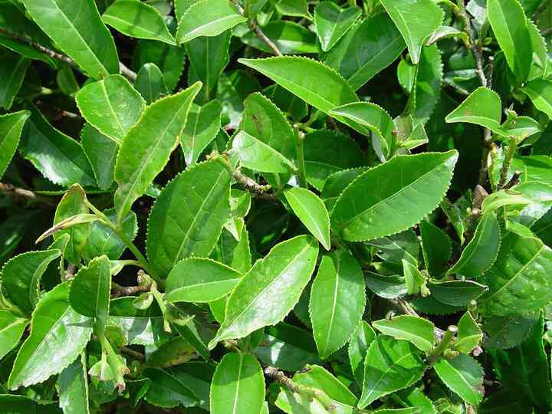
Source: Wikipedia — Camellia sinensis
Scientific name | Local name | Interesting fact
Camellia sinensis | chai | Green, oolong and black teas come from the same species; their differences mainly reflect how the leaves are processed.

Coffee plant
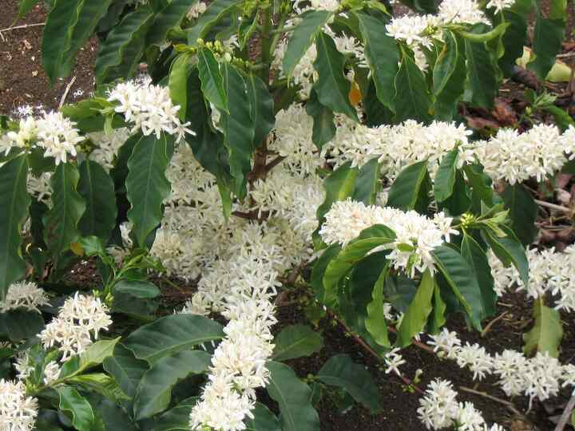
Source: Wikipedia — Coffea
Scientific name | Local name | Interesting fact
Coffea spp. | coffee | A coffee bean is a seed inside a fruit called a coffee cherry; Arabica and Robusta are the main commercial groups.

Bamboo
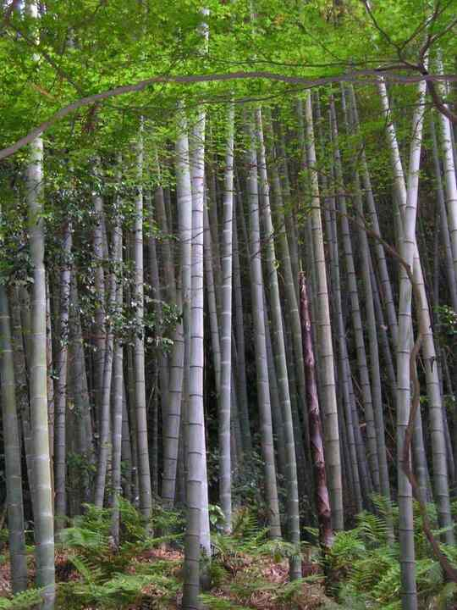
Source: Wikipedia — Bamboo
Scientific name | Local name | Interesting fact
Bambusoideae | baans | Bamboo is a grass, not a tree; some species grow extremely quickly, while others flower only after many decades.

Eucalyptus
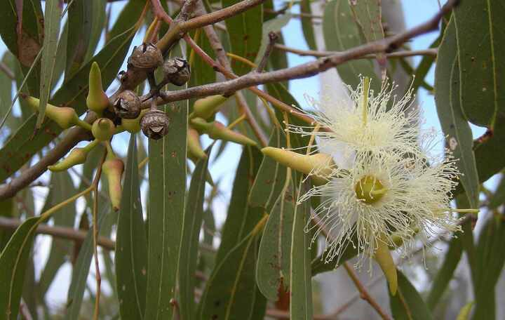
Source: Wikipedia — Eucalyptus
Scientific name | Local name | Interesting fact
Eucalyptus spp. | nilgiri | Many eucalyptus leaves contain cineole-rich oils, but eucalyptus is a large genus with species adapted to very different habitats.

Teak
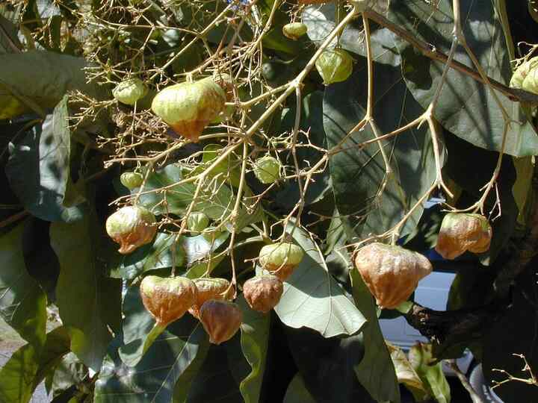
Source: Wikipedia — Teak
Scientific name | Local name | Interesting fact
Tectona grandis | sagwan | Teak wood is durable partly because its natural oils help resist moisture, fungi and many insects.

Sandalwood
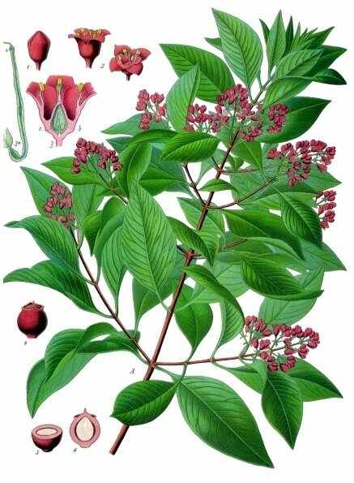
Source: Wikipedia — Santalum album
Scientific name | Local name | Interesting fact
Santalum album | chandan | Sandalwood's fragrant heartwood develops slowly; the tree is also a root hemiparasite that draws some resources from neighbouring plants.

Money plant (Pothos)
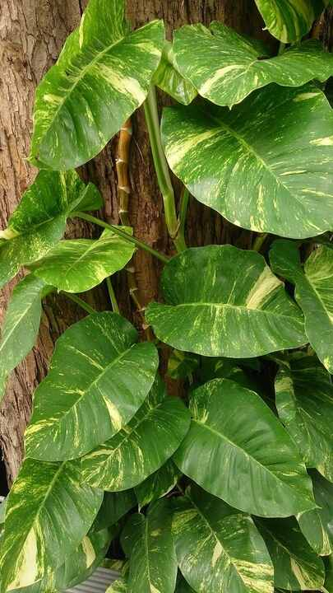
Source: Wikipedia — Epipremnum aureum
Scientific name | Local name | Interesting fact
Epipremnum aureum | money plant | Pothos can grow in water, but long-term growth still requires nutrients; its tissues contain irritating calcium oxalate crystals.

Snake plant
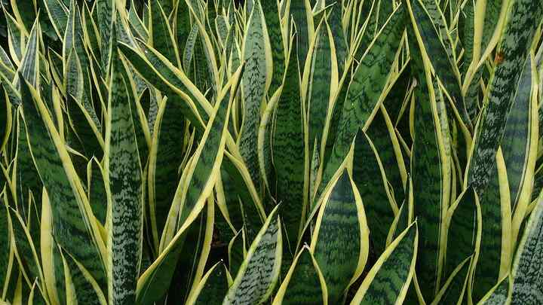
Source: Wikipedia — Dracaena trifasciata
Scientific name | Local name | Interesting fact
Dracaena trifasciata | snake plant | Its succulent leaves use CAM photosynthesis, opening their stomata mainly at night to reduce water loss.

