Mango
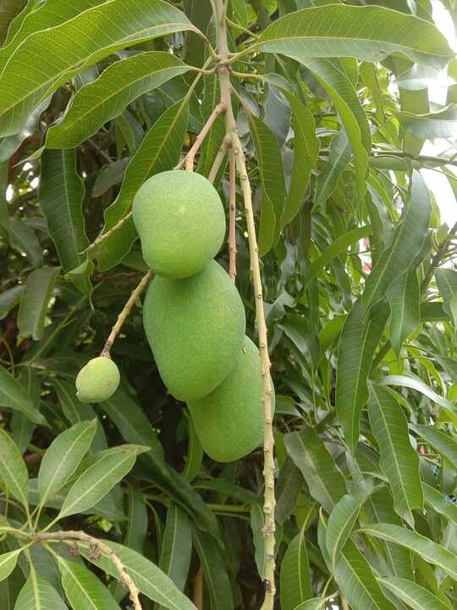
Source: Wikipedia — Mangifera indica
Scientific name | Mangifera indica
Local name | Aam (Hindi) · Maanga (Tamil)
Interesting | India's national fruit; a single tree can fruit for over 300 years, and India grows about half the world's mangoes.

Neem
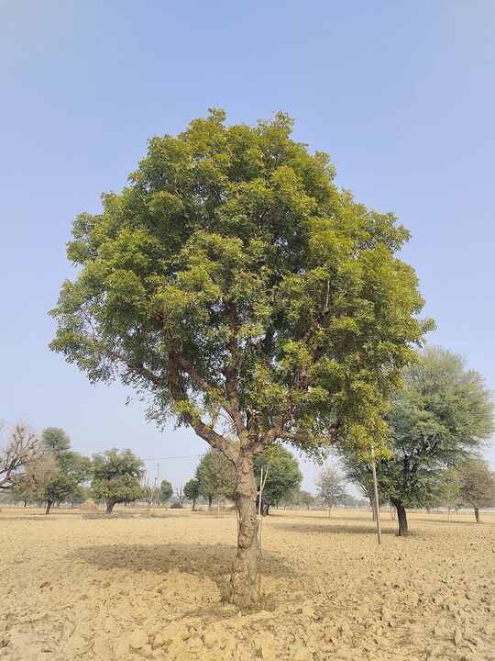
Source: Wikipedia — Azadirachta indica
Scientific name | Azadirachta indica
Local name | Neem (Hindi) · Vembu (Tamil)
Interesting | Its seeds yield azadirachtin, a natural insecticide; twigs have been used as toothbrushes for centuries.

Banyan
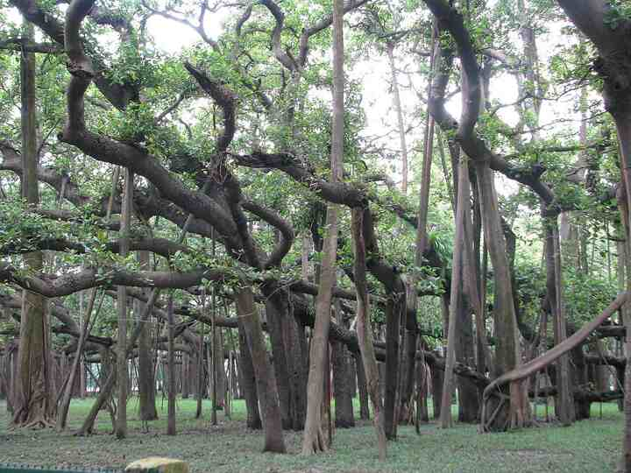
Source: Wikipedia — Ficus benghalensis
Scientific name | Ficus benghalensis
Local name | Bargad (Hindi) · Aalamaram (Tamil)
Interesting | India's national tree; its aerial prop roots become new trunks, letting one tree spread over hectares (Kolkata's Great Banyan).

Peepal
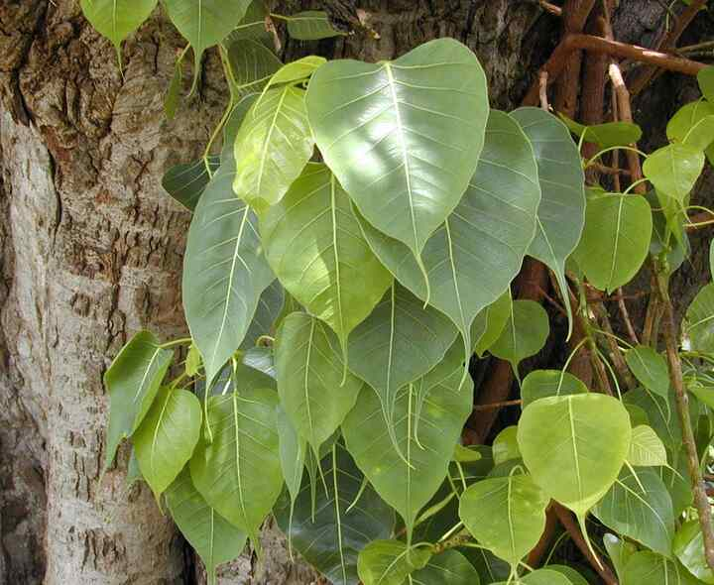
Source: Wikipedia — Ficus religiosa
Scientific name | Ficus religiosa
Local name | Peepal (Hindi) · Arasamaram (Tamil)
Interesting | The Bodhi tree under which the Buddha attained enlightenment; its leaves have a distinctive long 'drip tip'.

Tulsi (Holy basil)
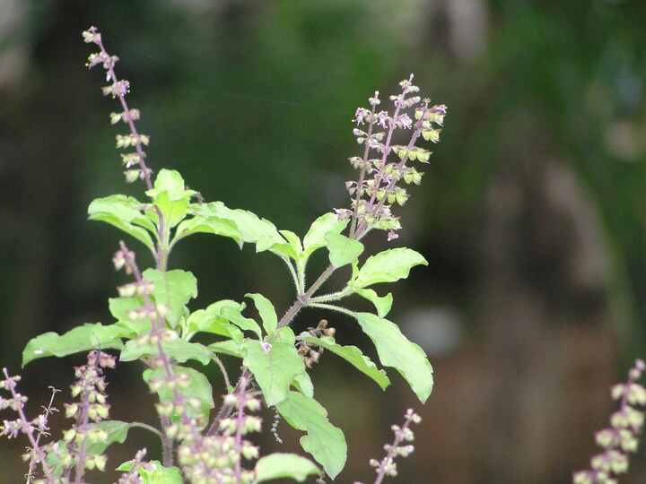
Source: Wikipedia — Ocimum tenuiflorum
Scientific name | Ocimum tenuiflorum
Local name | Tulsi (Hindi) · Thulasi (Tamil)
Interesting | Worshipped in many Hindu homes; its clove-like scent comes from eugenol, and it is widely used in Ayurvedic teas.

Aloe vera
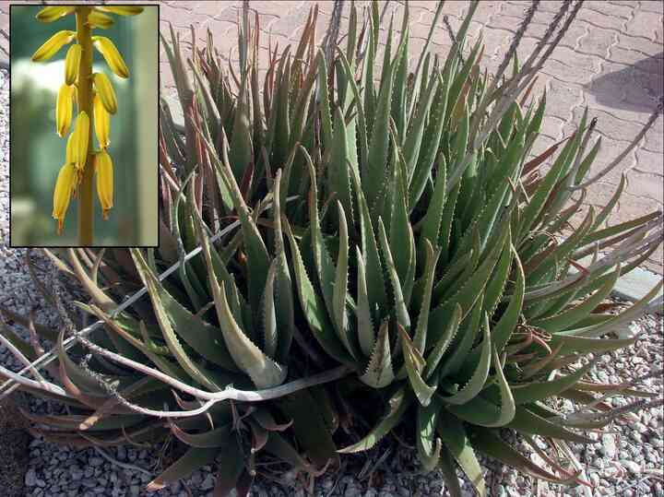
Source: Wikipedia — Aloe vera
Scientific name | Aloe vera
Local name | Ghritkumari (Hindi) · Katraazhai (Tamil)
Interesting | A succulent storing water in gel-filled leaves; uses CAM photosynthesis, opening its pores only at night.

Hibiscus
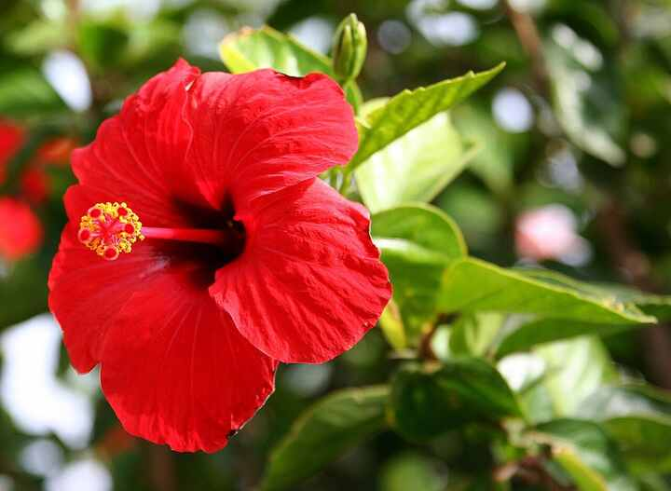
Source: Wikipedia — Hibiscus × rosa-sinensis
Scientific name | Hibiscus × rosa-sinensis
Local name | Gudhal (Hindi) · Semparuthi (Tamil)
Interesting | National flower of Malaysia; petals are used as a hair tonic and to dye food and shoe polish.

Rose
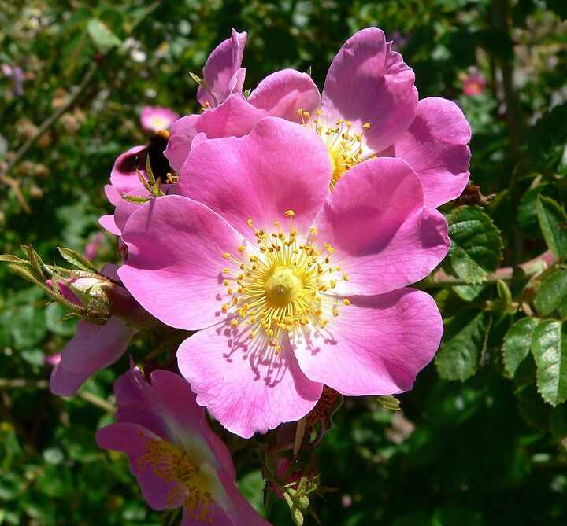
Source: Wikipedia — Rose
Scientific name | Rosa spp.
Local name | Gulab (Hindi) · Roja (Tamil)
Interesting | Its 'thorns' are technically prickles; rose oil (attar) takes thousands of kilos of petals per kilo of oil.

Jasmine
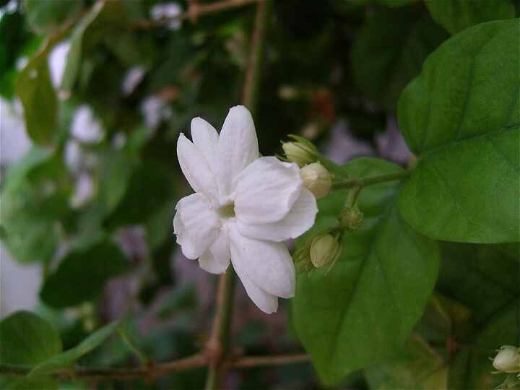
Source: Wikipedia — Jasminum sambac
Scientific name | Jasminum sambac
Local name | Mogra (Hindi) · Malli (Tamil)
Interesting | National flower of the Philippines; Madurai malli has a GI tag, and flowers open and release scent at night.

Marigold
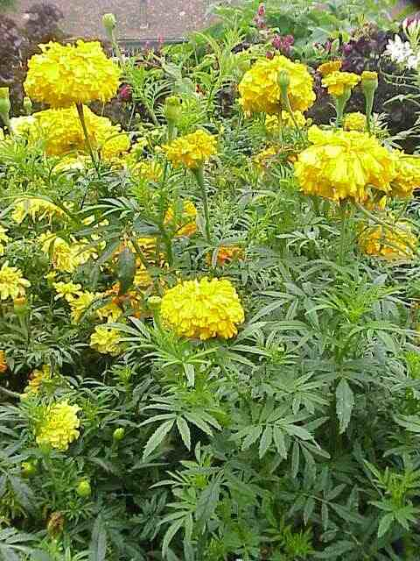
Source: Wikipedia — Tagetes erecta
Scientific name | Tagetes erecta
Local name | Genda (Hindi) · Samandhi (Tamil)
Interesting | Native to Mexico despite its ubiquity in Indian garlands; its roots suppress soil nematodes.

Sunflower
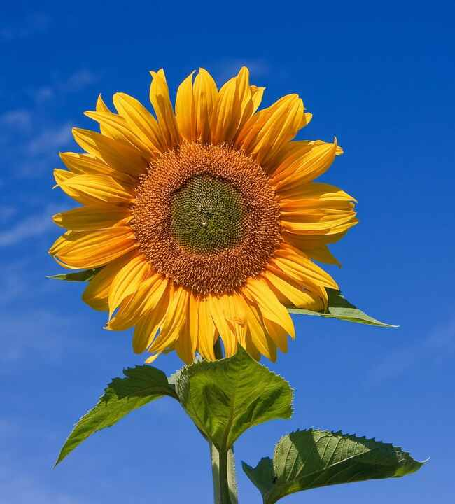
Source: Wikipedia — Common sunflower
Scientific name | Helianthus annuus
Local name | Surajmukhi (Hindi) · Sooriyagandhi (Tamil)
Interesting | Young buds track the sun (heliotropism), but mature heads stay facing east; seeds spiral in Fibonacci patterns.

Lotus
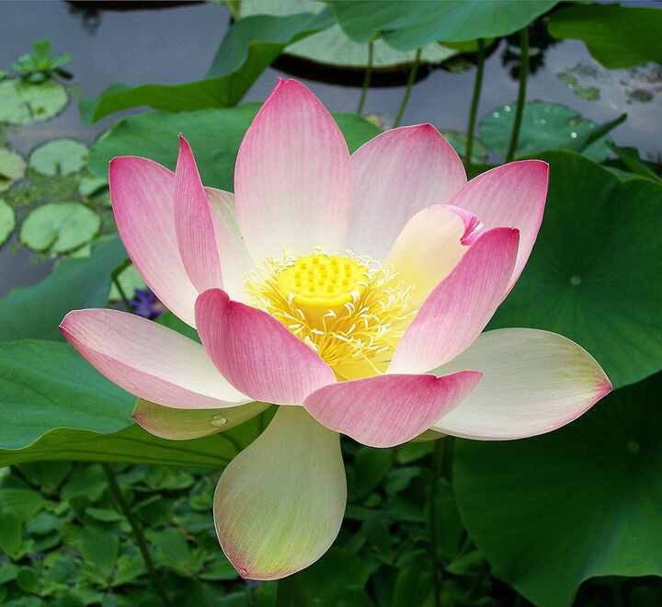
Source: Wikipedia — Nelumbo nucifera
Scientific name | Nelumbo nucifera
Local name | Kamal (Hindi) · Thamarai (Tamil)
Interesting | India's national flower; its leaves self-clean via the 'lotus effect', and seeds over 1,000 years old have germinated.

Water lily
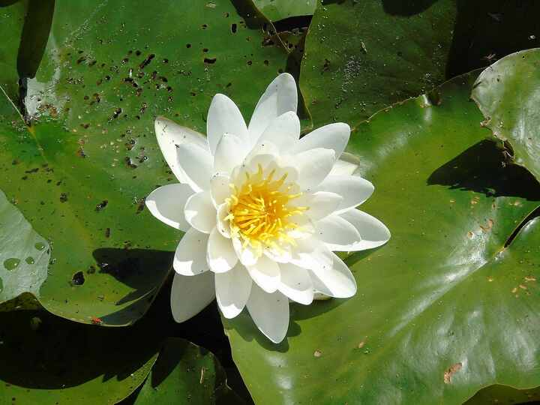
Source: Wikipedia — Nymphaea
Scientific name | Nymphaea spp.
Local name | Kumudini (Hindi) · Alli (Tamil)
Interesting | National flower of Bangladesh; unlike lotus, its leaves float flat on the water and have a slit.

Bougainvillea
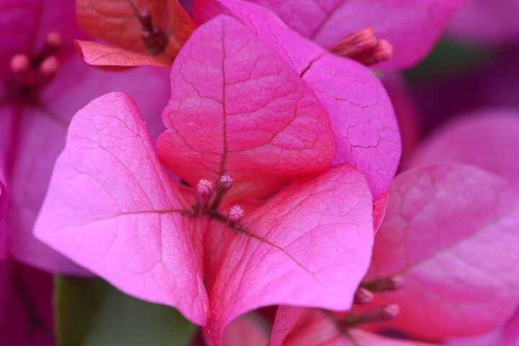
Source: Wikipedia — Bougainvillea
Scientific name | Bougainvillea spectabilis
Local name | Baganbilas (Hindi) · Kaagithapoo (Tamil)
Interesting | The colourful 'petals' are papery bracts; the real flowers are tiny white tubes inside.

Ixora
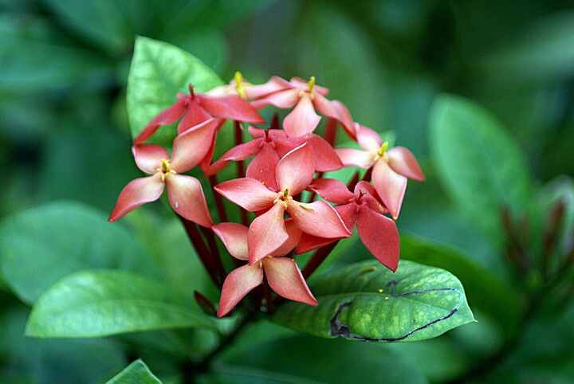
Source: Wikipedia — Ixora coccinea
Scientific name | Ixora coccinea
Local name | Rugmini (Hindi) · Vetchi (Tamil)
Interesting | Its tubular clusters are a favourite nectar source for butterflies; flowers are used in temple offerings.

Frangipani
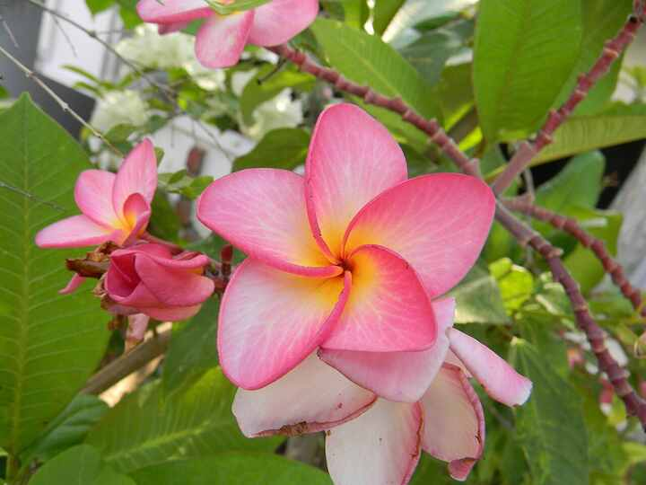
Source: Wikipedia — Plumeria
Scientific name | Plumeria spp.
Local name | Champa (Hindi) · Perungalli (Tamil)
Interesting | Its flowers have no nectar; they fool moths with scent at night. Often planted near temples.

Gulmohar
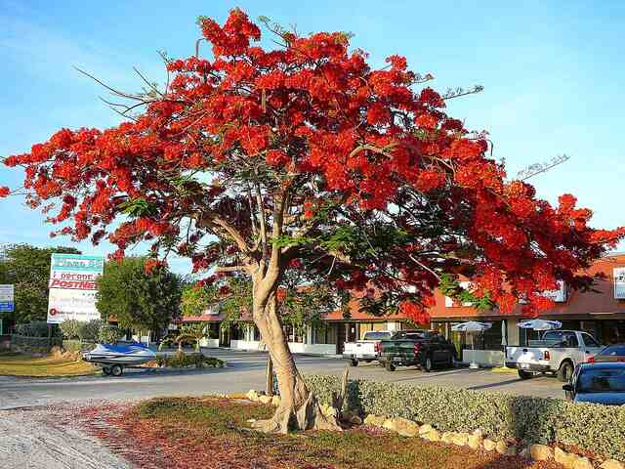
Source: Wikipedia — Delonix regia
Scientific name | Delonix regia
Local name | Gulmohar (Hindi) · Mayilkondrai (Tamil)
Interesting | Native to Madagascar, where it is endangered in the wild, yet it blazes red across Indian summers.

Ashoka tree
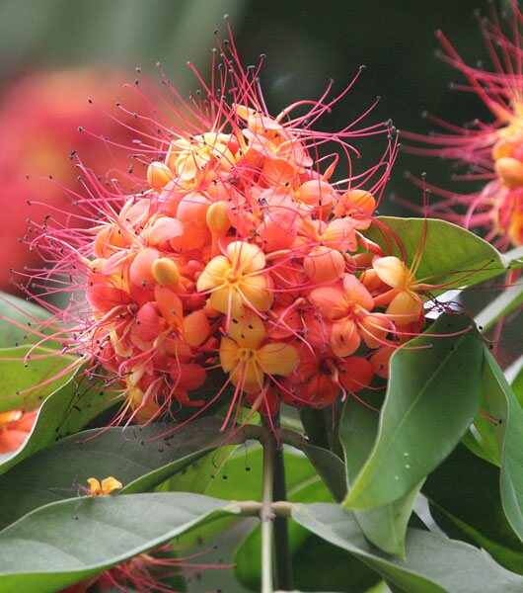
Source: Wikipedia — Saraca asoca
Scientific name | Saraca asoca
Local name | Ashok (Hindi) · Asogam (Tamil)
Interesting | Sacred in Hindu and Buddhist tradition (the Buddha was born under one); often confused with the tall mast tree Polyalthia.

Curry tree
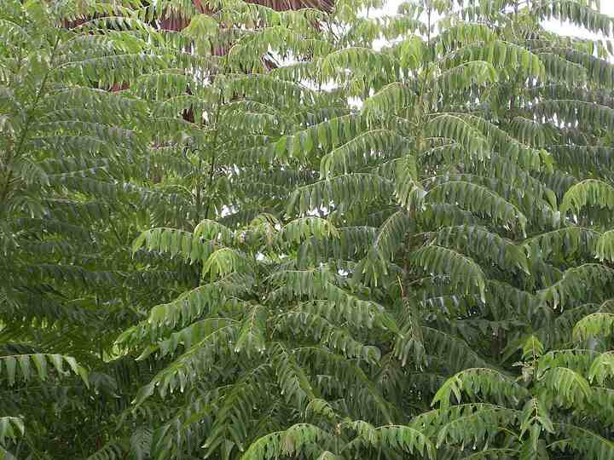
Source: Wikipedia — Curry tree
Scientific name | Murraya koenigii
Local name | Kadi patta (Hindi) · Karuveppilai (Tamil)
Interesting | Its leaves are essential to South Indian tempering; it's a citrus relative, and the berries are edible but seeds are toxic.

Coconut palm
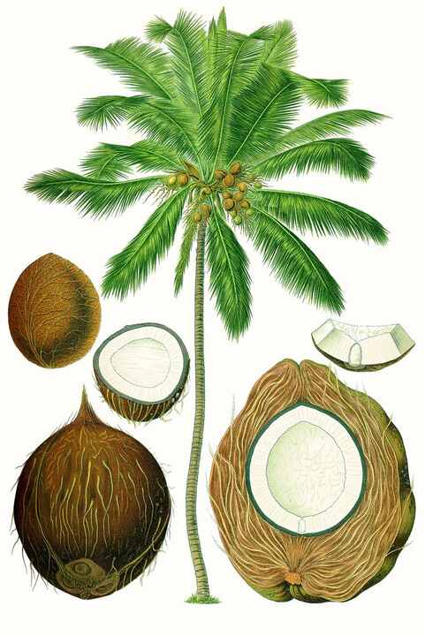
Source: Wikipedia — Coconut
Scientific name | Cocos nucifera
Local name | Nariyal (Hindi) · Thennai (Tamil)
Interesting | Called kalpavriksha, the 'tree of life', since every part is used; the fruit is a drupe, not a true nut.

Banana
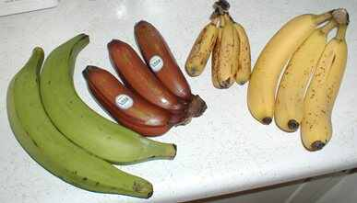
Source: Wikipedia — Banana
Scientific name | Musa spp.
Local name | Kela (Hindi) · Vaazhai (Tamil)
Interesting | The plant is a giant herb, not a tree; the fruit is botanically a berry, and India is the largest producer.

Papaya
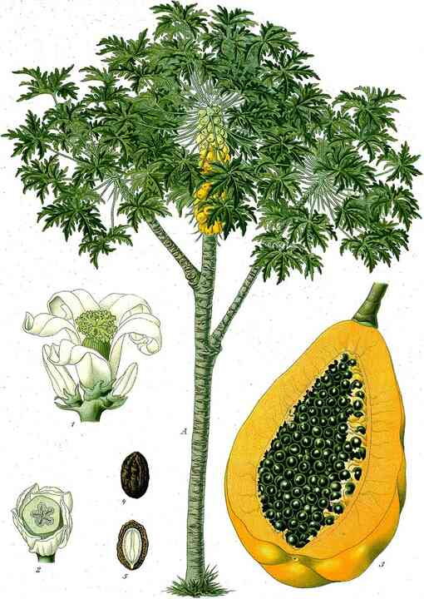
Source: Wikipedia — Papaya
Scientific name | Carica papaya
Local name | Papita (Hindi) · Pappaali (Tamil)
Interesting | Its latex contains papain, used to tenderise meat; plants can be male, female, or bisexual.

Guava
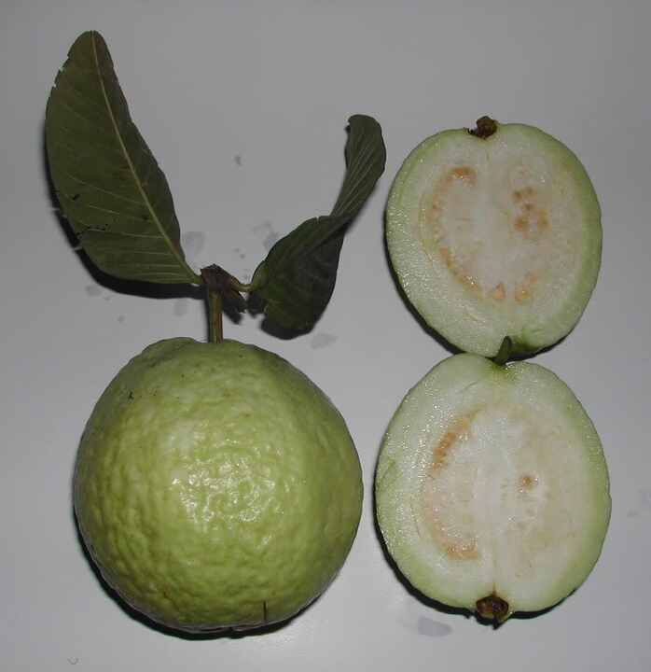
Source: Wikipedia — Psidium guajava
Scientific name | Psidium guajava
Local name | Amrood (Hindi) · Koyya (Tamil)
Interesting | Among the richest fruit sources of vitamin C, with several times that of an orange.

Pomegranate
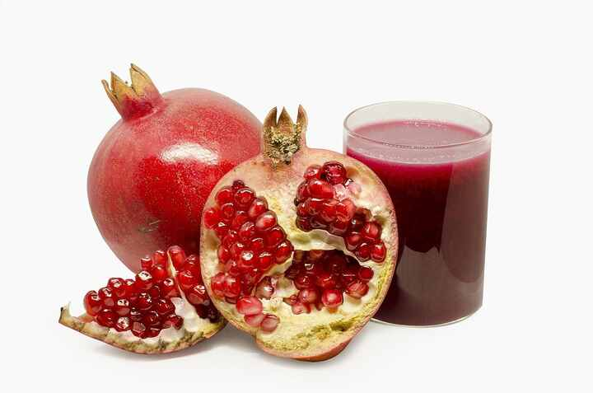
Source: Wikipedia — Pomegranate
Scientific name | Punica granatum
Local name | Anaar (Hindi) · Maadhulai (Tamil)
Interesting | Each juicy seed casing is called an aril; one fruit can hold 600+ of them.

Lemon
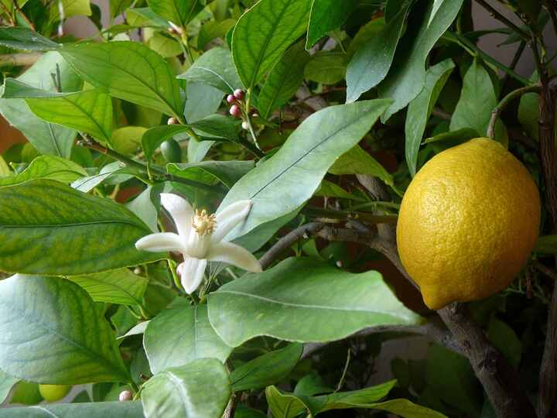
Source: Wikipedia — Lemon
Scientific name | Citrus limon
Local name | Nimbu (Hindi) · Elumichai (Tamil)
Interesting | Likely a hybrid of bitter orange and citron; in India lemon and chillies are hung to ward off the evil eye.

Sweet orange
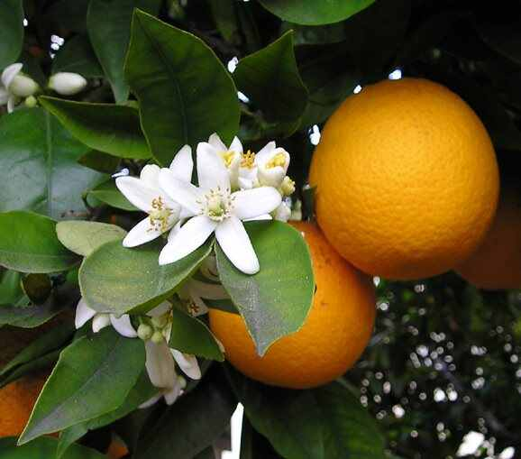
Source: Wikipedia — Citrus × sinensis
Scientific name | Citrus × sinensis
Local name | Santra / Mosambi (Hindi) · Aarenju / Saathukudi (Tamil)
Interesting | A hybrid of pomelo and mandarin; Nagpur is called 'Orange City'. Green oranges are often fully ripe.

Apple
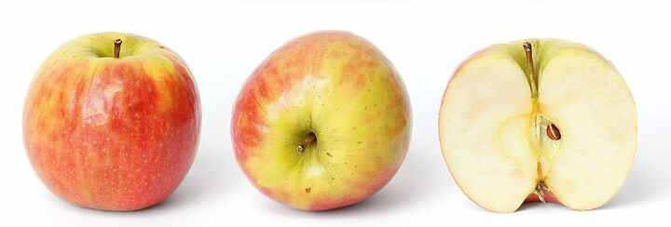
Source: Wikipedia — Apple
Scientific name | Malus domestica
Local name | Seb (Hindi) · Aappil (Tamil)
Interesting | Descends from wild apples of Kazakhstan's Tian Shan; seeds don't grow true, so varieties are grafted.

Grapevine
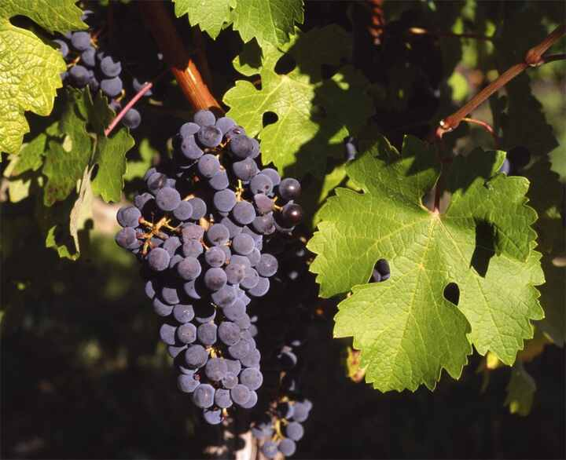
Source: Wikipedia — Vitis vinifera
Scientific name | Vitis vinifera
Local name | Angoor (Hindi) · Thiraatchai (Tamil)
Interesting | Nashik is India's wine and grape capital; grapes do not ripen further after picking.

Strawberry
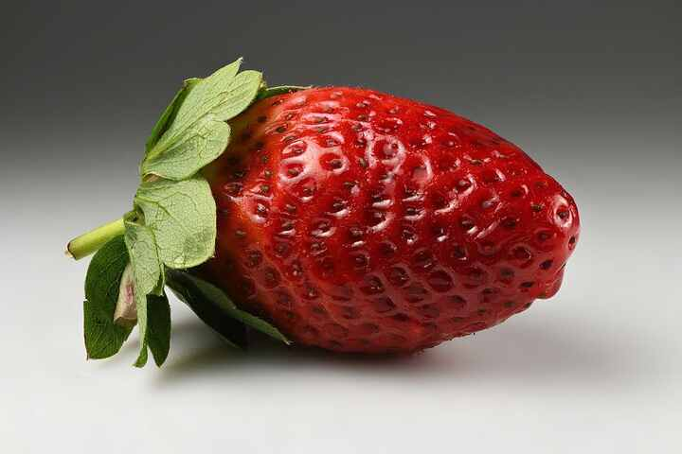
Source: Wikipedia — Strawberry
Scientific name | Fragaria × ananassa
Local name | Strawberry (Hindi) · Strawberry (Tamil)
Interesting | Not a true berry: the 'seeds' outside are the actual fruits (achenes). Mahabaleshwar is India's strawberry hub.

Pineapple
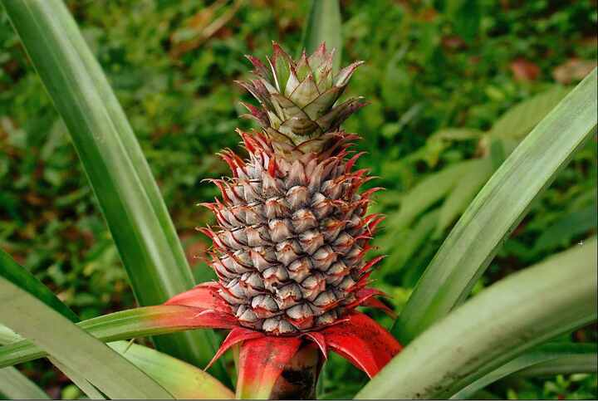
Source: Wikipedia — Pineapple
Scientific name | Ananas comosus
Local name | Ananas (Hindi) · Annaasi (Tamil)
Interesting | A composite fruit formed from fused berries; its bromelain enzyme digests proteins, making tongues tingle.

Watermelon
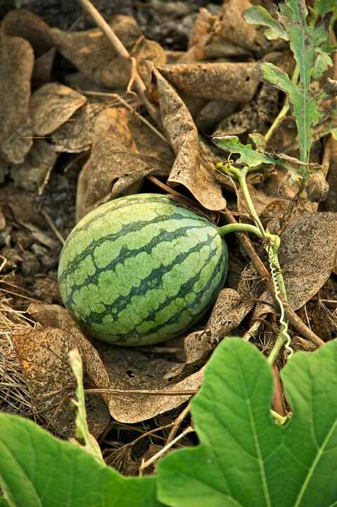
Source: Wikipedia — Watermelon
Scientific name | Citrullus lanatus
Local name | Tarbooz (Hindi) · Tharboosani (Tamil)
Interesting | About 92% water; originated in Africa, where wild forms are bitter.

Tomato
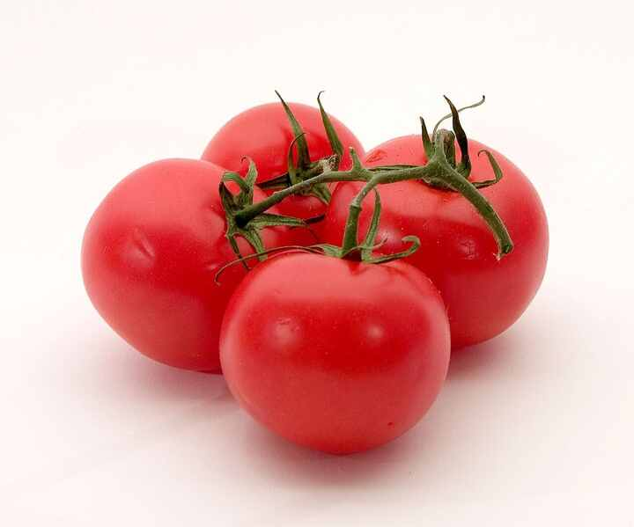
Source: Wikipedia — Tomato
Scientific name | Solanum lycopersicum
Local name | Tamatar (Hindi) · Thakkaali (Tamil)
Interesting | A New World fruit that reached India only in the 16th–17th century; once feared in Europe as poisonous.

Eggplant (Brinjal)
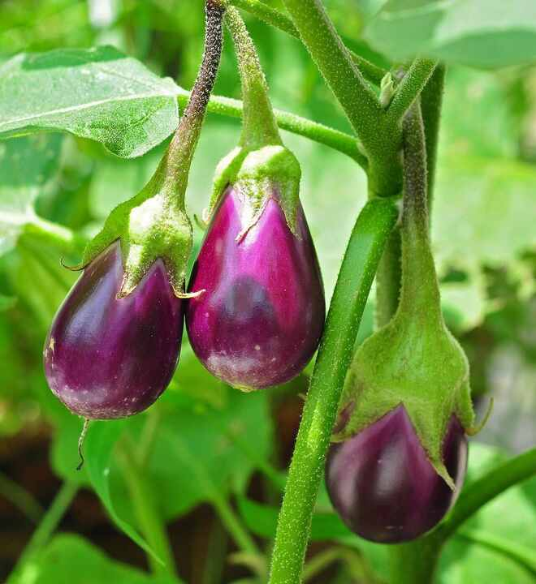
Source: Wikipedia — Eggplant
Scientific name | Solanum melongena
Local name | Baingan (Hindi) · Kathirikkai (Tamil)
Interesting | Domesticated in India; Bt brinjal became a landmark GM debate, and is under moratorium in India since 2010.

Chili pepper
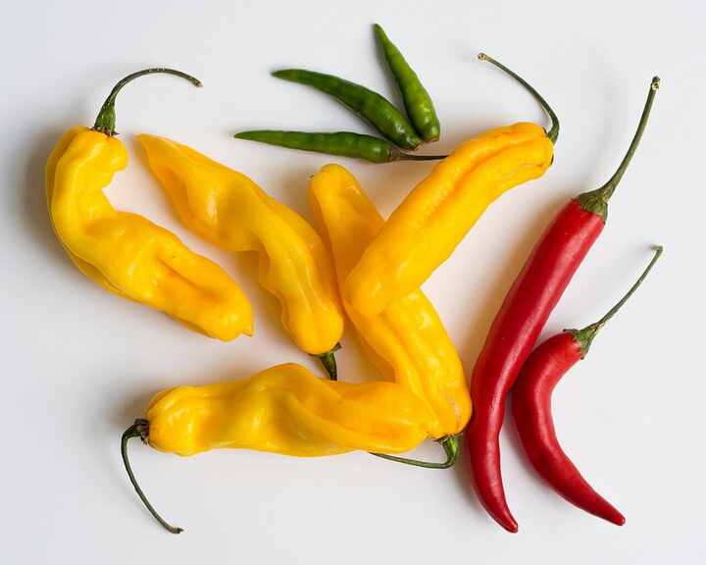
Source: Wikipedia — Chili pepper
Scientific name | Capsicum annuum
Local name | Mirch (Hindi) · Milagai (Tamil)
Interesting | Arrived in India with the Portuguese; capsaicin deters mammals but not birds, which spread the seeds.

Okra
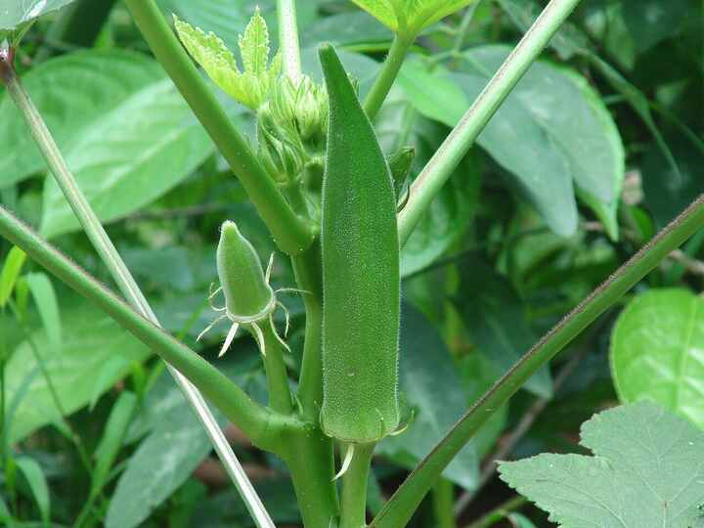
Source: Wikipedia — Okra
Scientific name | Abelmoschus esculentus
Local name | Bhindi (Hindi) · Vendaikkai (Tamil)
Interesting | Called 'lady's finger'; its mucilage thickens soups like gumbo, and it's a hibiscus relative.

Cucumber
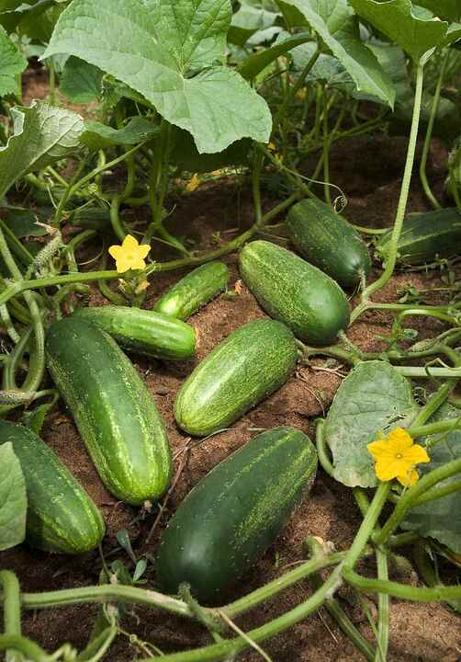
Source: Wikipedia — Cucumber
Scientific name | Cucumis sativus
Local name | Kheera (Hindi) · Vellarikkai (Tamil)
Interesting | Native to the Himalayan foothills; botanically a fruit, and about 95% water.

Pumpkin
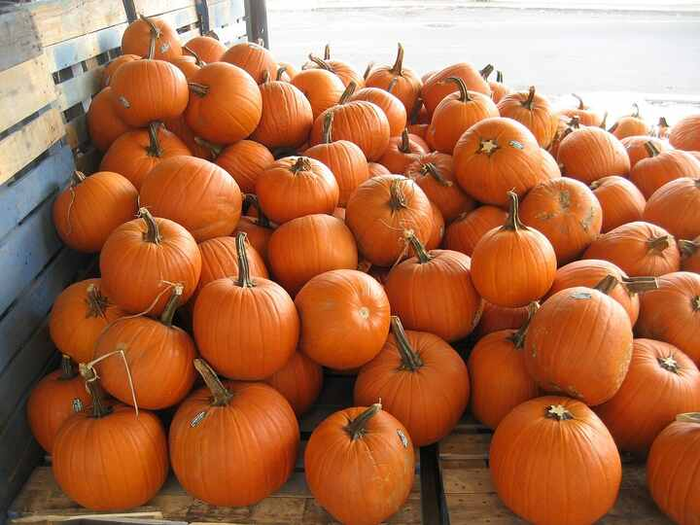
Source: Wikipedia — Pumpkin
Scientific name | Cucurbita spp.
Local name | Kaddu (Hindi) · Parangikkai (Tamil)
Interesting | A New World squash; the heaviest recorded pumpkins exceed 1,200 kg.

Bottle gourd
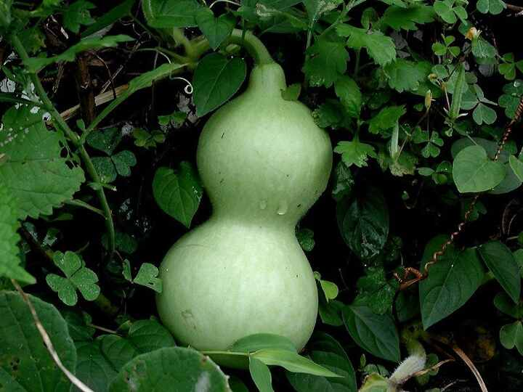
Source: Wikipedia — Calabash
Scientific name | Lagenaria siceraria
Local name | Lauki (Hindi) · Suraikkai (Tamil)
Interesting | One of the first cultivated plants; dried gourds are used as water bottles and in instruments like the sitar.

Bitter melon
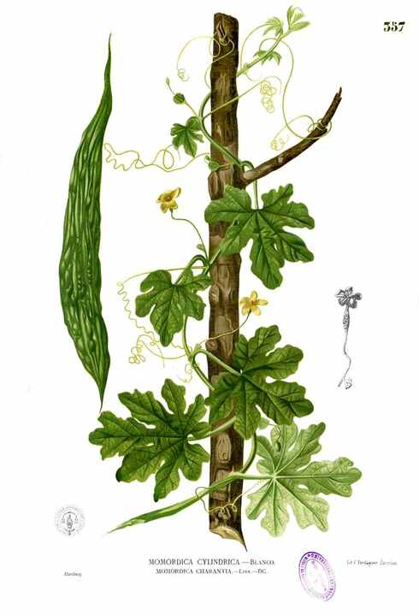
Source: Wikipedia — Momordica charantia
Scientific name | Momordica charantia
Local name | Karela (Hindi) · Paavakkai (Tamil)
Interesting | Among the most bitter vegetables; contains charantin and is studied for lowering blood sugar.

Spinach
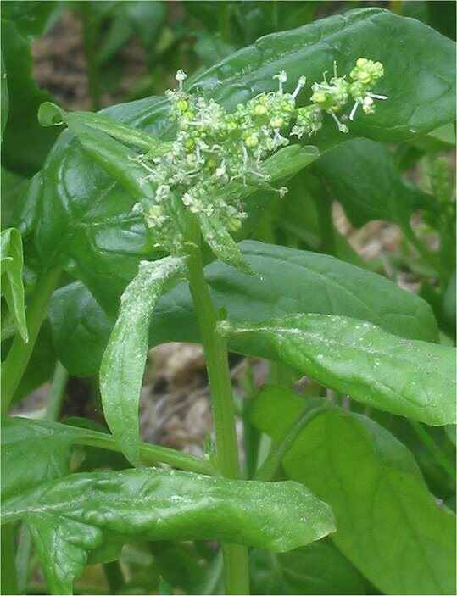
Source: Wikipedia — Spinach
Scientific name | Spinacia oleracea
Local name | Palak (Hindi) · Pasalai keerai (Tamil)
Interesting | Its iron is famously overstated (a decimal-error myth), and oxalates limit absorption.

Coriander
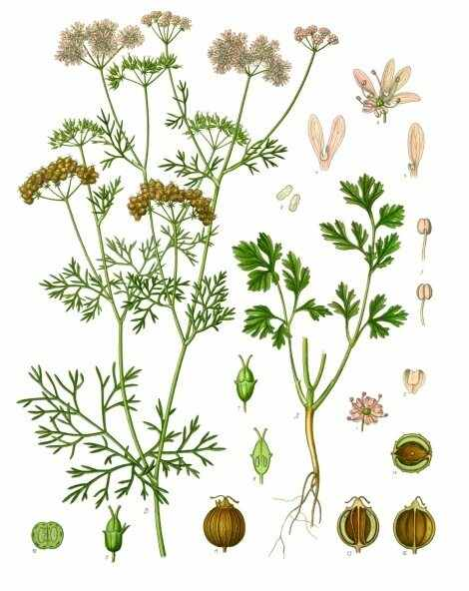
Source: Wikipedia — Coriander
Scientific name | Coriandrum sativum
Local name | Dhaniya (Hindi) · Kothamalli (Tamil)
Interesting | Leaves taste soapy to some people due to a gene variant (OR6A2) sensing aldehydes.

Mint
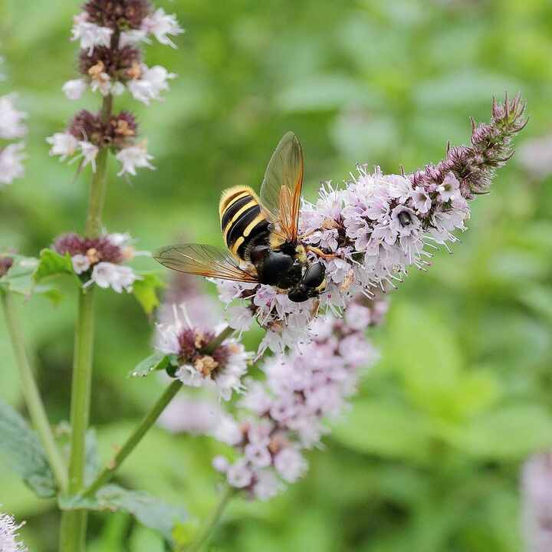
Source: Wikipedia — Mentha
Scientific name | Mentha spp.
Local name | Pudina (Hindi) · Pudhina (Tamil)
Interesting | Spreads aggressively through runners; menthol triggers cold-sensing receptors without lowering temperature.

Fenugreek
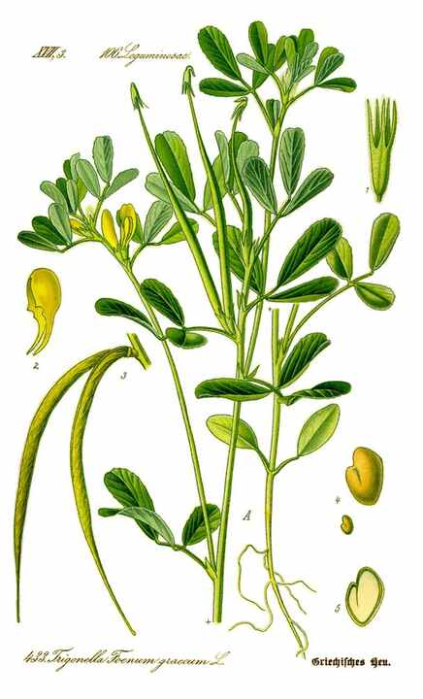
Source: Wikipedia — Fenugreek
Scientific name | Trigonella foenum-graecum
Local name | Methi (Hindi) · Vendhayam (Tamil)
Interesting | Seeds contain sotolon, which smells like maple syrup and can even scent sweat.

Mustard plant
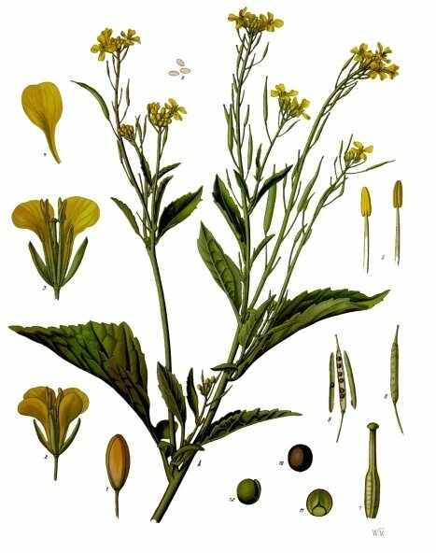
Source: Wikipedia — Brassica juncea
Scientific name | Brassica juncea
Local name | Sarson (Hindi) · Kadugu (Tamil)
Interesting | Yellow fields of sarson define Punjab's winter; its seeds power the tadka and mustard oil.

Ginger
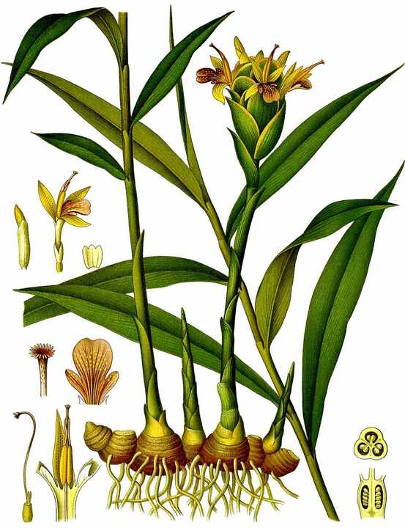
Source: Wikipedia — Ginger
Scientific name | Zingiber officinale
Local name | Adrak (Hindi) · Inji (Tamil)
Interesting | The 'root' is a rhizome (underground stem); dried ginger is called sonth / chukku.

Turmeric
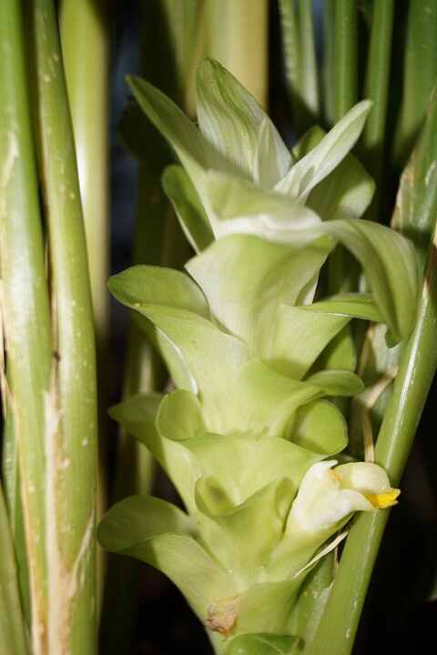
Source: Wikipedia — Turmeric
Scientific name | Curcuma longa
Local name | Haldi (Hindi) · Manjal (Tamil)
Interesting | Its curcumin gives the colour; famously subject of a 1990s patent revoked on Indian traditional knowledge.

Garlic
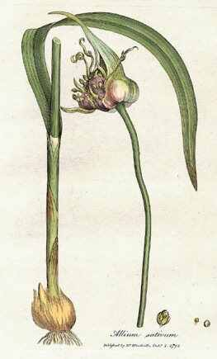
Source: Wikipedia — Garlic
Scientific name | Allium sativum
Local name | Lehsun (Hindi) · Poondu (Tamil)
Interesting | Allicin forms only when cloves are crushed, which is why chopped garlic smells stronger.

Onion
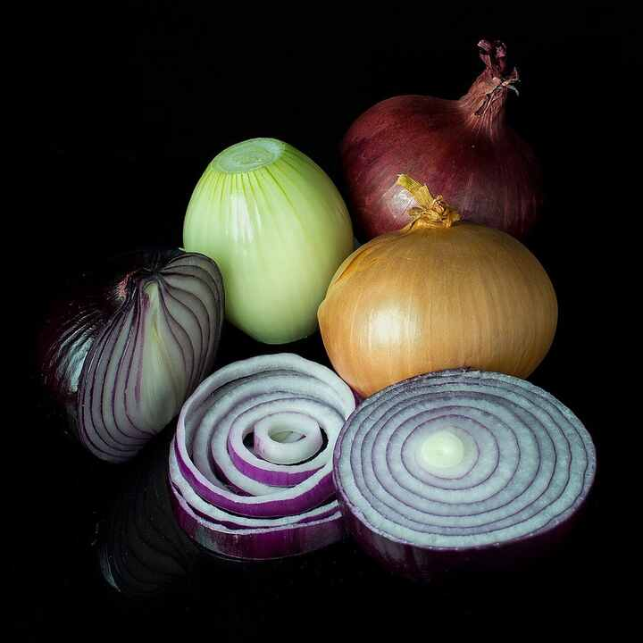
Source: Wikipedia — Onion
Scientific name | Allium cepa
Local name | Pyaaz (Hindi) · Vengaayam (Tamil)
Interesting | Cutting releases syn-propanethial-S-oxide, the gas that stings eyes; onion prices can sway Indian elections.

Potato
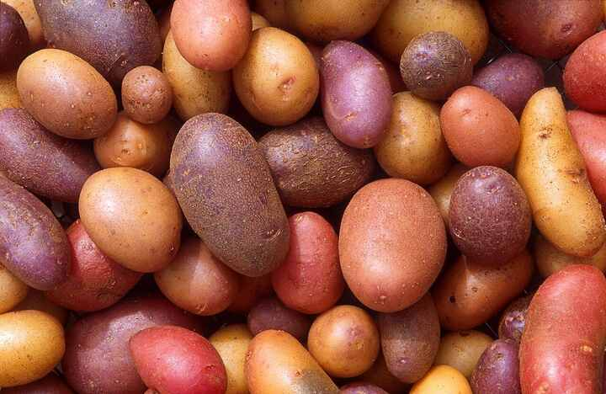
Source: Wikipedia — Potato
Scientific name | Solanum tuberosum
Local name | Aloo (Hindi) · Urulaikizhangu (Tamil)
Interesting | Domesticated in the Andes; green patches contain toxic solanine. India is the second-largest producer.

Sweet potato
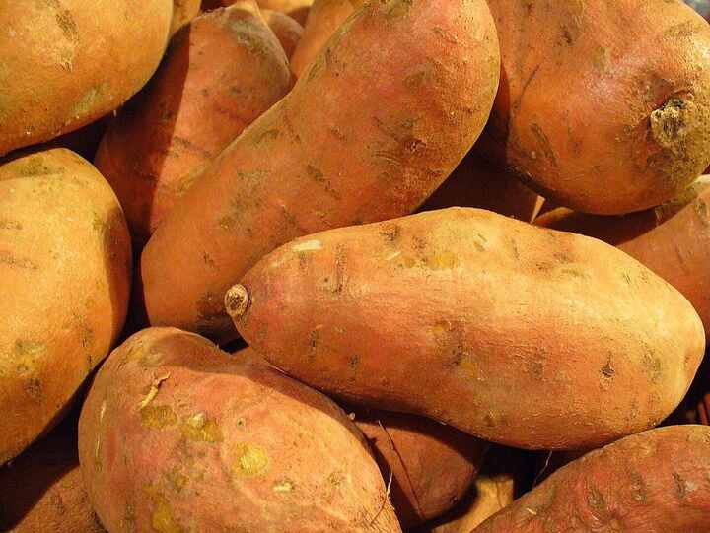
Source: Wikipedia — Sweet potato
Scientific name | Ipomoea batatas
Local name | Shakarkand (Hindi) · Sakkaraivalli kizhangu (Tamil)
Interesting | A morning-glory relative, not related to potato; its genome carries genes naturally transferred from bacteria.

Carrot
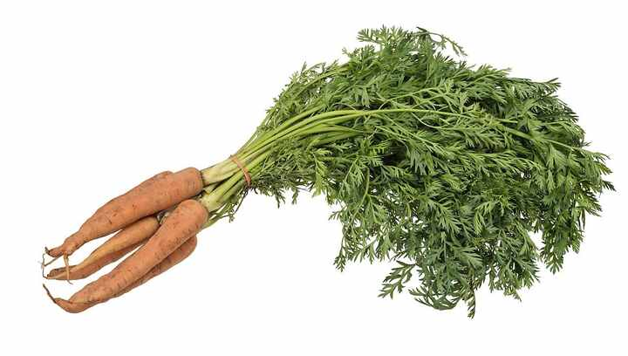
Source: Wikipedia — Carrot
Scientific name | Daucus carota
Local name | Gajar (Hindi) · Carrot (Tamil)
Interesting | Early carrots were purple or yellow; the Delhi red carrot makes winter gajar halwa.

Radish
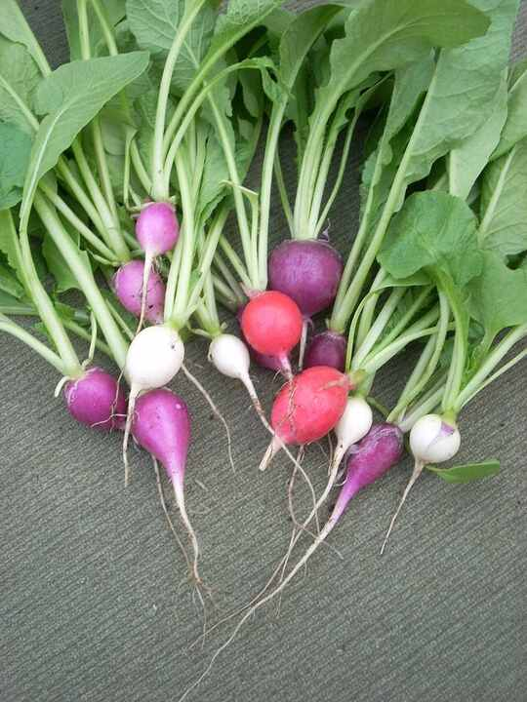
Source: Wikipedia — Radish
Scientific name | Raphanus sativus
Local name | Mooli (Hindi) · Mullangi (Tamil)
Interesting | Can be harvested in under a month; its pungency comes from glucosinolates.

Beetroot
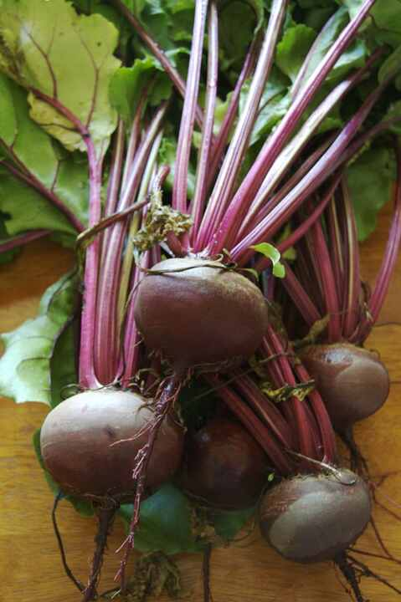
Source: Wikipedia — Beetroot
Scientific name | Beta vulgaris
Local name | Chukandar (Hindi) · Beetroot (Tamil)
Interesting | Betanin pigment can turn urine pink (beeturia); the same species gives us sugar beet.

Cabbage
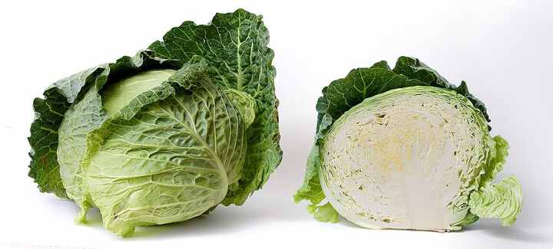
Source: Wikipedia — Cabbage
Scientific name | Brassica oleracea var. capitata
Local name | Patta gobhi (Hindi) · Muttaikose (Tamil)
Interesting | Cabbage, cauliflower, broccoli and kale are all the same species, bred for different parts.

Cauliflower
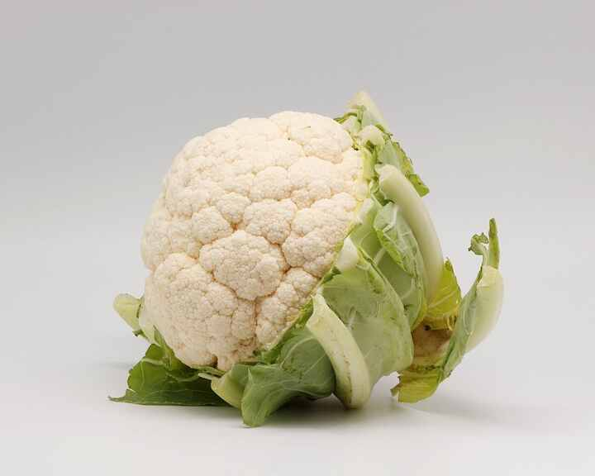
Source: Wikipedia — Cauliflower
Scientific name | Brassica oleracea var. botrytis
Local name | Phool gobhi (Hindi) · Pookkosu (Tamil)
Interesting | The head is a mass of arrested flower buds; Romanesco variants show striking fractal spirals.

Broccoli
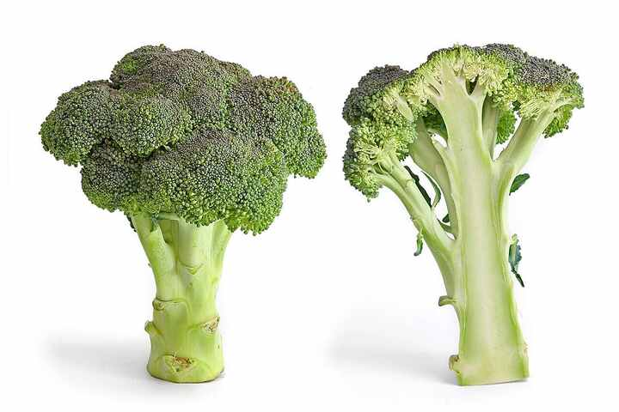
Source: Wikipedia — Broccoli
Scientific name | Brassica oleracea var. italica
Local name | Hari gobhi (Hindi) · Brokkoli (Tamil)
Interesting | Bred from wild cabbage in Italy; rich in sulforaphane.

Pea
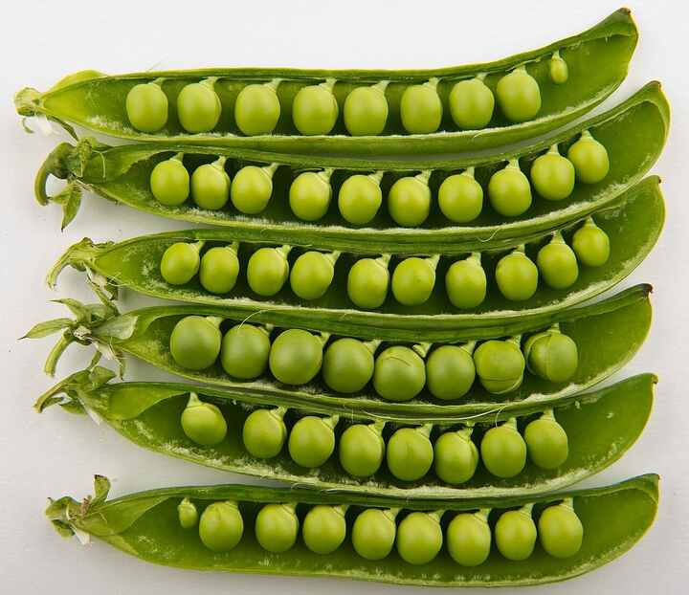
Source: Wikipedia — Pea
Scientific name | Pisum sativum
Local name | Matar (Hindi) · Pattaani (Tamil)
Interesting | Gregor Mendel's pea experiments founded modern genetics.

Chickpea
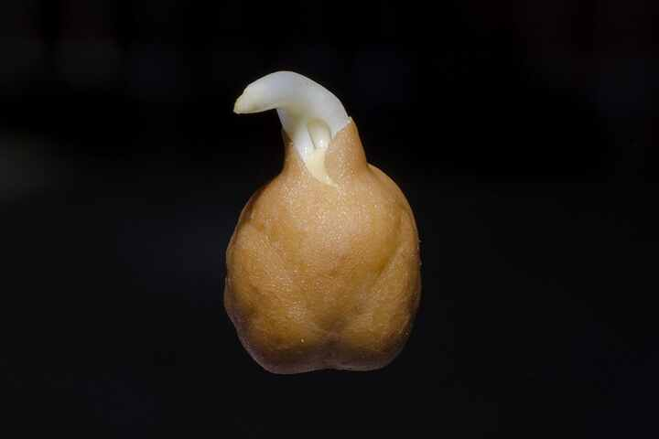
Source: Wikipedia — Chickpea
Scientific name | Cicer arietinum
Local name | Chana (Hindi) · Kondakadalai (Tamil)
Interesting | India produces ~70% of the world's chickpeas; as a legume it fixes nitrogen in soil.

Lentil
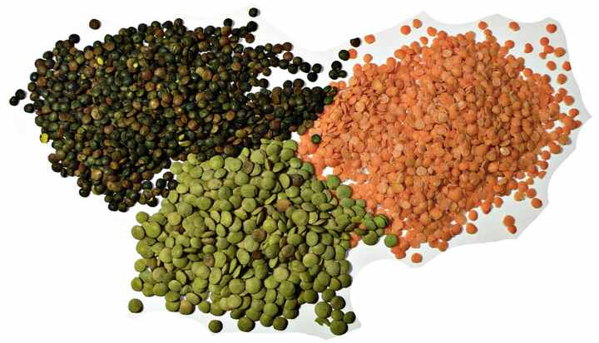
Source: Wikipedia — Lentil
Scientific name | Lens culinaris
Local name | Masoor (Hindi) · Masoor paruppu (Tamil)
Interesting | Among the oldest domesticated crops (~9,000 years); the optical 'lens' is named after its shape.

Soybean
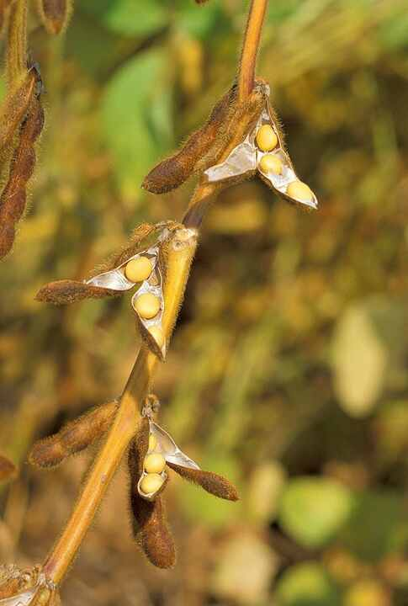
Source: Wikipedia — Soybean
Scientific name | Glycine max
Local name | Soyabean (Hindi) · Soya mochai (Tamil)
Interesting | About 40% protein; Madhya Pradesh is called India's 'Soya State'.

Rice
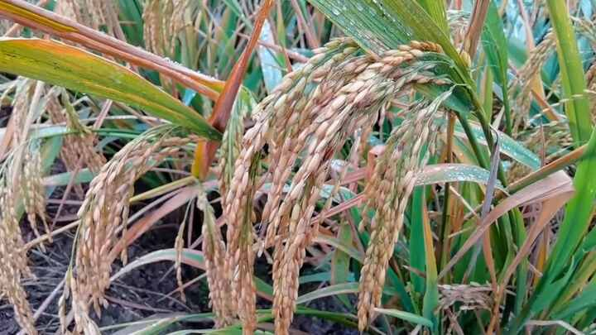
Source: Wikipedia — Rice
Scientific name | Oryza sativa
Local name | Chawal / Dhaan (Hindi) · Nel / Arisi (Tamil)
Interesting | Feeds over half of humanity; its hollow stems let air reach roots in flooded paddies.

Wheat
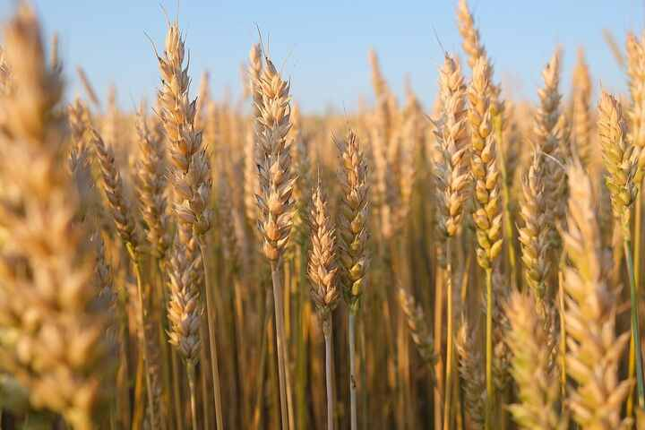
Source: Wikipedia — Wheat
Scientific name | Triticum aestivum
Local name | Gehun (Hindi) · Godhumai (Tamil)
Interesting | Bread wheat is a hexaploid hybrid of three grass species; dwarf varieties drove India's Green Revolution.

Maize (Corn)
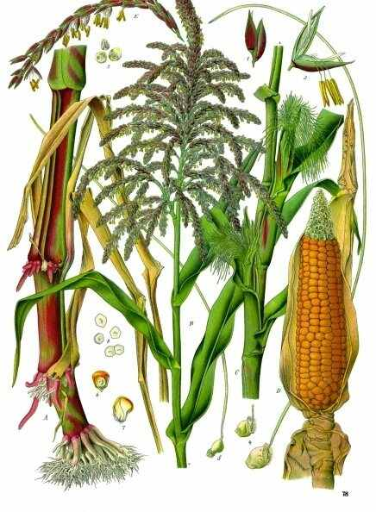
Source: Wikipedia — Maize
Scientific name | Zea mays
Local name | Makka / Bhutta (Hindi) · Makkaacholam (Tamil)
Interesting | Domesticated from teosinte in Mexico; each silk strand connects to one kernel.

Sugarcane
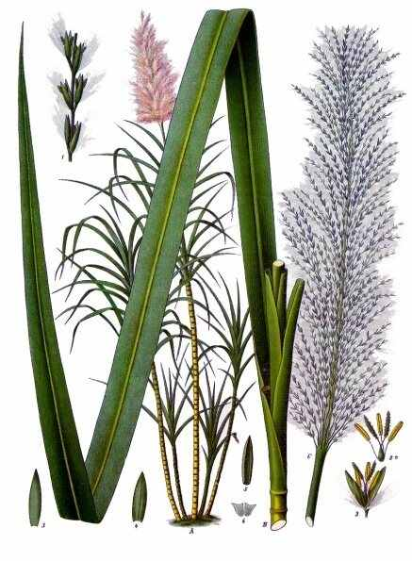
Source: Wikipedia — Sugarcane
Scientific name | Saccharum officinarum
Local name | Ganna (Hindi) · Karumbu (Tamil)
Interesting | India pioneered crystallised sugar (khanda, the root of 'candy'); it uses efficient C4 photosynthesis.

Cotton
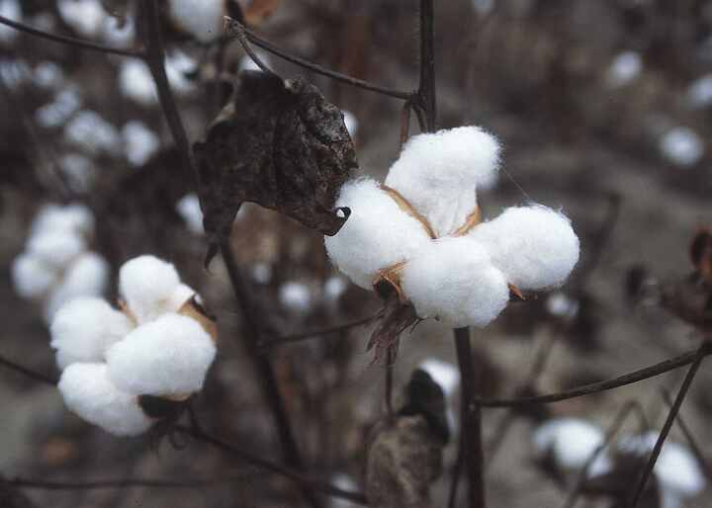
Source: Wikipedia — Cotton
Scientific name | Gossypium spp.
Local name | Kapas (Hindi) · Paruthi (Tamil)
Interesting | The Indus Valley spun cotton ~5,000 years ago; each fibre is a single seed-hair cell.

Tea plant
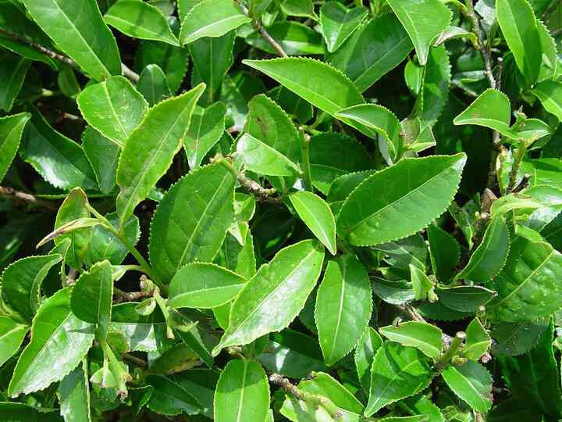
Source: Wikipedia — Camellia sinensis
Scientific name | Camellia sinensis
Local name | Chai (Hindi) · Theyilai (Tamil)
Interesting | Assam hosts a native variety (assamica); green, black and white tea all come from this one species.

Coffee plant
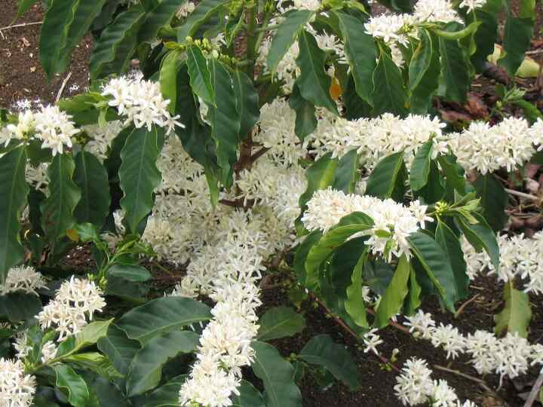
Source: Wikipedia — Coffea
Scientific name | Coffea arabica / C. canephora
Local name | Coffee (Hindi) · Kaapi (Tamil)
Interesting | Legend says Baba Budan smuggled 7 beans from Yemen to Chikmagalur in the 1600s.

Bamboo
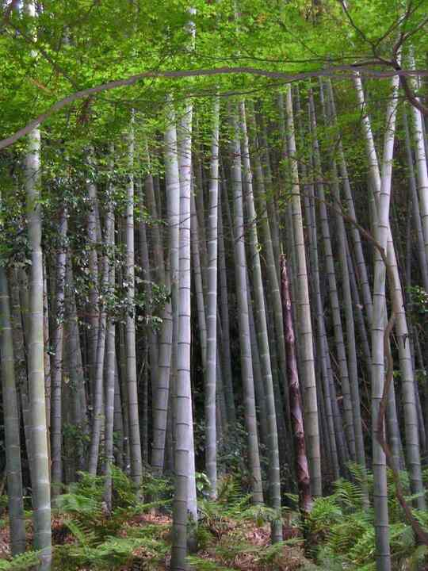
Source: Wikipedia — Bamboo
Scientific name | Bambusoideae (subfamily)
Local name | Baans (Hindi) · Moongil (Tamil)
Interesting | A grass, not a tree; some species grow ~90 cm a day and flower in synchronized mass events decades apart.

Eucalyptus
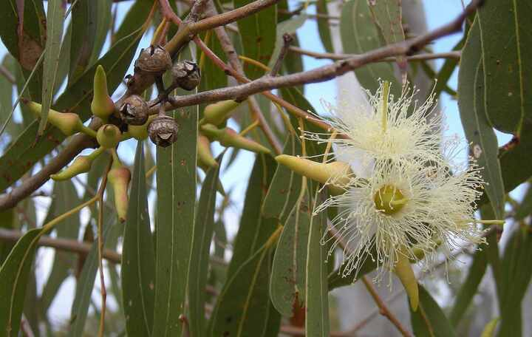
Source: Wikipedia — Eucalyptus
Scientific name | Eucalyptus spp.
Local name | Safeda / Nilgiri (Hindi) · Thailamaram (Tamil)
Interesting | Native to Australia; widely planted in India but criticised for heavy water use. Koalas eat its leaves.

Teak
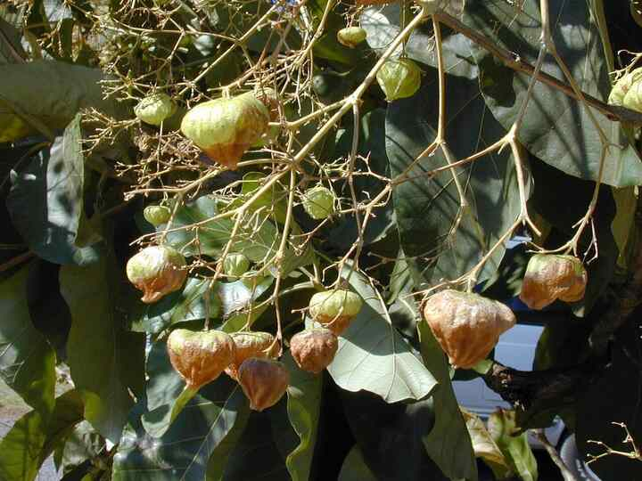
Source: Wikipedia — Teak
Scientific name | Tectona grandis
Local name | Sagwan (Hindi) · Thekku (Tamil)
Interesting | Its natural oils resist water and termites; Nilambur in Kerala has the world's oldest teak plantation.

Sandalwood
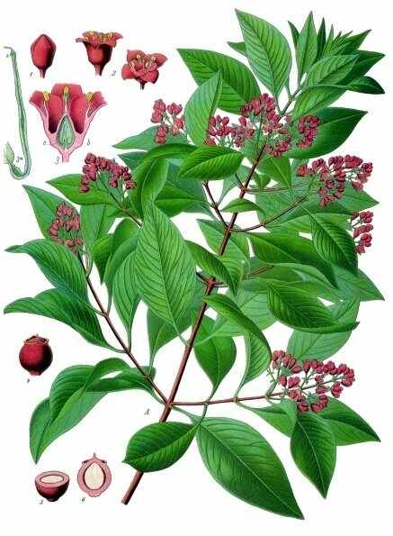
Source: Wikipedia — Santalum album
Scientific name | Santalum album
Local name | Chandan (Hindi) · Santhanam (Tamil)
Interesting | A root hemiparasite that taps other plants; the fragrant heartwood takes decades to form.

Money plant (Pothos)
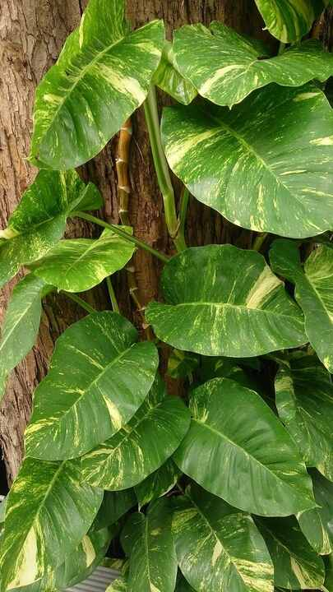
Source: Wikipedia — Epipremnum aureum
Scientific name | Epipremnum aureum
Local name | Money plant (Hindi) · Money plant (Tamil)
Interesting | Nicknamed 'devil's ivy' as it's almost impossible to kill; rarely flowers in cultivation.

Snake plant
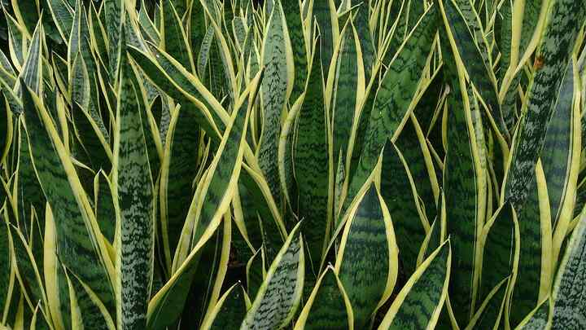
Source: Wikipedia — Dracaena trifasciata
Scientific name | Dracaena trifasciata
Local name | Nagphani (Hindi) · Maamiyar naakku (Tamil)
Interesting | Tamil and English both call it 'mother-in-law's tongue'; its fibre (bowstring hemp) was used for bowstrings.

