Mango
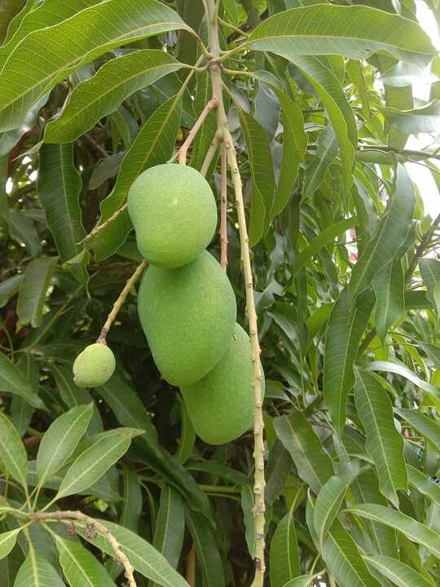
Scientific name | Local name (Hindi) | Interesting fact
Mangifera indica | Aam | Mango belongs to the cashew family; each fruit develops from a single flower ovary.
Source: Wikipedia — Mangifera indica

Neem
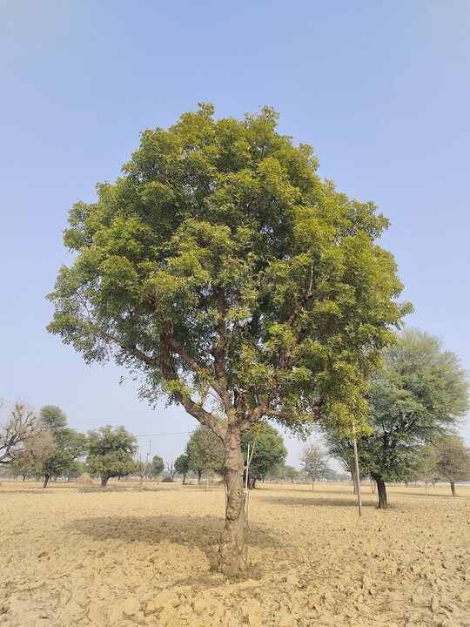
Scientific name | Local name (Hindi) | Interesting fact
Azadirachta indica | Neem | Neem seeds contain azadirachtin, a compound widely used in botanical insect-control products.
Source: Wikipedia — Azadirachta indica

Banyan
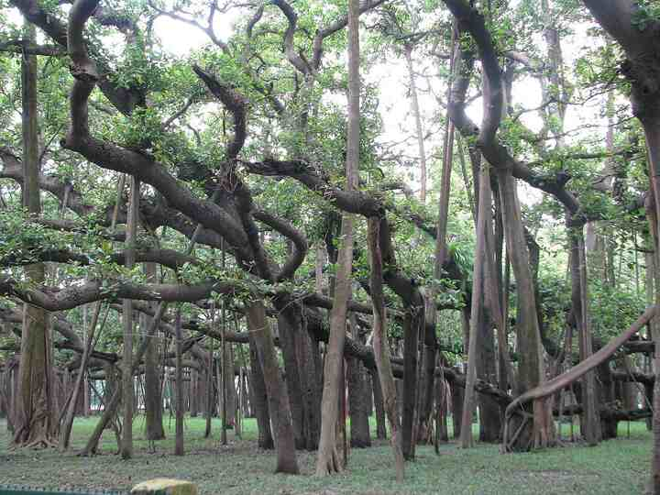
Scientific name | Local name (Hindi) | Interesting fact
Ficus benghalensis | Bargad | Aerial roots descend from its branches and thicken into prop trunks that support a vast crown.
Source: Wikipedia — Ficus benghalensis

Peepal
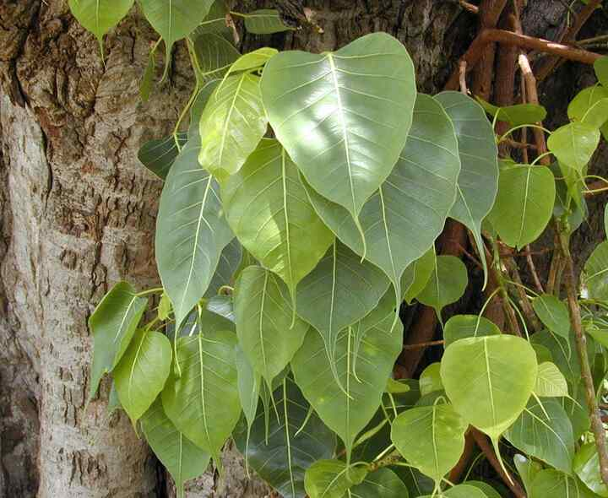
Scientific name | Local name (Hindi) | Interesting fact
Ficus religiosa | Peepal | Its long leaf tips help rainwater drain quickly, a useful feature during the monsoon.
Source: Wikipedia — Ficus religiosa

Tulsi (Holy basil)
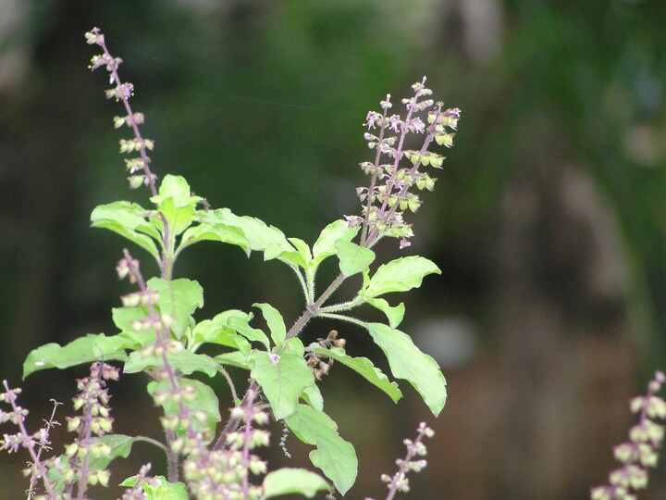
Scientific name | Local name (Hindi) | Interesting fact
Ocimum tenuiflorum | Tulsi | The aromatic leaves contain eugenol and other volatile oils; several distinct cultivated forms exist.
Source: Wikipedia — Ocimum tenuiflorum

Aloe vera
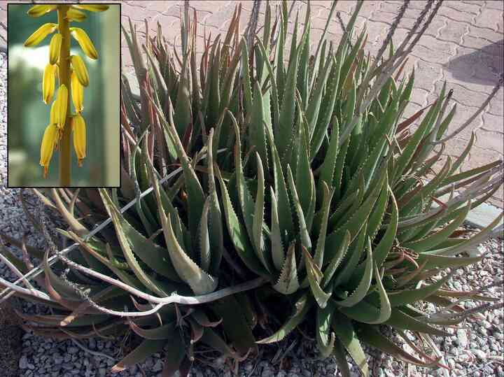
Scientific name | Local name (Hindi) | Interesting fact
Aloe vera | Gwarpatha | This succulent stores water in thick leaves and sends up tall spikes of tubular flowers.
Source: Wikipedia — Aloe vera

Hibiscus
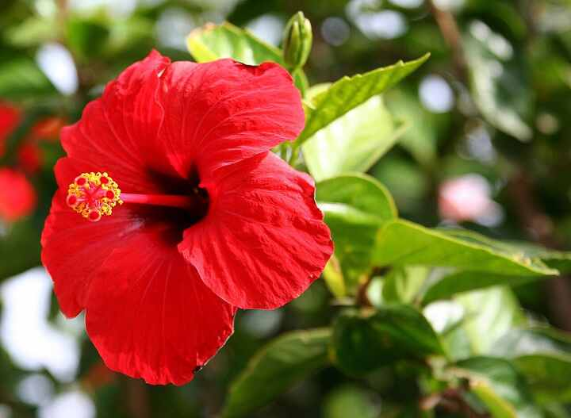
Scientific name | Local name (Hindi) | Interesting fact
Hibiscus × rosa-sinensis | Gudhal | Individual flowers are short-lived, but a healthy shrub can produce new blooms repeatedly.
Source: Wikipedia — Hibiscus × rosa-sinensis

Rose
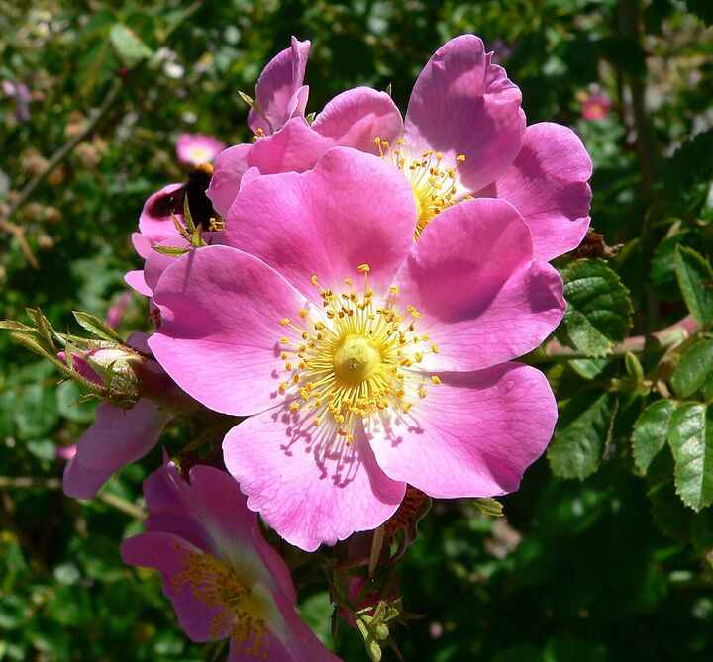
Scientific name | Local name (Hindi) | Interesting fact
Rosa spp. | Gulab | After pollination, many roses form vitamin-rich accessory fruits called rose hips.
Source: Wikipedia — Rose

Jasmine
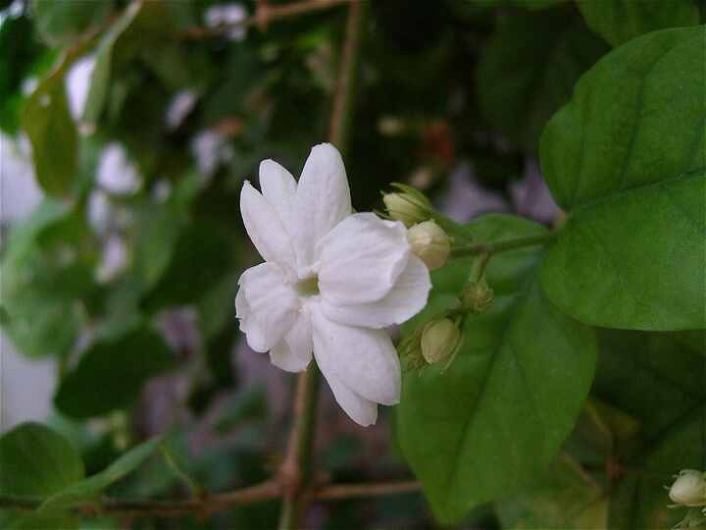
Scientific name | Local name (Hindi) | Interesting fact
Jasminum sambac | Mogra | Its intensely fragrant flowers are widely woven into garlands and used to scent jasmine tea.
Source: Wikipedia — Jasminum sambac

Marigold
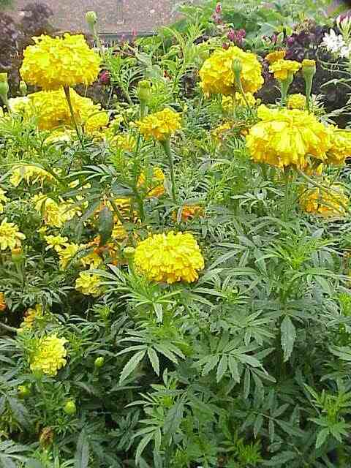
Scientific name | Local name (Hindi) | Interesting fact
Tagetes erecta | Genda | The petals contain lutein, a yellow pigment used in food and poultry-feed colouring.
Source: Wikipedia — Tagetes erecta

Sunflower
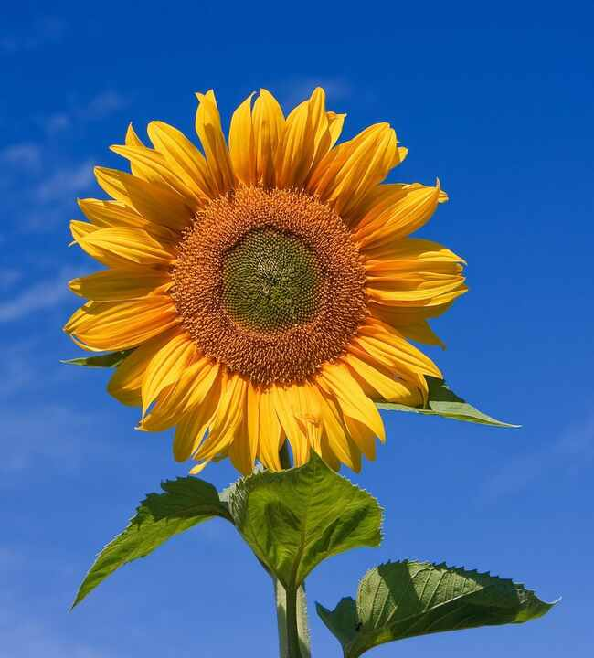
Scientific name | Local name (Hindi) | Interesting fact
Helianthus annuus | Surajmukhi | Young flower heads track the sun; mature heads usually stop moving and face east.
Source: Wikipedia — Common sunflower

Lotus
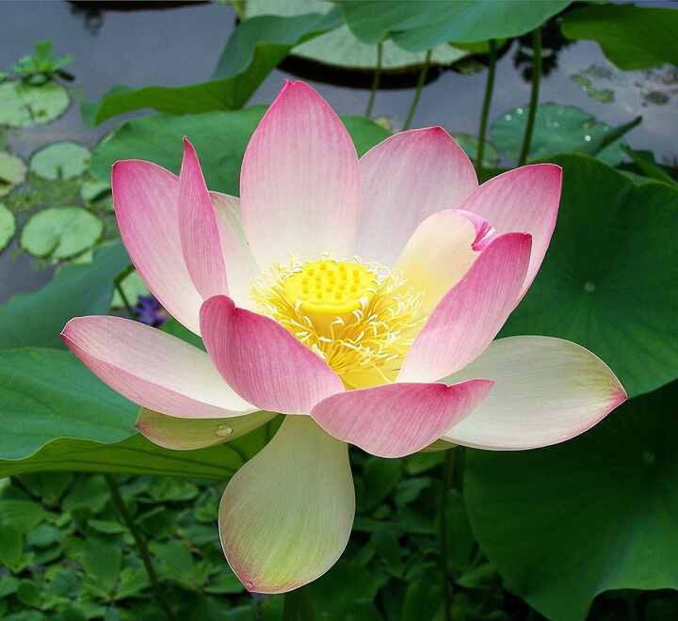
Scientific name | Local name (Hindi) | Interesting fact
Nelumbo nucifera | Kamal | Microscopic waxy bumps make lotus leaves strongly water-repellent, inspiring the term 'lotus effect'.
Source: Wikipedia — Nelumbo nucifera

Water lily
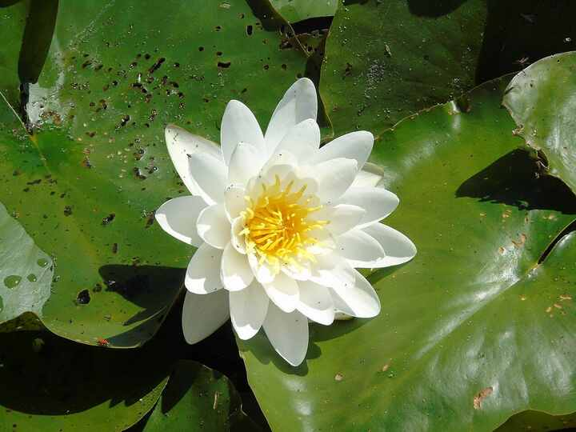
Scientific name | Local name (Hindi) | Interesting fact
Nymphaea spp. | Kumudini | Because the leaves float, most of their stomata are on the upper surface rather than underneath.
Source: Wikipedia — Nymphaea

Bougainvillea
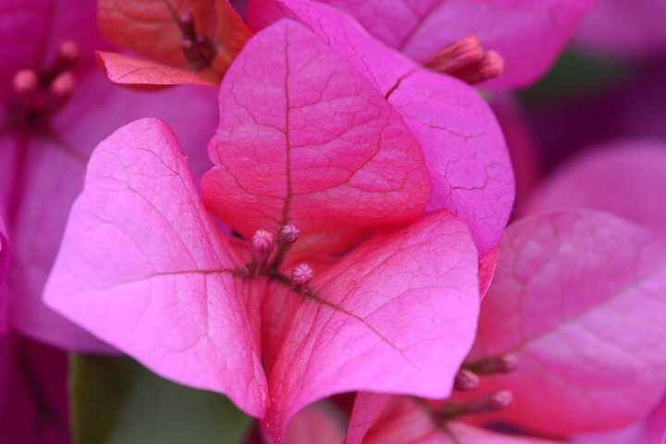
Scientific name | Local name (Hindi) | Interesting fact
Bougainvillea spp. | Boganvel | Its showy colours come from papery bracts; the true flowers inside are small and pale.
Source: Wikipedia — Bougainvillea

Ixora
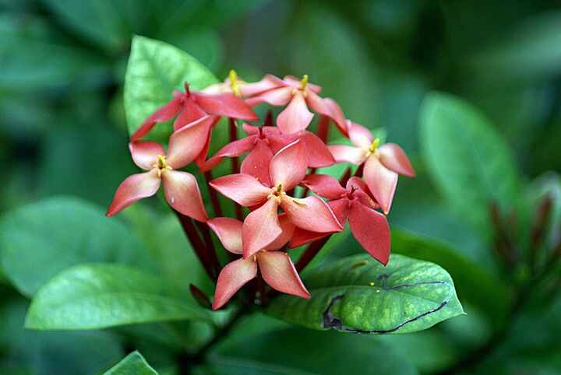
Scientific name | Local name (Hindi) | Interesting fact
Ixora coccinea | Rukmini | Dense clusters of narrow tubular flowers attract butterflies and other long-tongued pollinators.
Source: Wikipedia — Ixora coccinea

Frangipani
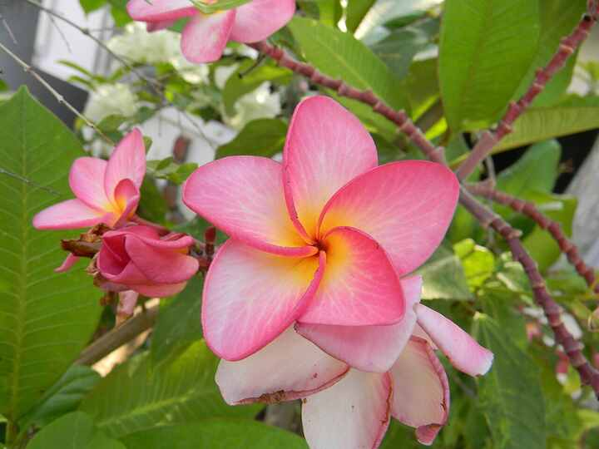
Scientific name | Local name (Hindi) | Interesting fact
Plumeria rubra | Champa | Its thick branches store water, and stem cuttings can root readily in warm conditions.
Source: Wikipedia — Plumeria

Gulmohar
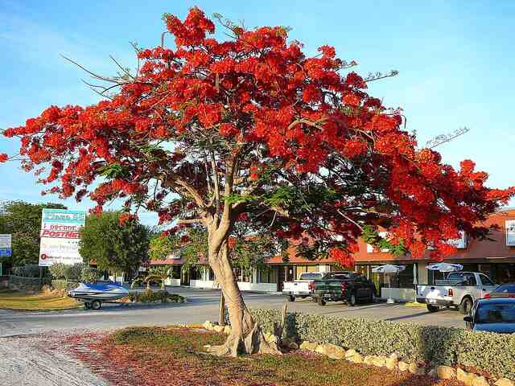
Scientific name | Local name (Hindi) | Interesting fact
Delonix regia | Gulmohar | This flamboyant legume produces long, woody seed pods that may remain on the tree for months.
Source: Wikipedia — Delonix regia

Ashoka tree
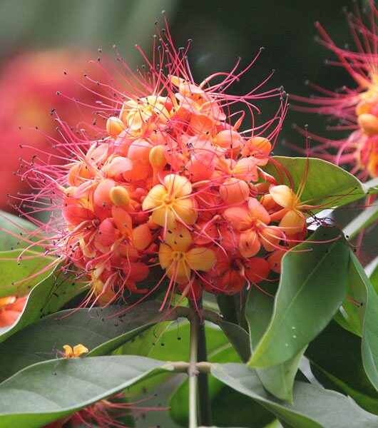
Scientific name | Local name (Hindi) | Interesting fact
Saraca asoca | Ashok | The true Ashoka has clustered orange-red flowers and is often confused with the tall false Ashoka.
Source: Wikipedia — Saraca asoca

Curry tree
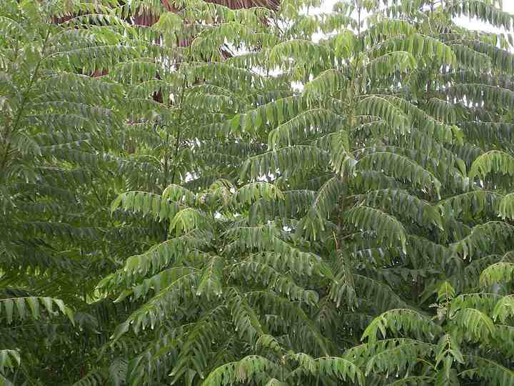
Scientific name | Local name (Hindi) | Interesting fact
Murraya koenigii | Kadi patta | Fresh leaves release their characteristic aroma when crushed because they contain volatile terpenes.
Source: Wikipedia — Curry tree

Coconut palm
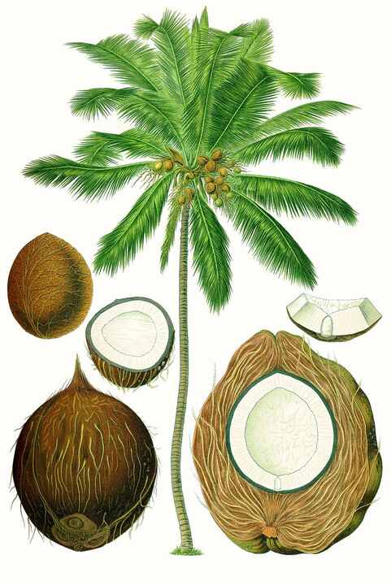
Scientific name | Local name (Hindi) | Interesting fact
Cocos nucifera | Nariyal | The fibrous, buoyant fruit can survive seawater journeys, helping the species disperse between coasts.
Source: Wikipedia — Coconut

Banana
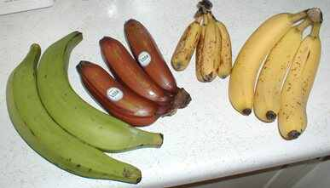
Scientific name | Local name (Hindi) | Interesting fact
Musa spp. | Kela | A banana plant is a giant herb, not a tree; its apparent trunk is a leaf sheath.
Source: Wikipedia — Banana

Papaya
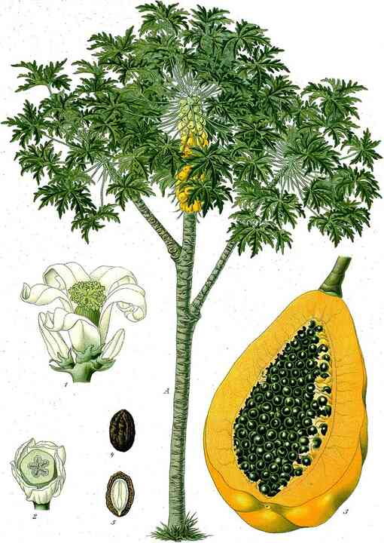
Scientific name | Local name (Hindi) | Interesting fact
Carica papaya | Papita | Papaya plants may bear male, female or bisexual flowers; their milky latex contains papain.
Source: Wikipedia — Papaya

Guava
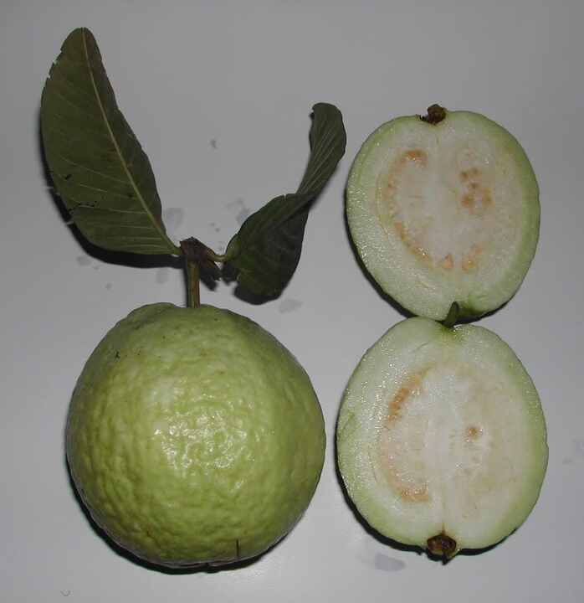
Scientific name | Local name (Hindi) | Interesting fact
Psidium guajava | Amrood | Botanically, guava is a berry with many small seeds embedded in fragrant pulp.
Source: Wikipedia — Psidium guajava

Pomegranate
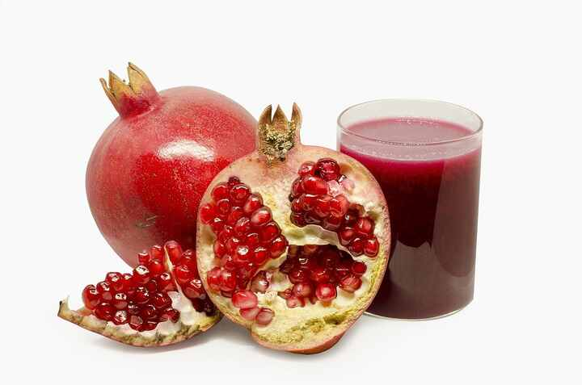
Scientific name | Local name (Hindi) | Interesting fact
Punica granatum | Anar | The juicy red part around each seed is an aril, not the seed itself.
Source: Wikipedia — Pomegranate

Lemon
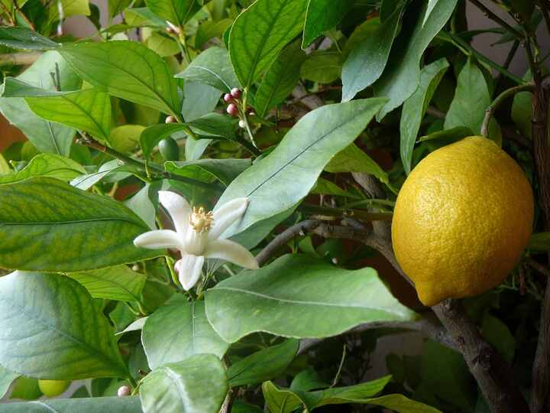
Scientific name | Local name (Hindi) | Interesting fact
Citrus × limon | Nimbu | Genetic evidence shows lemon arose as a hybrid involving citron and bitter orange.
Source: Wikipedia — Lemon

Sweet orange
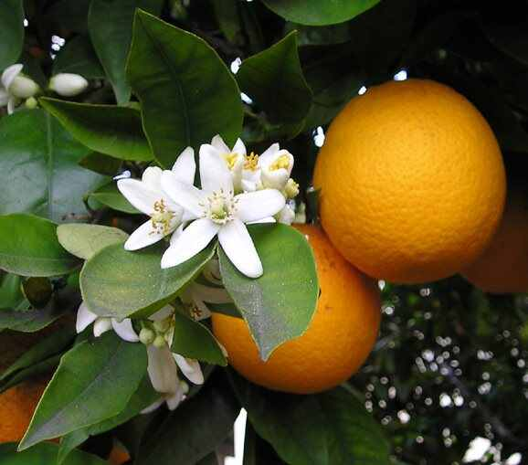
Scientific name | Local name (Hindi) | Interesting fact
Citrus × sinensis | Santra | Sweet orange is an ancient hybrid descended mainly from mandarin and pomelo.
Source: Wikipedia — Citrus × sinensis

Apple
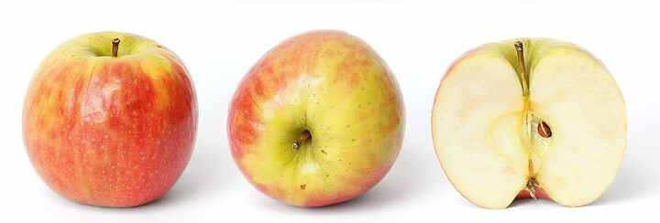
Scientific name | Local name (Hindi) | Interesting fact
Malus domestica | Seb | Most edible flesh develops from flower tissue around the ovary; the core is the true fruit.
Source: Wikipedia — Apple

Grapevine
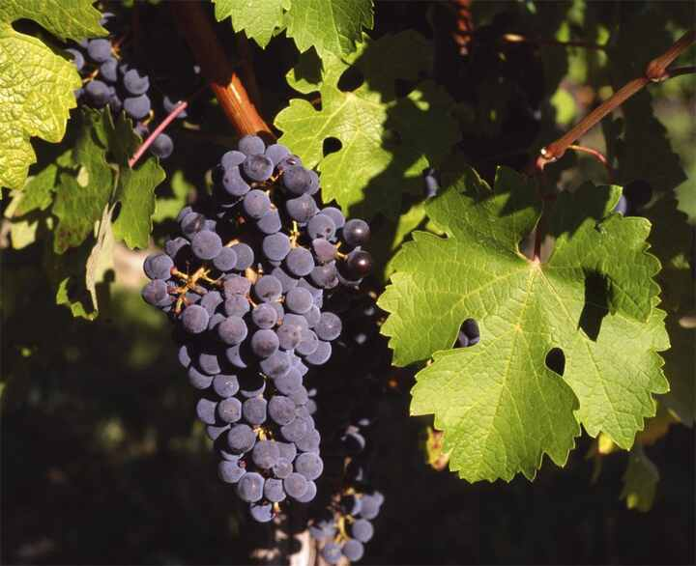
Scientific name | Local name (Hindi) | Interesting fact
Vitis vinifera | Angoor | Grapevines climb with tendrils, and each grape is botanically a berry.
Source: Wikipedia — Vitis vinifera

Strawberry
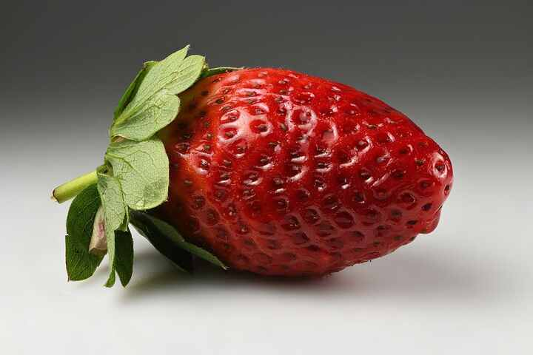
Scientific name | Local name (Hindi) | Interesting fact
Fragaria × ananassa | Strawberry | A strawberry is not a true berry; the 'seeds' outside are separate fruits called achenes.
Source: Wikipedia — Strawberry

Pineapple
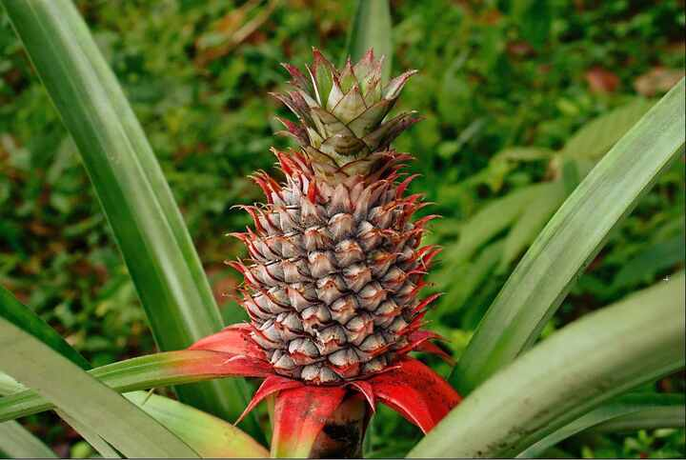
Scientific name | Local name (Hindi) | Interesting fact
Ananas comosus | Ananas | One pineapple is a multiple fruit formed when many flowers and their ovaries fuse together.
Source: Wikipedia — Pineapple

Watermelon
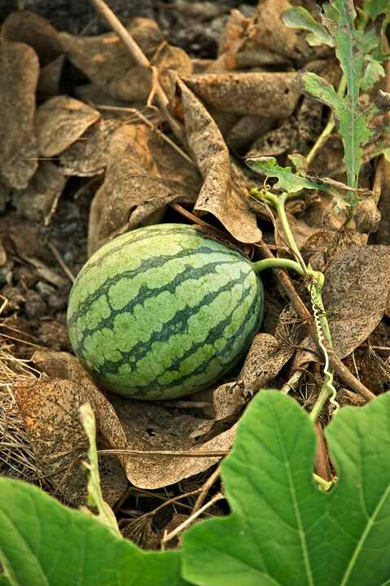
Scientific name | Local name (Hindi) | Interesting fact
Citrullus lanatus | Tarbooz | Its fruit is a specialised berry called a pepo, with a hard rind and fleshy centre.
Source: Wikipedia — Watermelon

Tomato
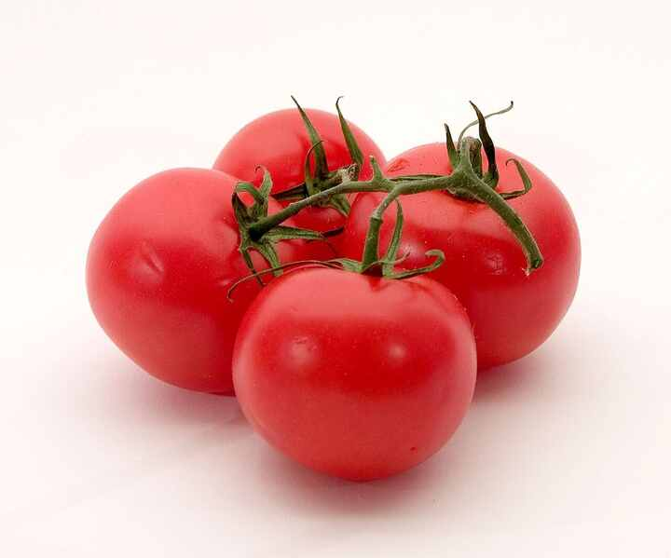
Scientific name | Local name (Hindi) | Interesting fact
Solanum lycopersicum | Tamatar | Botanically a berry, tomato was domesticated in the Americas before spreading around the world.
Source: Wikipedia — Tomato

Eggplant (Brinjal)
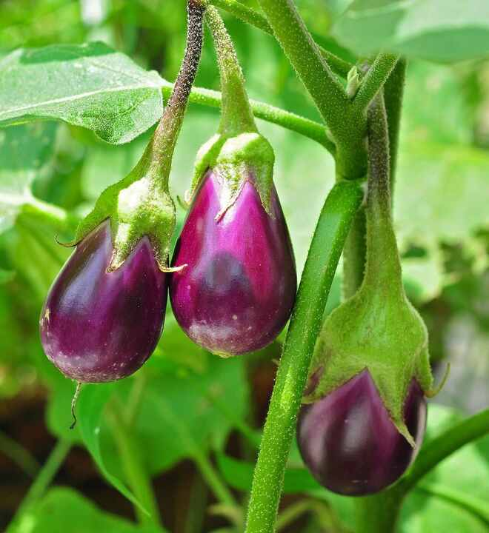
Scientific name | Local name (Hindi) | Interesting fact
Solanum melongena | Baingan | Some traditional varieties are small, white and egg-shaped, which explains the English name 'eggplant'.
Source: Wikipedia — Eggplant

Chili pepper
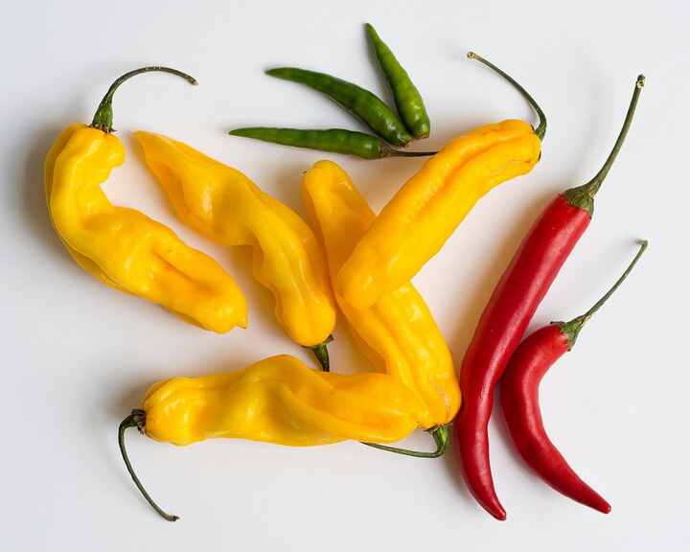
Scientific name | Local name (Hindi) | Interesting fact
Capsicum annuum | Mirch | Most capsaicin is produced in the pale inner placenta, not in the seeds themselves.
Source: Wikipedia — Chili pepper

Okra
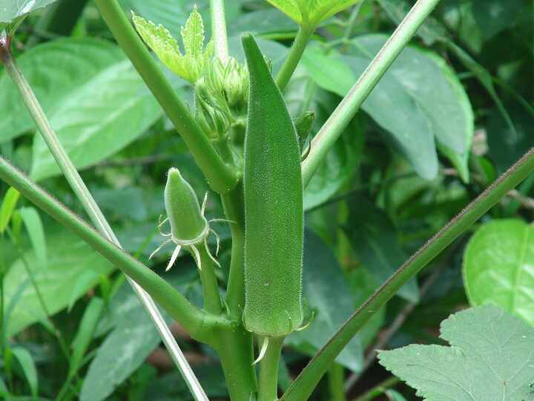
Scientific name | Local name (Hindi) | Interesting fact
Abelmoschus esculentus | Bhindi | Its pods release mucilage when cooked, naturally thickening soups and stews.
Source: Wikipedia — Okra

Cucumber
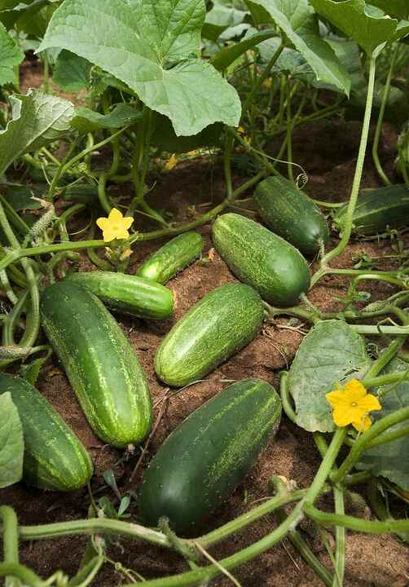
Scientific name | Local name (Hindi) | Interesting fact
Cucumis sativus | Kheera | Cucumber fruits are about 95 percent water, and bee pollination is important for many varieties.
Source: Wikipedia — Cucumber

Pumpkin
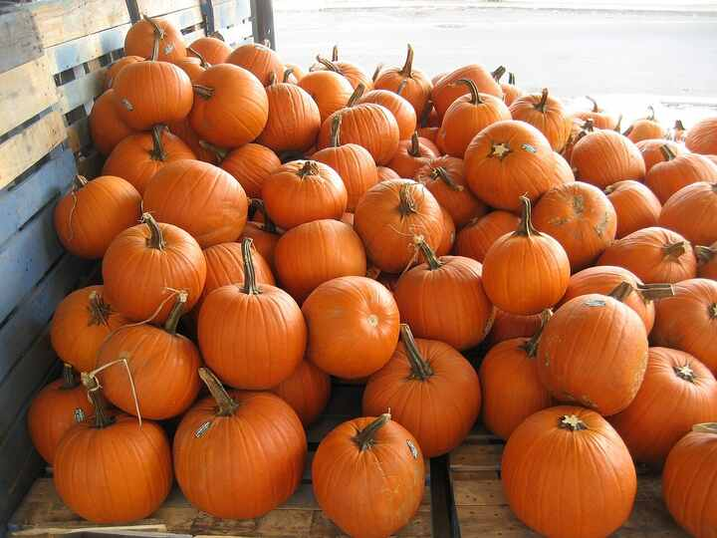
Scientific name | Local name (Hindi) | Interesting fact
Cucurbita spp. | Kaddu | Pumpkins are pepo fruits; their blossoms are edible and are used in several cuisines.
Source: Wikipedia — Pumpkin

Bottle gourd
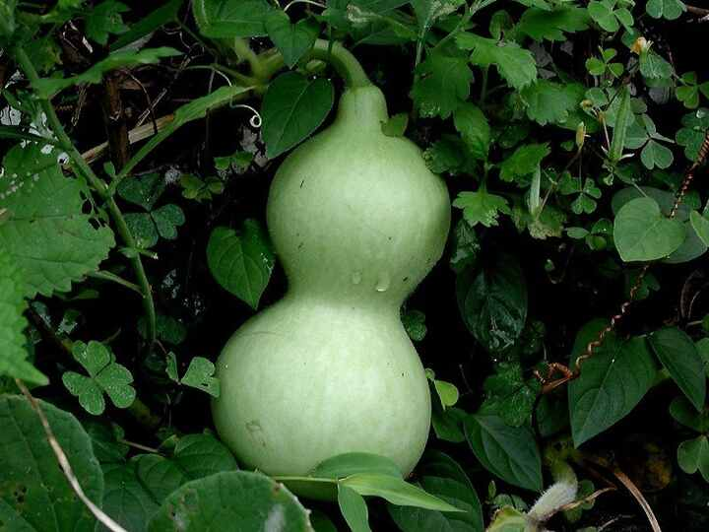
Scientific name | Local name (Hindi) | Interesting fact
Lagenaria siceraria | Lauki | It is among the earliest domesticated plants; dried shells have long served as bottles and utensils.
Source: Wikipedia — Calabash

Bitter melon
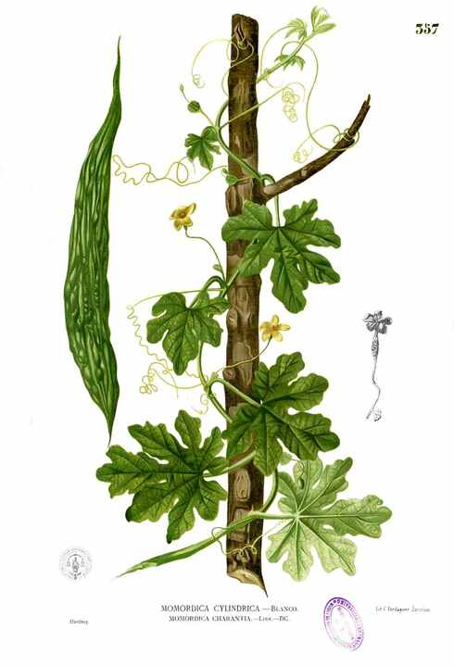
Scientific name | Local name (Hindi) | Interesting fact
Momordica charantia | Karela | At maturity the fruit splits open, revealing seeds covered by vivid red pulp.
Source: Wikipedia — Momordica charantia

Spinach
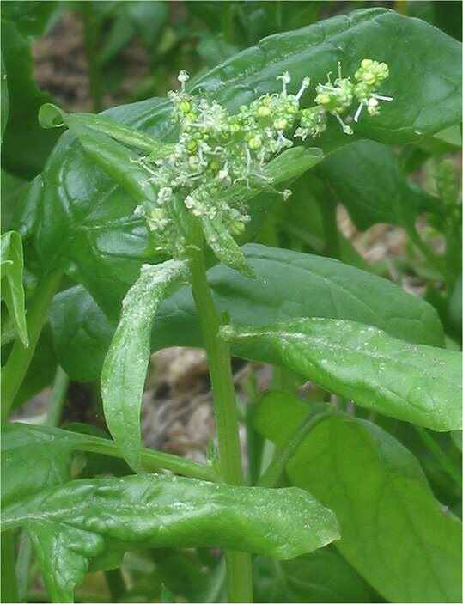
Scientific name | Local name (Hindi) | Interesting fact
Spinacia oleracea | Palak | Long days and warm weather make spinach bolt, shifting growth from leaves to flowers.
Source: Wikipedia — Spinach

Coriander
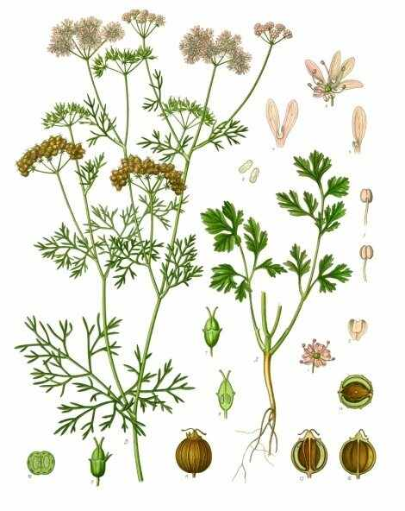
Scientific name | Local name (Hindi) | Interesting fact
Coriandrum sativum | Dhania | The leaves and dried seeds have strikingly different aromas but come from the same plant.
Source: Wikipedia — Coriander

Mint
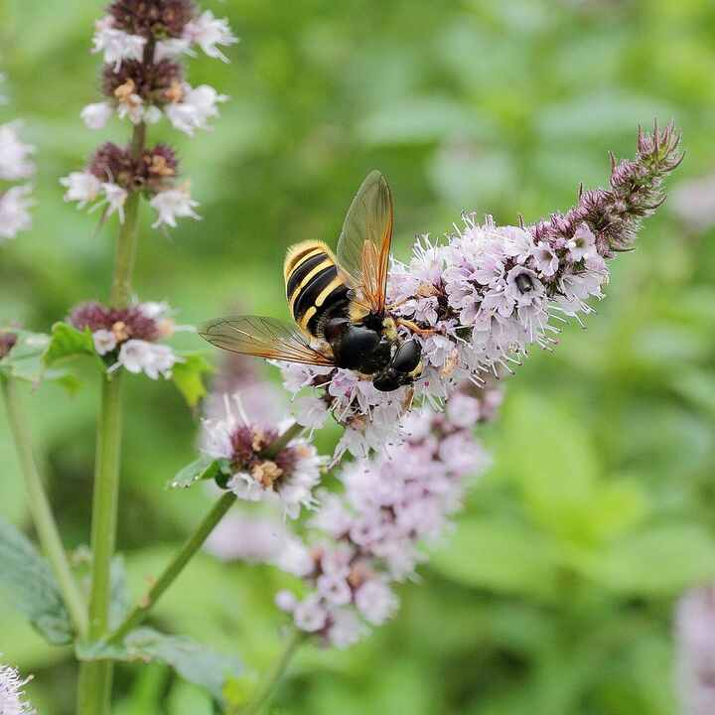
Scientific name | Local name (Hindi) | Interesting fact
Mentha spp. | Pudina | Mint spreads through underground runners, so it can quickly escape a garden bed.
Source: Wikipedia — Mentha

Fenugreek
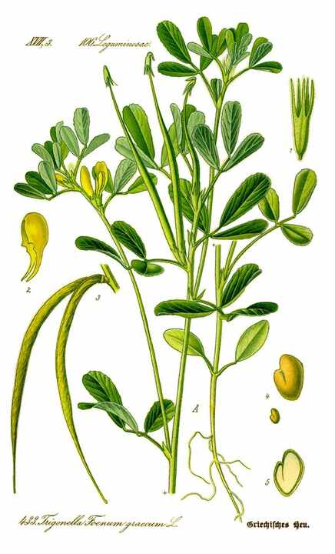
Scientific name | Local name (Hindi) | Interesting fact
Trigonella foenum-graecum | Methi | Both leaves and seeds are edible; the aroma includes sotolon, also found in maple syrup.
Source: Wikipedia — Fenugreek

Mustard plant
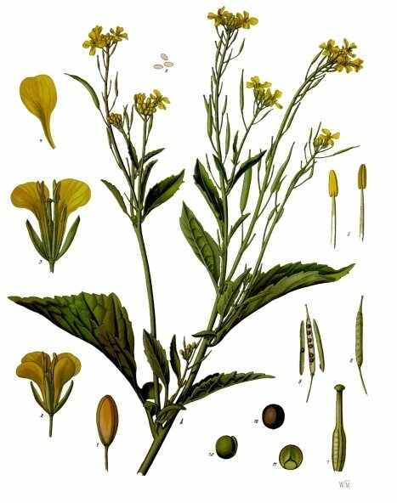
Scientific name | Local name (Hindi) | Interesting fact
Brassica juncea | Sarson | Its pungent flavour develops when crushed seed compounds react with water.
Source: Wikipedia — Brassica juncea

Ginger
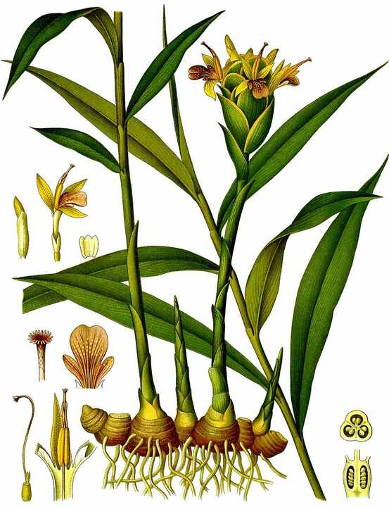
Scientific name | Local name (Hindi) | Interesting fact
Zingiber officinale | Adrak | The edible 'root' is actually a rhizome, a horizontal underground stem that produces shoots.
Source: Wikipedia — Ginger

Turmeric
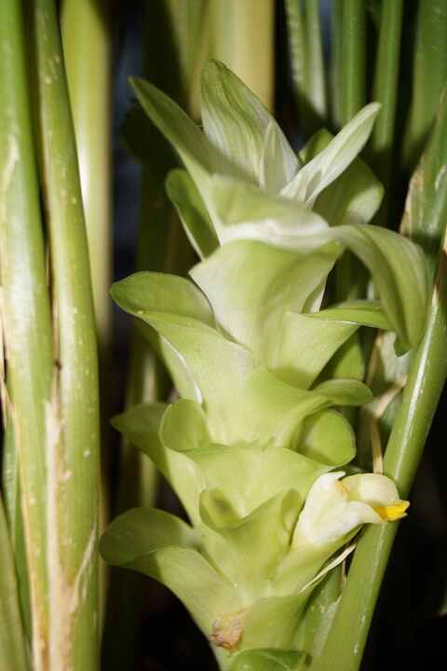
Scientific name | Local name (Hindi) | Interesting fact
Curcuma longa | Haldi | The underground rhizome is boiled, dried and ground; curcumin supplies its strong yellow colour.
Source: Wikipedia — Turmeric

Garlic
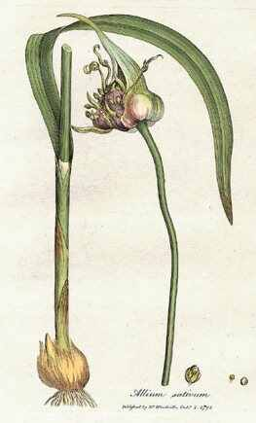
Scientific name | Local name (Hindi) | Interesting fact
Allium sativum | Lahsun | A garlic bulb consists of fleshy storage leaves, and each clove can grow a new plant.
Source: Wikipedia — Garlic

Onion
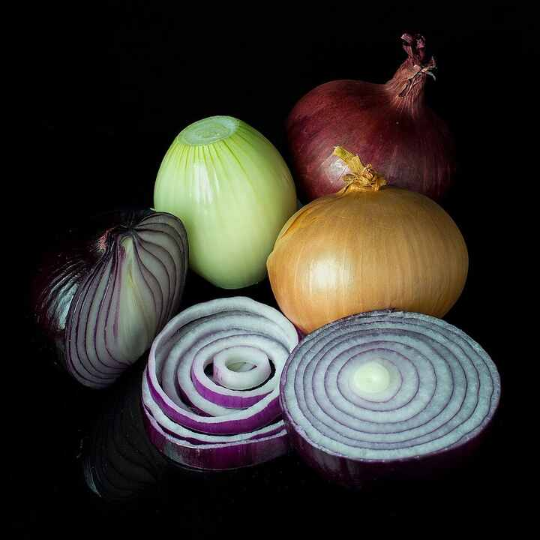
Scientific name | Local name (Hindi) | Interesting fact
Allium cepa | Pyaz | An onion's layers are swollen leaf bases; cutting them releases volatile sulfur compounds.
Source: Wikipedia — Onion

Potato
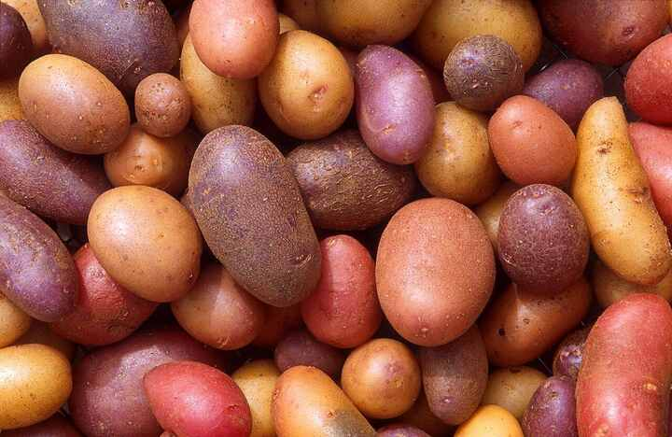
Scientific name | Local name (Hindi) | Interesting fact
Solanum tuberosum | Aloo | A potato is a swollen underground stem, and its 'eyes' are buds that can sprout.
Source: Wikipedia — Potato

Sweet potato
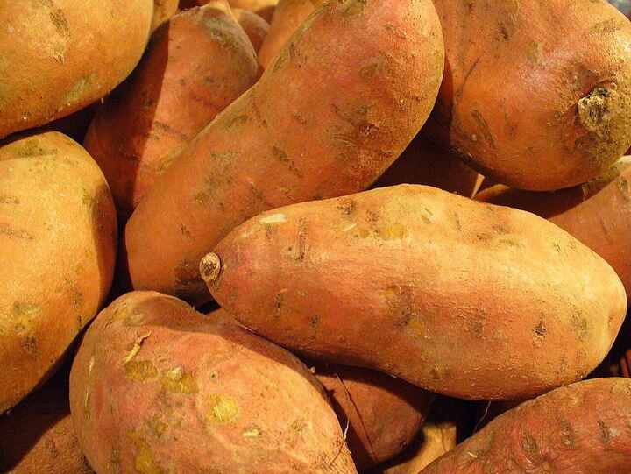
Scientific name | Local name (Hindi) | Interesting fact
Ipomoea batatas | Shakarkand | Unlike potato, it is a storage root and belongs to the morning-glory family.
Source: Wikipedia — Sweet potato

Carrot
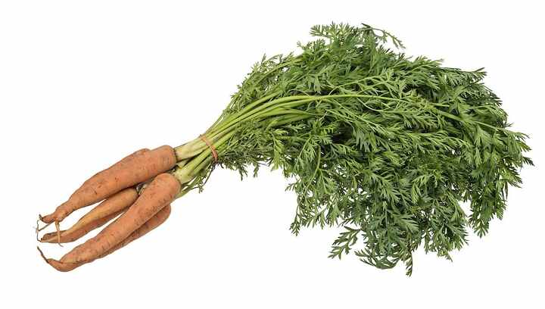
Scientific name | Local name (Hindi) | Interesting fact
Daucus carota subsp. sativus | Gajar | Cultivated carrots were often purple or yellow before orange forms became widespread.
Source: Wikipedia — Carrot

Radish
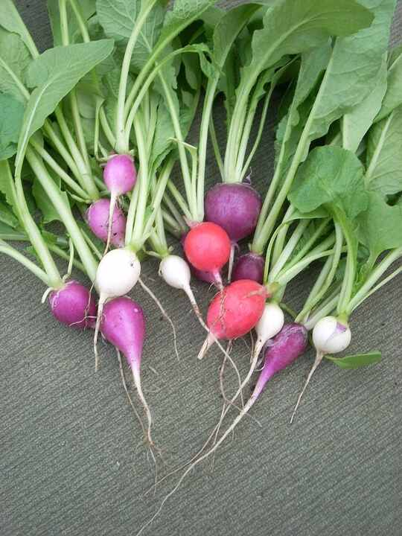
Scientific name | Local name (Hindi) | Interesting fact
Raphanus sativus | Mooli | Radish grows quickly, and the crisp seed pods of some varieties are also eaten.
Source: Wikipedia — Radish

Beetroot
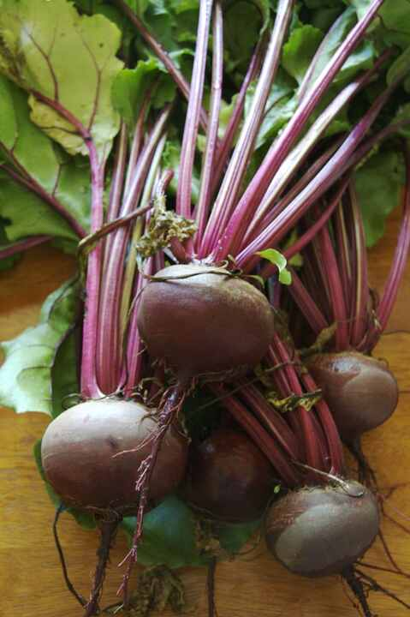
Scientific name | Local name (Hindi) | Interesting fact
Beta vulgaris | Chukandar | Each corky 'seed' is often a cluster of true seeds, so several seedlings may emerge.
Source: Wikipedia — Beetroot

Cabbage
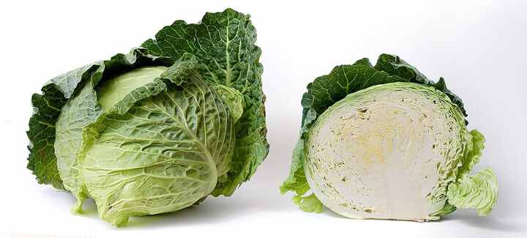
Scientific name | Local name (Hindi) | Interesting fact
Brassica oleracea var. capitata | Patta gobhi | Cabbage, broccoli, cauliflower and kale are forms of one species shaped by selective breeding.
Source: Wikipedia — Cabbage

Cauliflower
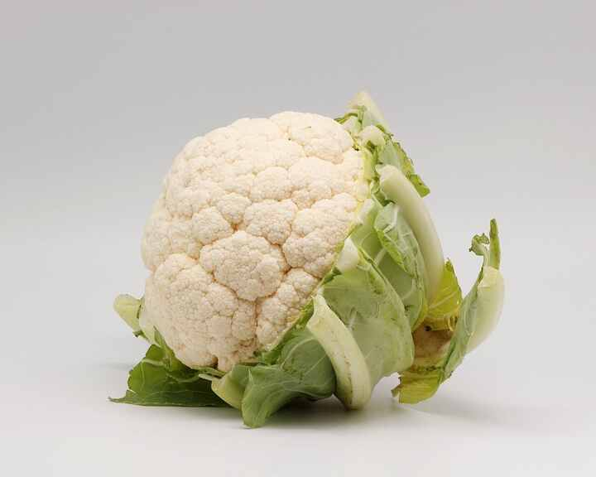
Scientific name | Local name (Hindi) | Interesting fact
Brassica oleracea var. botrytis | Phool gobhi | The edible white curd is a mass of compact, undeveloped flower structures.
Source: Wikipedia — Cauliflower

Broccoli
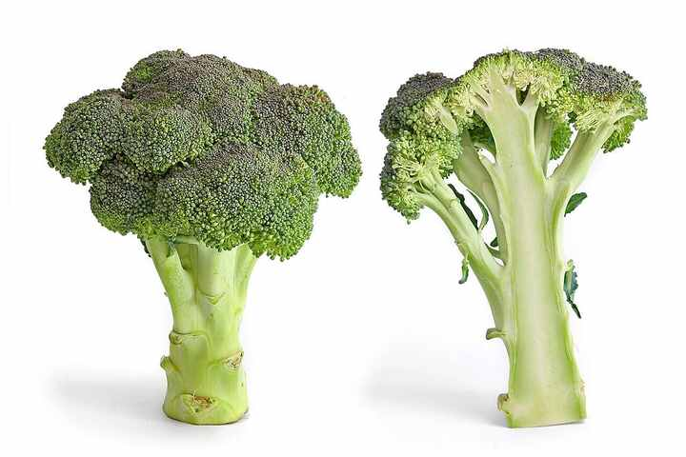
Scientific name | Local name (Hindi) | Interesting fact
Brassica oleracea var. italica | Broccoli | The head is a dense cluster of unopened flower buds; left unharvested, they bloom yellow.
Source: Wikipedia — Broccoli

Pea
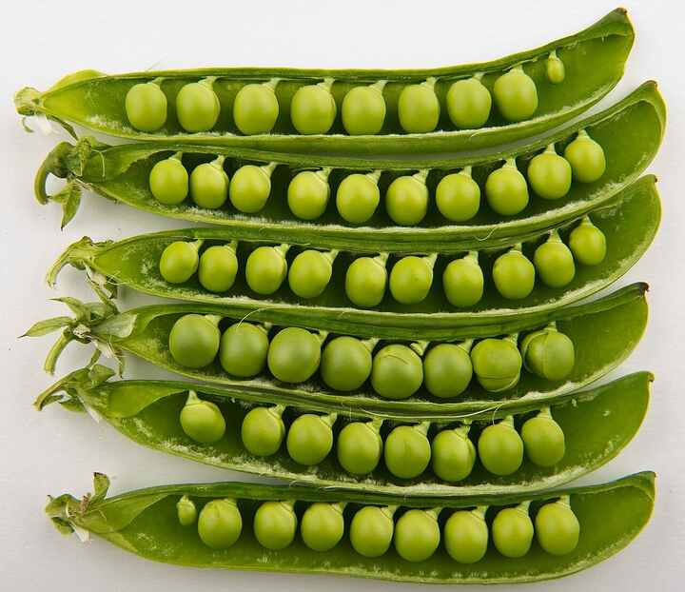
Scientific name | Local name (Hindi) | Interesting fact
Pisum sativum | Matar | Root nodules house bacteria that convert atmospheric nitrogen into compounds the plant can use.
Source: Wikipedia — Pea

Chickpea
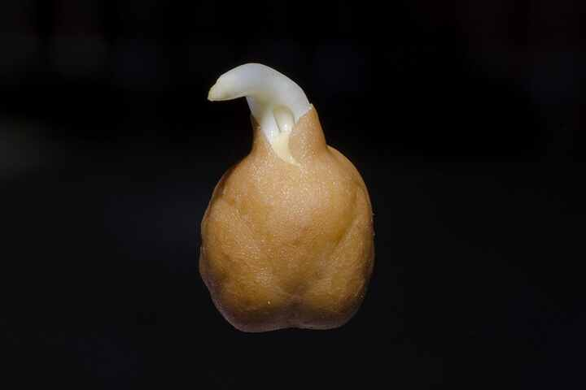
Scientific name | Local name (Hindi) | Interesting fact
Cicer arietinum | Chana | Each small inflated pod usually contains only one or two chickpeas.
Source: Wikipedia — Chickpea

Lentil
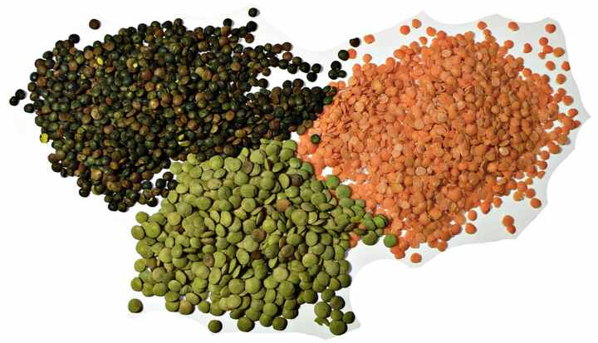
Scientific name | Local name (Hindi) | Interesting fact
Lens culinaris | Masoor | The optical lens was named for its resemblance to the small, double-convex lentil seed.
Source: Wikipedia — Lentil

Soybean
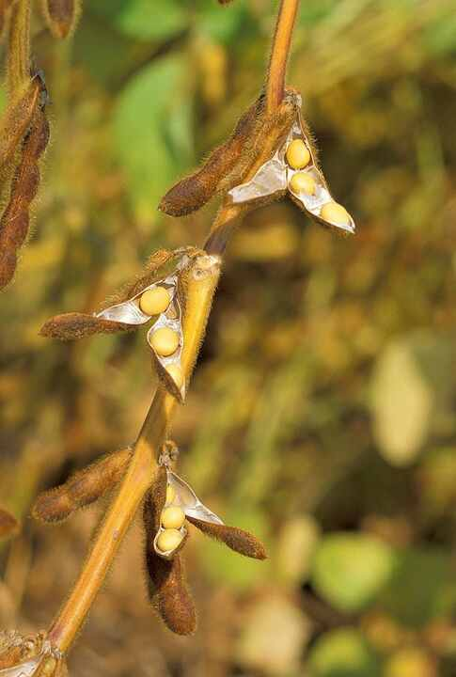
Scientific name | Local name (Hindi) | Interesting fact
Glycine max | Soyabean | Tofu, tempeh, miso and soy sauce all begin with the same protein-rich seed.
Source: Wikipedia — Soybean

Rice
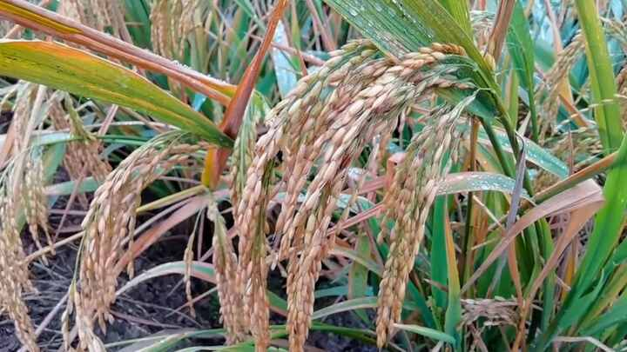
Scientific name | Local name (Hindi) | Interesting fact
Oryza sativa | Dhan | Air channels called aerenchyma help rice roots survive in waterlogged paddy soil.
Source: Wikipedia — Rice

Wheat
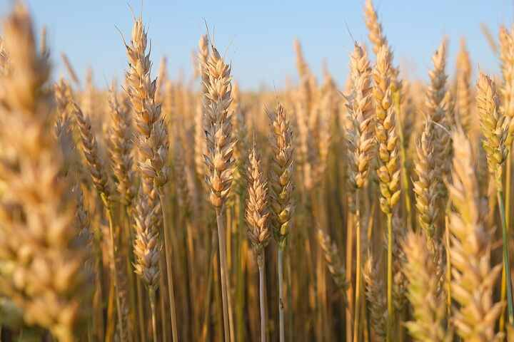
Scientific name | Local name (Hindi) | Interesting fact
Triticum aestivum | Gehun | Each wheat kernel is a caryopsis, a fruit whose wall is fused to the seed coat.
Source: Wikipedia — Wheat

Maize (Corn)
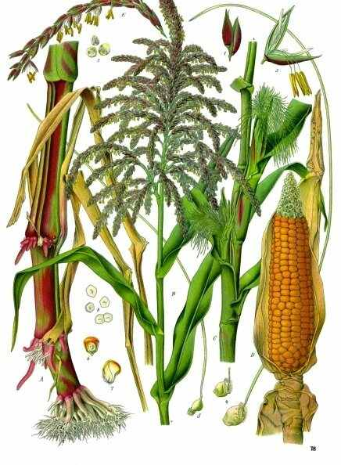
Scientific name | Local name (Hindi) | Interesting fact
Zea mays | Makka | Every silk strand connects to one ovule; successful pollination produces one kernel.
Source: Wikipedia — Maize

Sugarcane
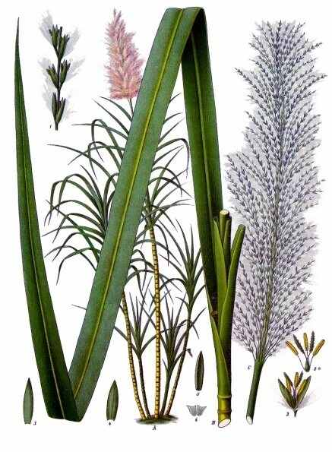
Scientific name | Local name (Hindi) | Interesting fact
Saccharum officinarum | Ganna | Sugar accumulates in the fibrous stems, and crops are commonly propagated from stem cuttings.
Source: Wikipedia — Sugarcane

Cotton
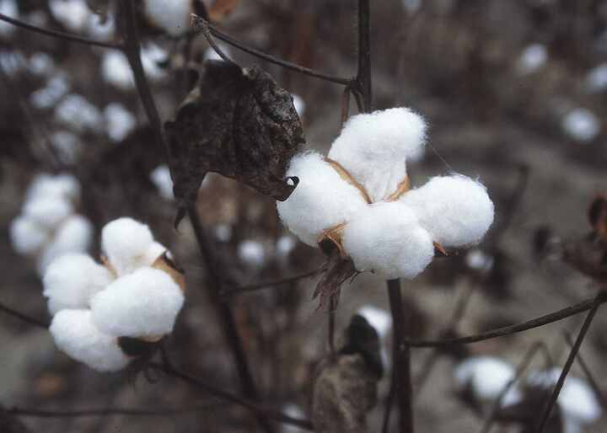
Scientific name | Local name (Hindi) | Interesting fact
Gossypium spp. | Kapas | Each cotton fibre is a single, extremely elongated cell growing from the seed coat.
Source: Wikipedia — Cotton

Tea plant
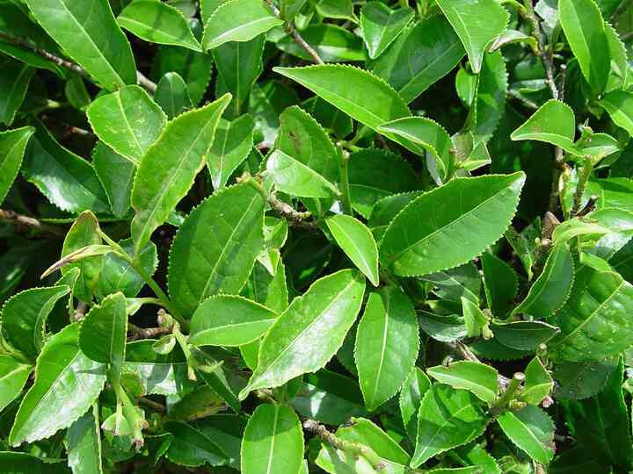
Scientific name | Local name (Hindi) | Interesting fact
Camellia sinensis | Chai | Green, oolong and black teas come from the same species but undergo different processing.
Source: Wikipedia — Camellia sinensis

Coffee plant
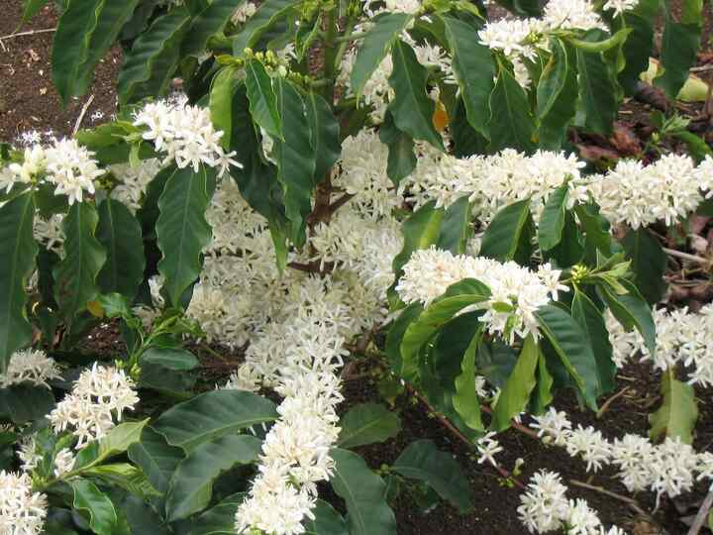
Scientific name | Local name (Hindi) | Interesting fact
Coffea arabica | Coffee | Coffee 'beans' are seeds inside a fruit called a coffee cherry, usually two per fruit.
Source: Wikipedia — Coffea

Bamboo
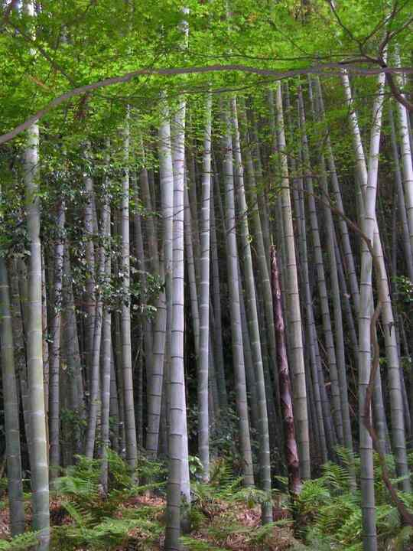
Scientific name | Local name (Hindi) | Interesting fact
Bambusa spp. | Baans | Bamboo is a grass; its hollow stems, called culms, can reach tree-like heights.
Source: Wikipedia — Bamboo

Eucalyptus
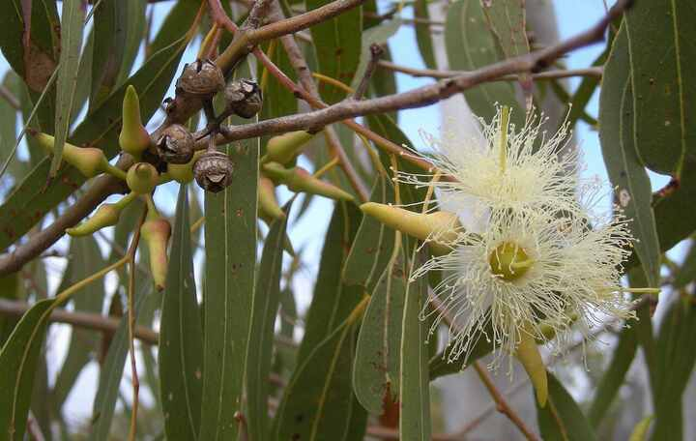
Scientific name | Local name (Hindi) | Interesting fact
Eucalyptus spp. | Safeda | Its leaves contain conspicuous oil glands, and bark form is an important identification feature.
Source: Wikipedia — Eucalyptus

Teak
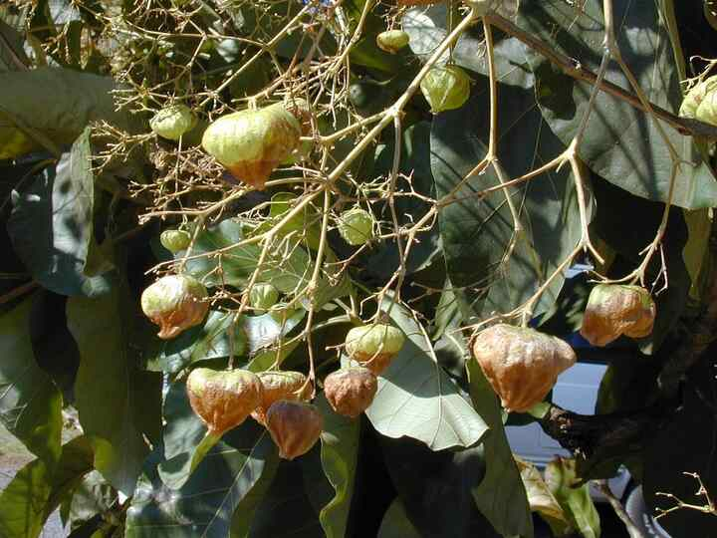
Scientific name | Local name (Hindi) | Interesting fact
Tectona grandis | Sagwan | Natural oils make teak timber unusually resistant to water, fungi and decay.
Source: Wikipedia — Teak

Sandalwood
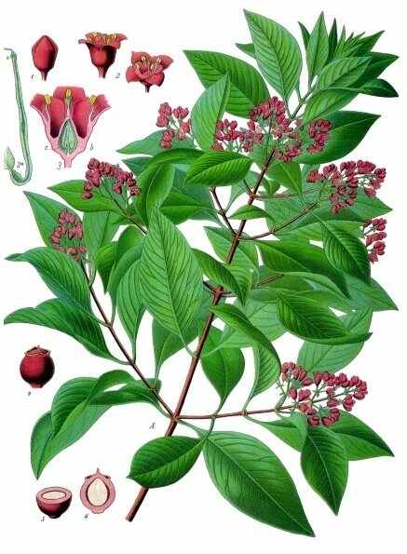
Scientific name | Local name (Hindi) | Interesting fact
Santalum album | Chandan | Sandalwood is a root hemiparasite, tapping nearby plants for water and mineral nutrients.
Source: Wikipedia — Santalum album

Money plant (Pothos)
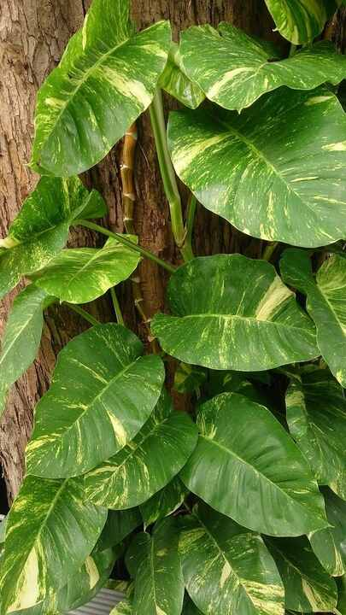
Scientific name | Local name (Hindi) | Interesting fact
Epipremnum aureum | Money plant | It climbs using aerial roots; mature outdoor leaves become much larger and deeply divided.
Source: Wikipedia — Epipremnum aureum

Snake plant
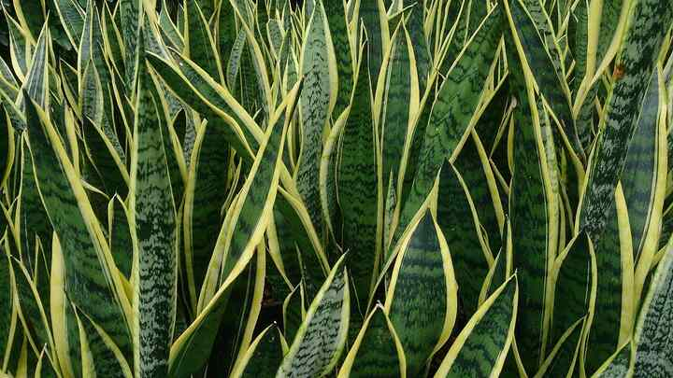
Scientific name | Local name (Hindi) | Interesting fact
Dracaena trifasciata | Sanp ka paudha | It uses CAM photosynthesis, opening most stomata at night to conserve water.
Source: Wikipedia — Dracaena trifasciata

