Mango
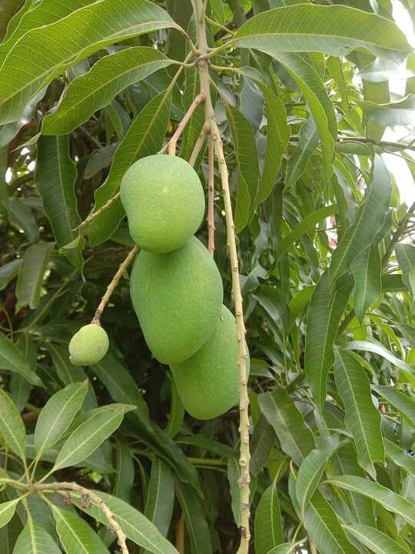
Source: Wikipedia — Mangifera indica

Neem
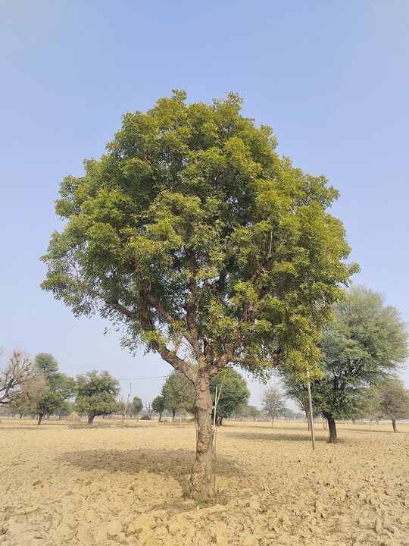
Source: Wikipedia — Azadirachta indica

Banyan
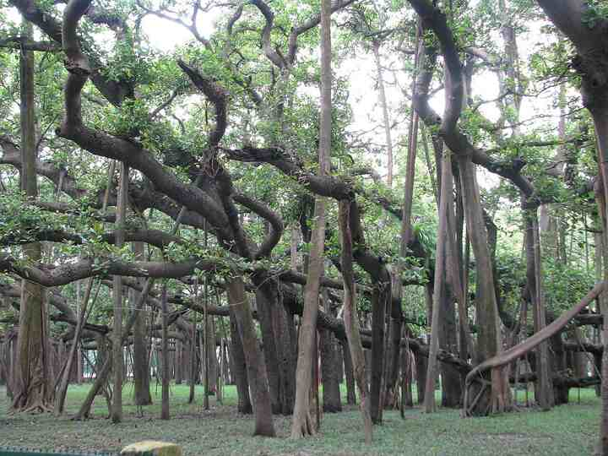
Source: Wikipedia — Ficus benghalensis

Peepal
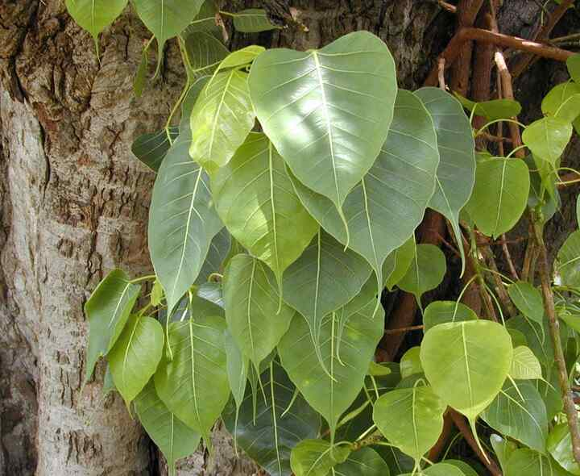
Source: Wikipedia — Ficus religiosa

Tulsi (Holy basil)
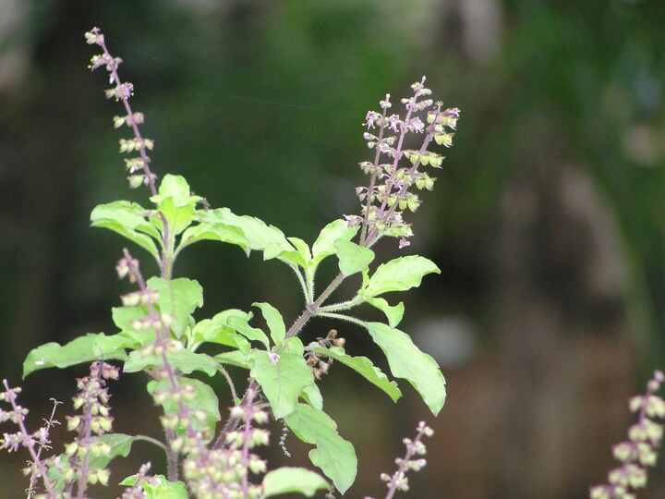
Source: Wikipedia — Ocimum tenuiflorum

Aloe vera
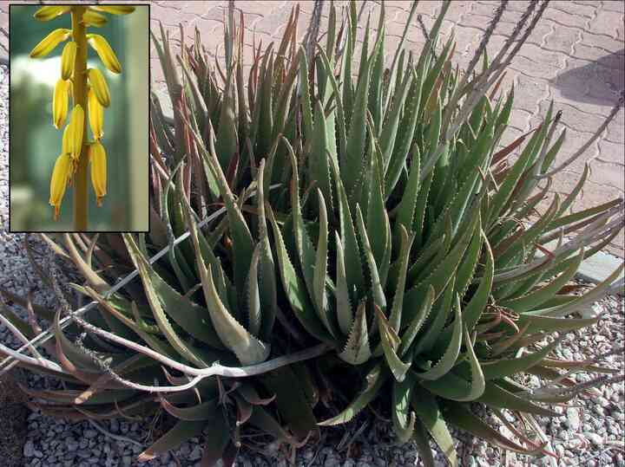
Source: Wikipedia — Aloe vera

Hibiscus
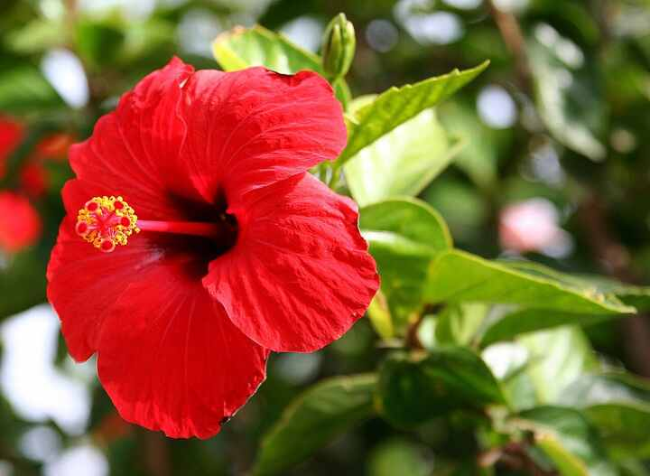
Source: Wikipedia — Hibiscus × rosa-sinensis

Rose
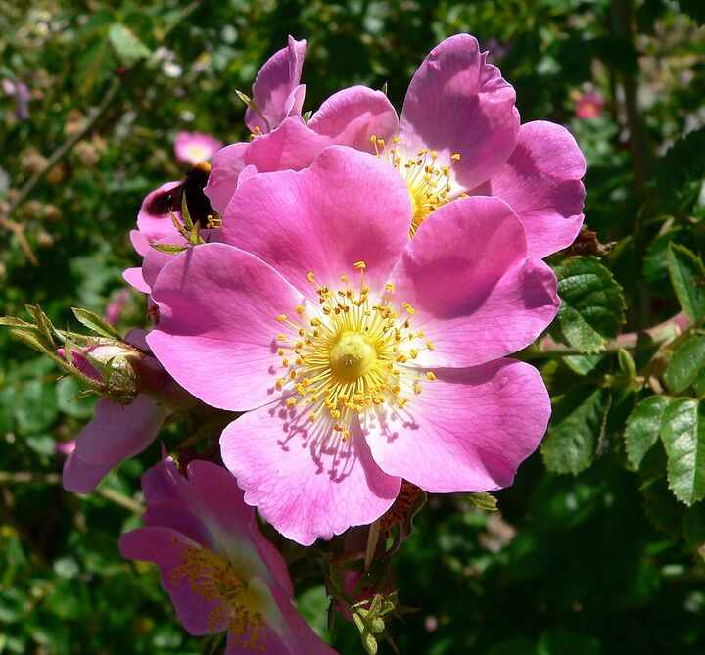
Source: Wikipedia — Rose

Jasmine
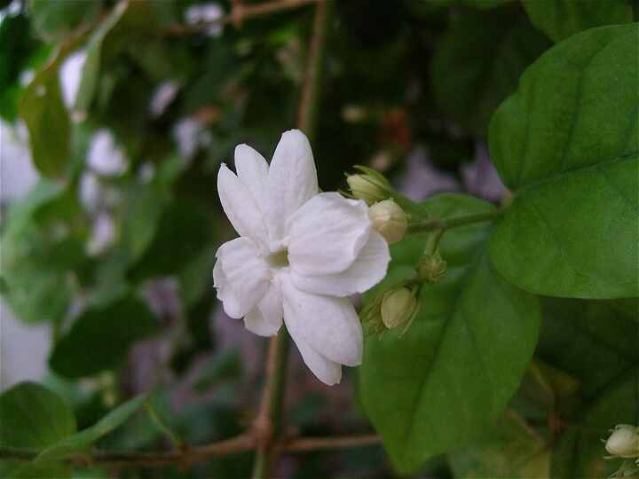
Source: Wikipedia — Jasminum sambac

Marigold
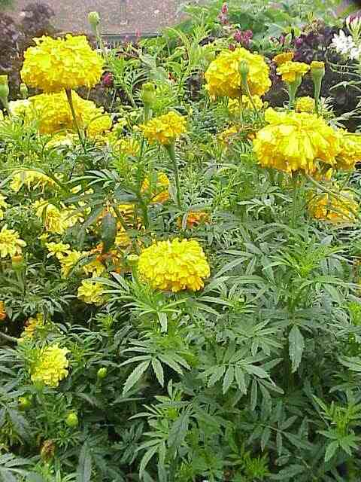
Source: Wikipedia — Tagetes erecta

Sunflower
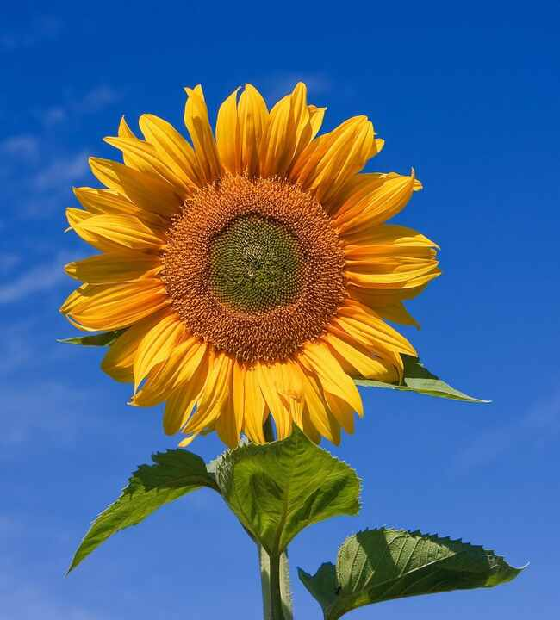
Source: Wikipedia — Common sunflower

Lotus
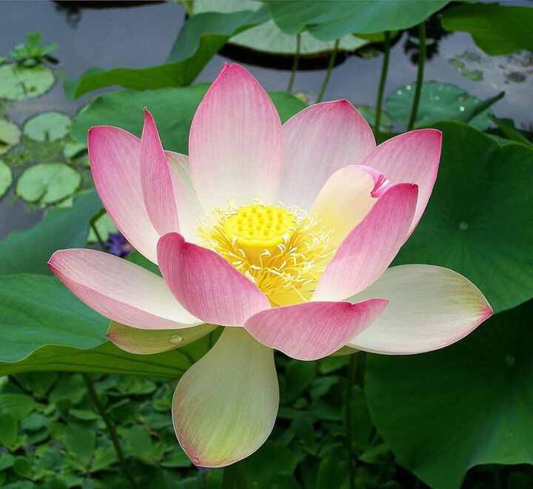
Source: Wikipedia — Nelumbo nucifera

Water lily
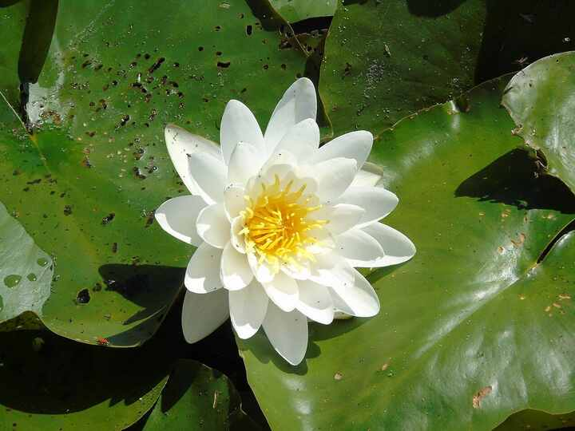
Source: Wikipedia — Nymphaea

Bougainvillea
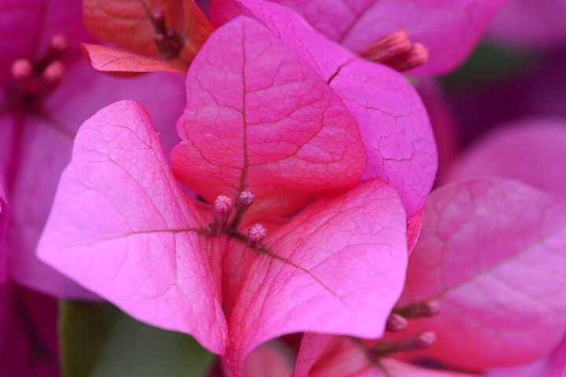
Source: Wikipedia — Bougainvillea

Ixora
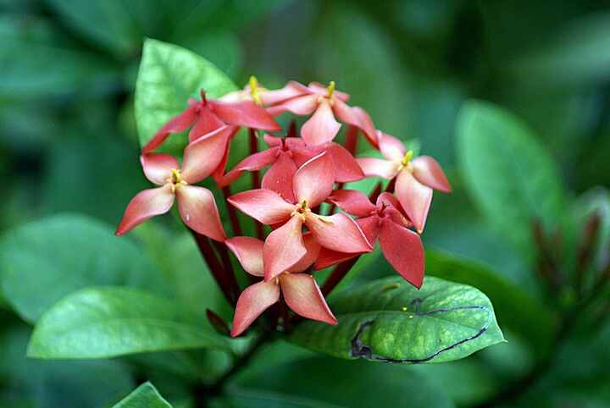
Source: Wikipedia — Ixora coccinea

Frangipani
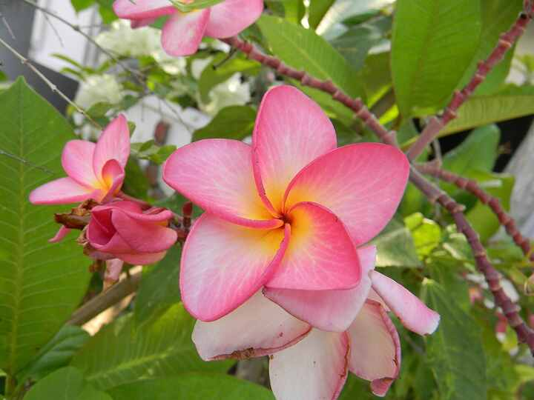
Source: Wikipedia — Plumeria

Gulmohar
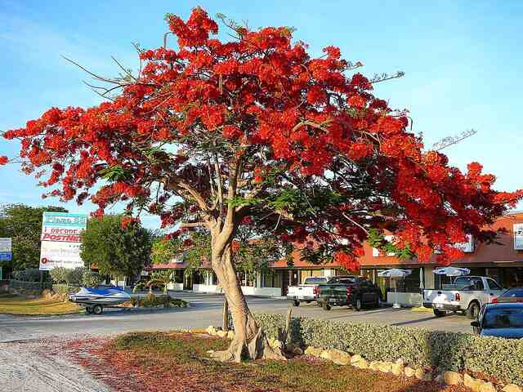
Source: Wikipedia — Delonix regia

Ashoka tree
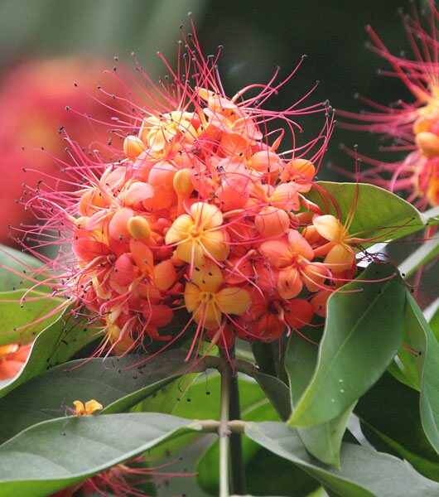
Source: Wikipedia — Saraca asoca

Curry tree
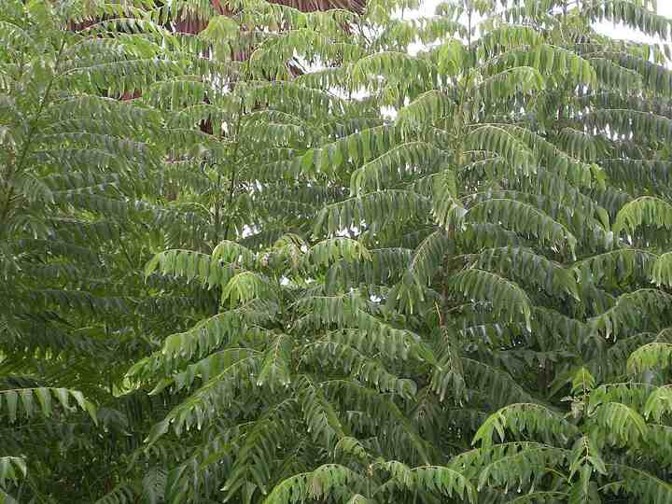
Source: Wikipedia — Curry tree

Coconut palm
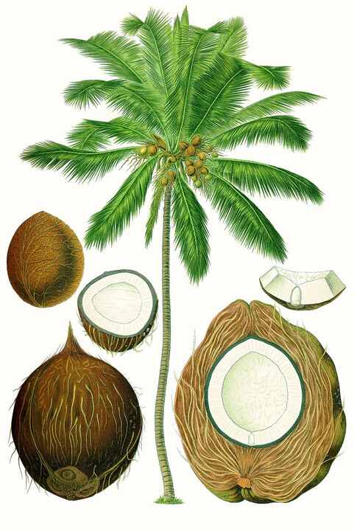
Source: Wikipedia — Coconut

Banana
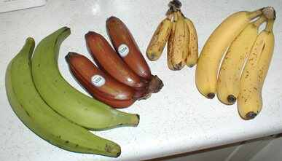
Source: Wikipedia — Banana

Papaya
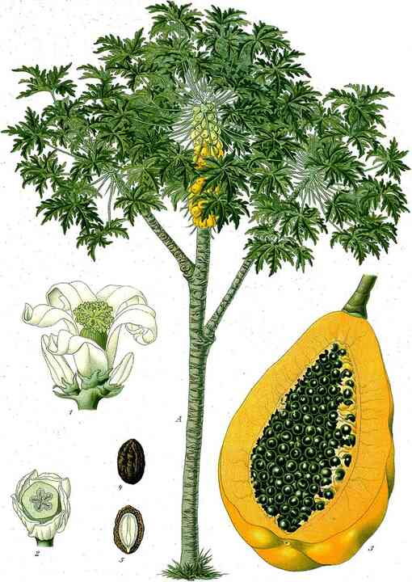
Source: Wikipedia — Papaya

Guava
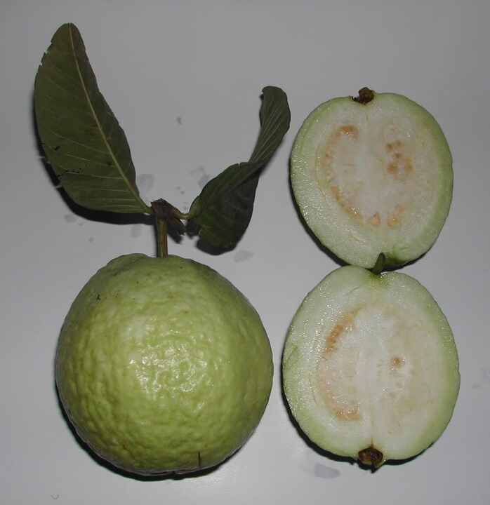
Source: Wikipedia — Psidium guajava

Pomegranate
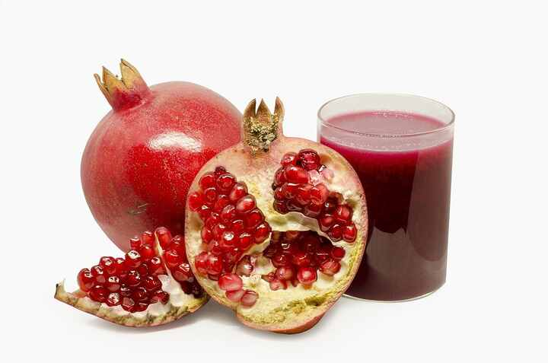
Source: Wikipedia — Pomegranate

Lemon
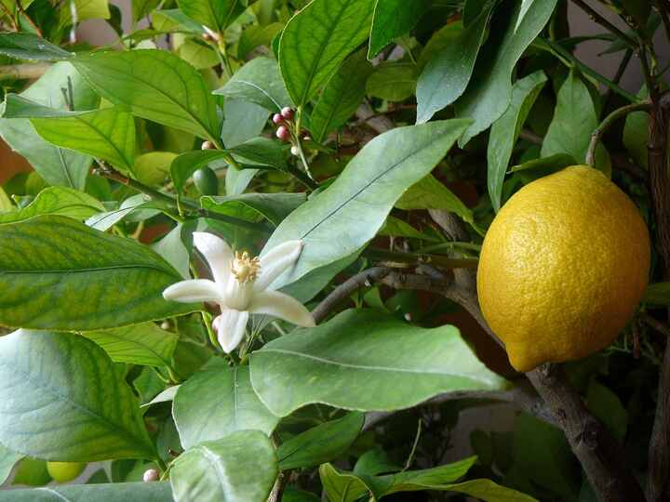
Source: Wikipedia — Lemon

Sweet orange
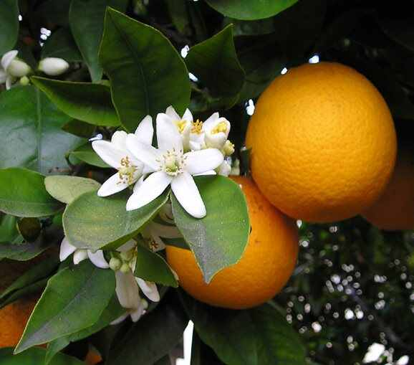
Source: Wikipedia — Citrus × sinensis

Apple
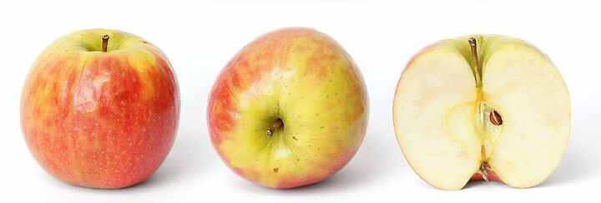
Source: Wikipedia — Apple

Grapevine
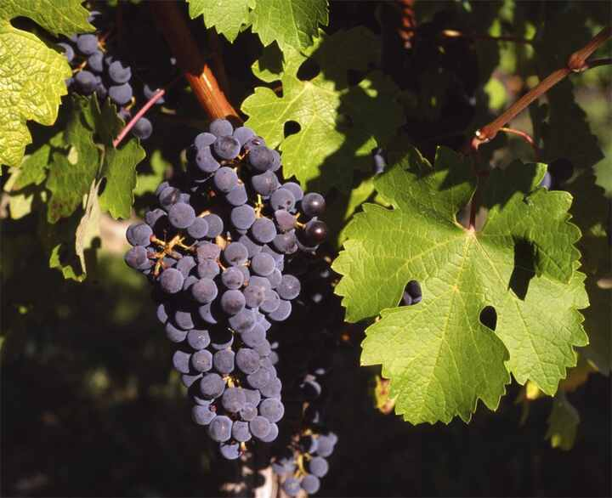
Source: Wikipedia — Vitis vinifera

Strawberry
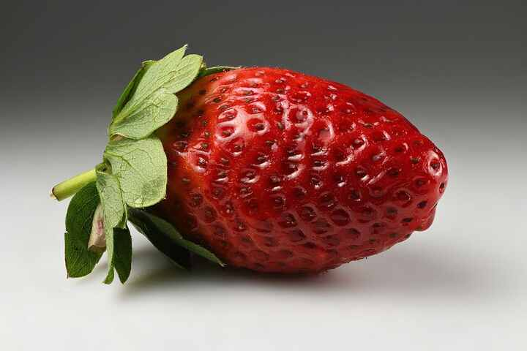
Source: Wikipedia — Strawberry

Pineapple
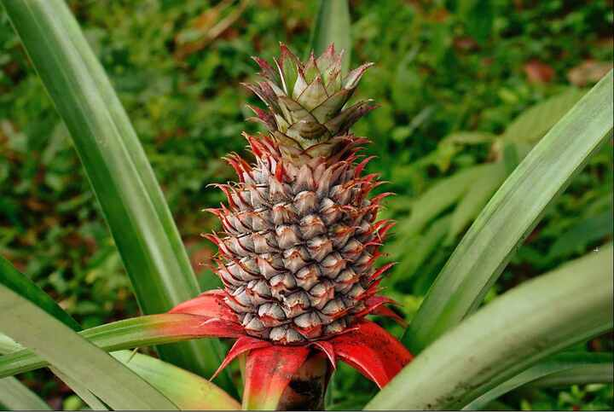
Source: Wikipedia — Pineapple

Watermelon
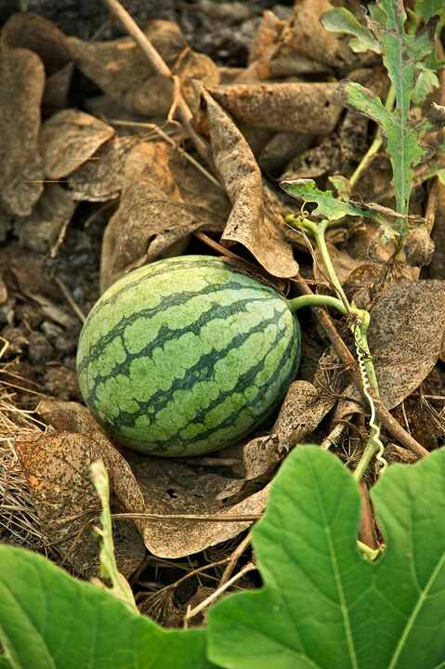
Source: Wikipedia — Watermelon

Tomato
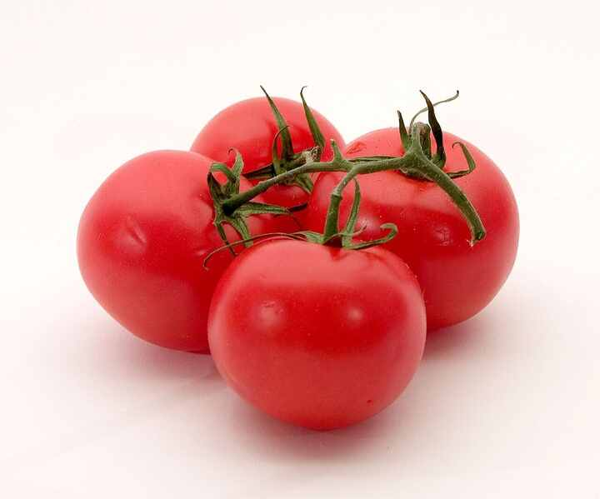
Source: Wikipedia — Tomato

Eggplant (Brinjal)
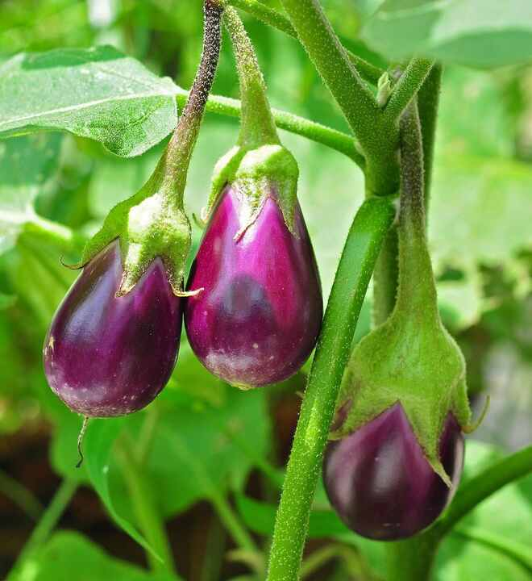
Source: Wikipedia — Eggplant

Chili pepper
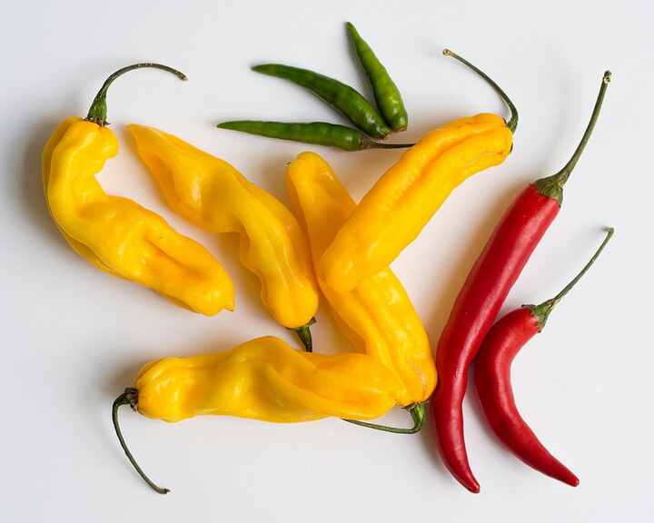
Source: Wikipedia — Chili pepper

Okra
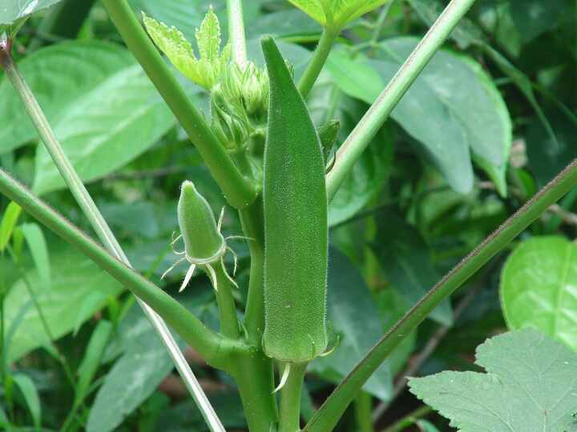
Source: Wikipedia — Okra

Cucumber
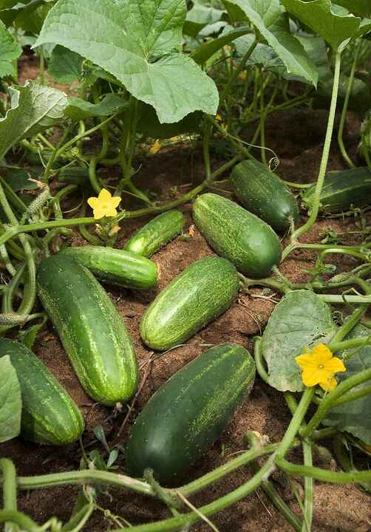
Source: Wikipedia — Cucumber

Pumpkin
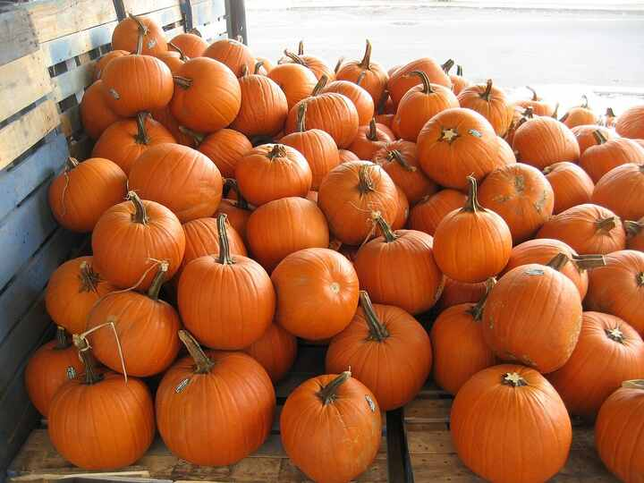
Source: Wikipedia — Pumpkin

Bottle gourd
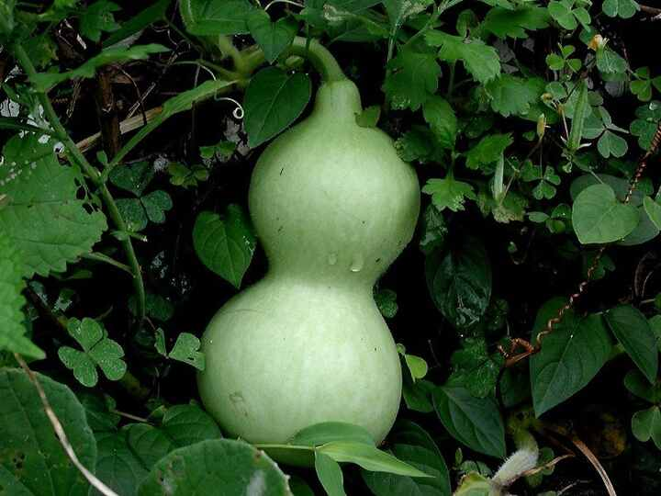
Source: Wikipedia — Calabash

Bitter melon
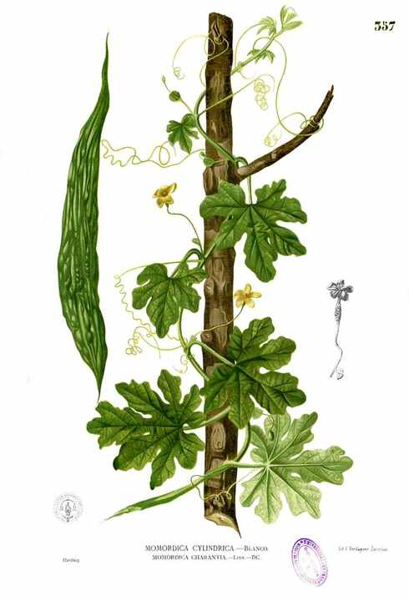
Source: Wikipedia — Momordica charantia

Spinach
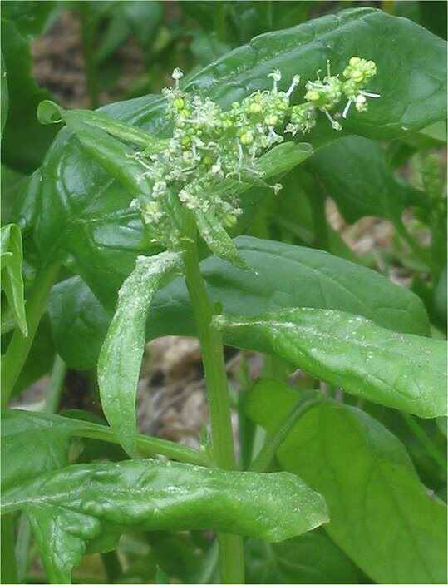
Source: Wikipedia — Spinach

Coriander
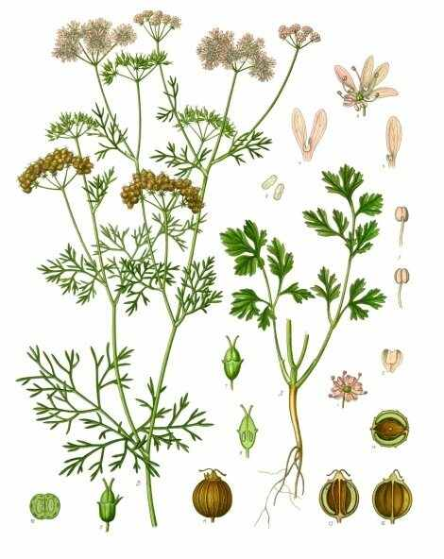
Source: Wikipedia — Coriander

Mint
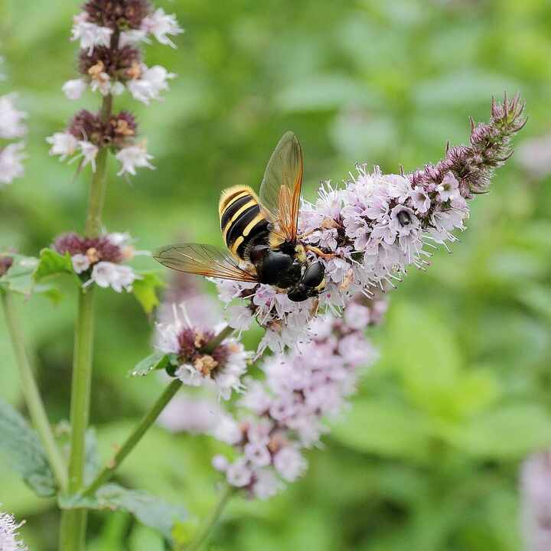
Source: Wikipedia — Mentha

Fenugreek
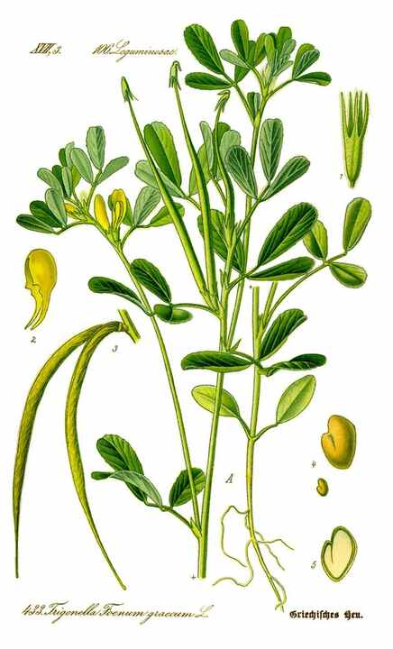
Source: Wikipedia — Fenugreek

Mustard plant
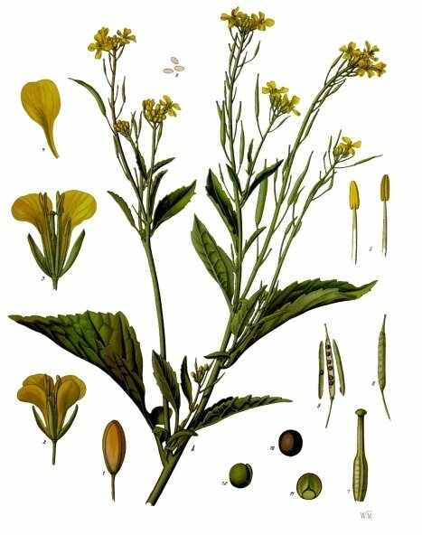
Source: Wikipedia — Brassica juncea

Ginger
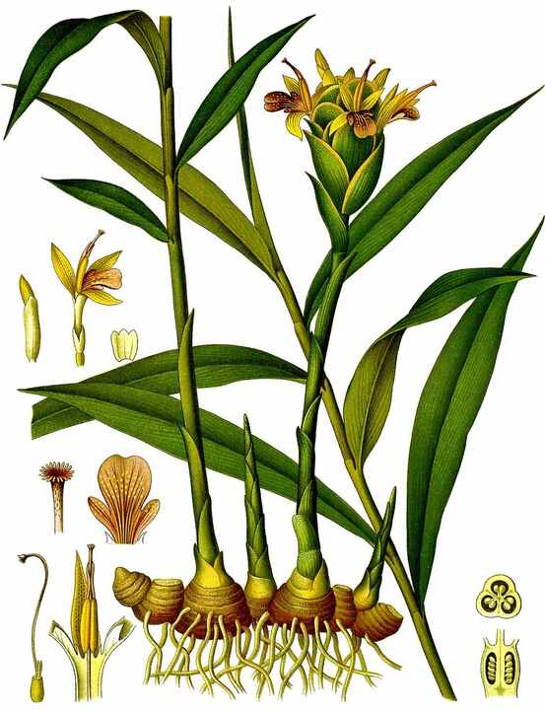
Source: Wikipedia — Ginger

Turmeric
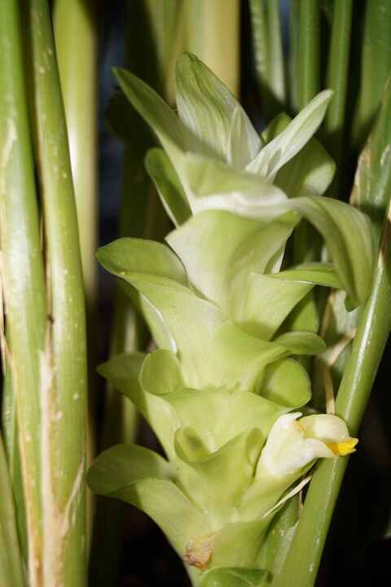
Source: Wikipedia — Turmeric

Garlic
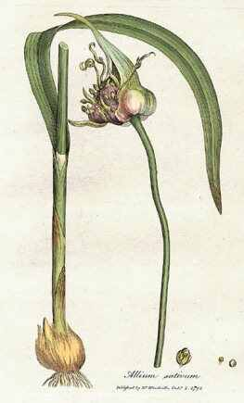
Source: Wikipedia — Garlic

Onion
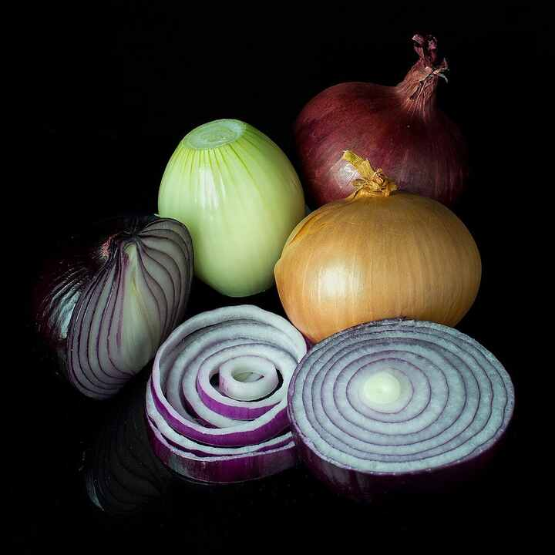
Source: Wikipedia — Onion

Potato
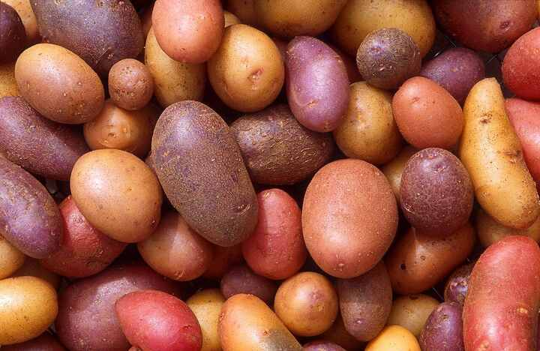
Source: Wikipedia — Potato

Sweet potato
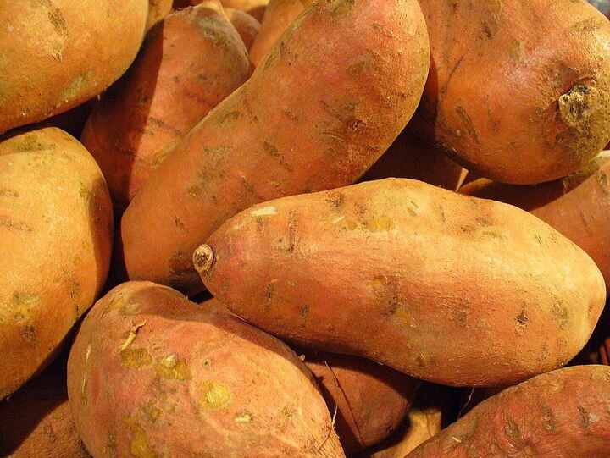
Source: Wikipedia — Sweet potato

Carrot
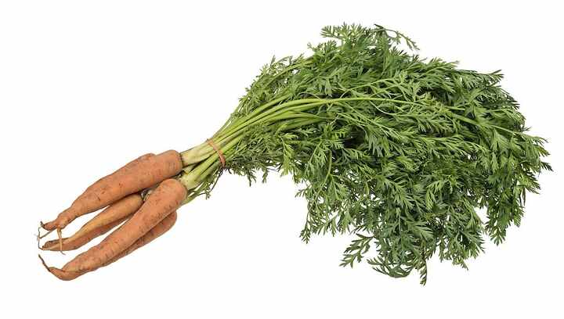
Source: Wikipedia — Carrot

Radish
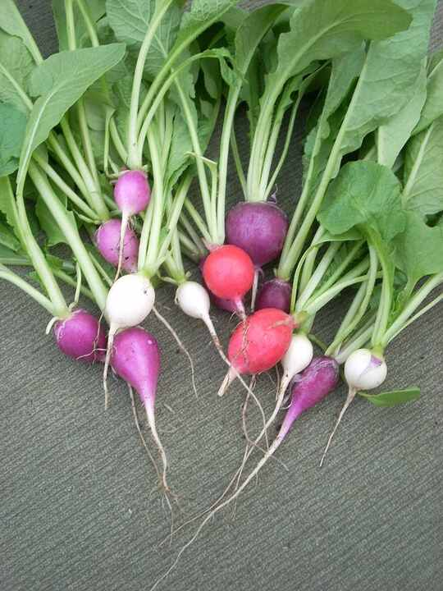
Source: Wikipedia — Radish

Beetroot
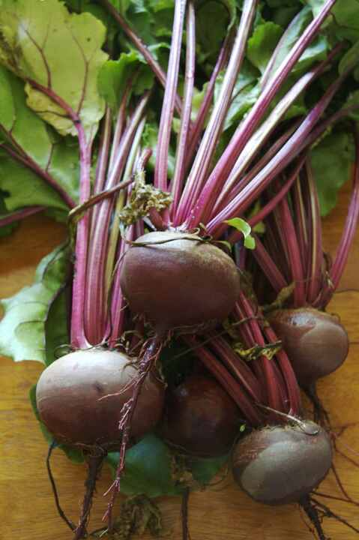
Source: Wikipedia — Beetroot

Cabbage
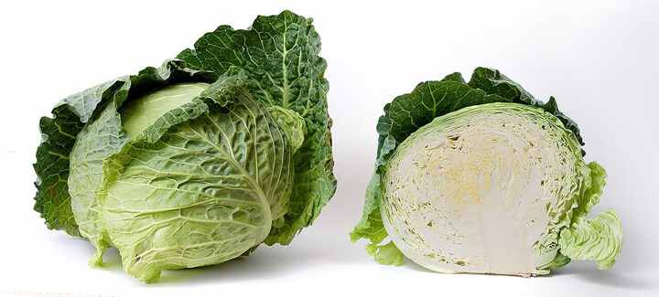
Source: Wikipedia — Cabbage

Cauliflower
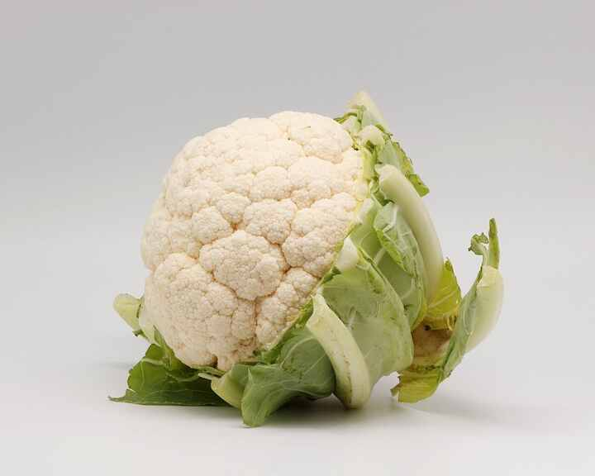
Source: Wikipedia — Cauliflower

Broccoli
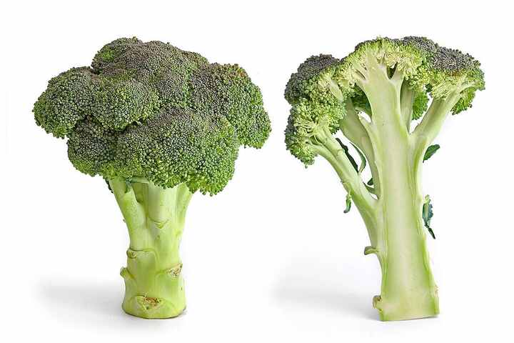
Source: Wikipedia — Broccoli

Pea
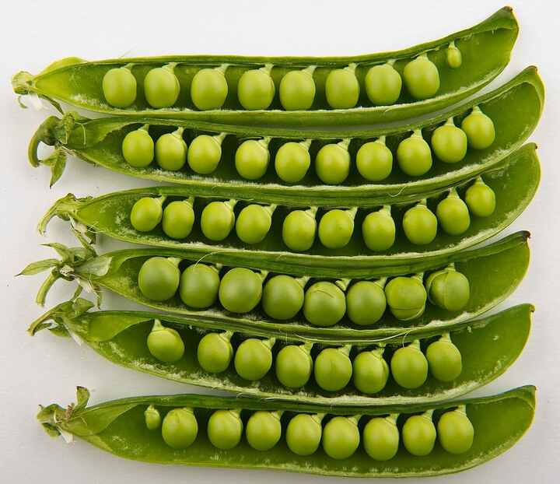
Source: Wikipedia — Pea

Chickpea
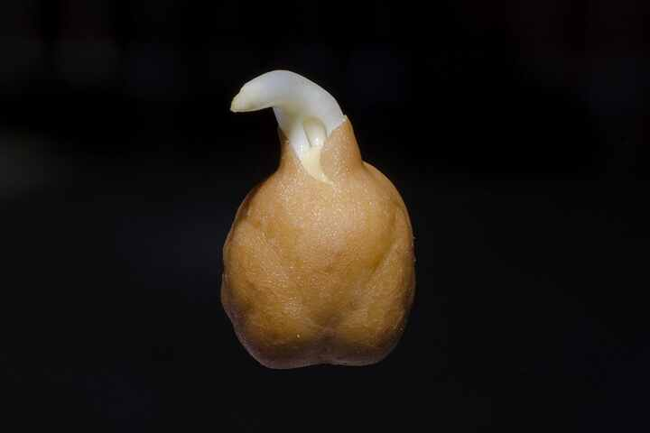
Source: Wikipedia — Chickpea

Lentil
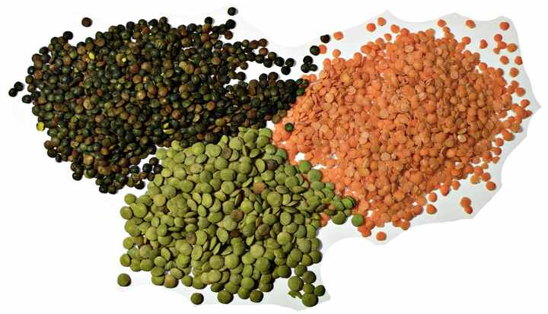
Source: Wikipedia — Lentil

Soybean
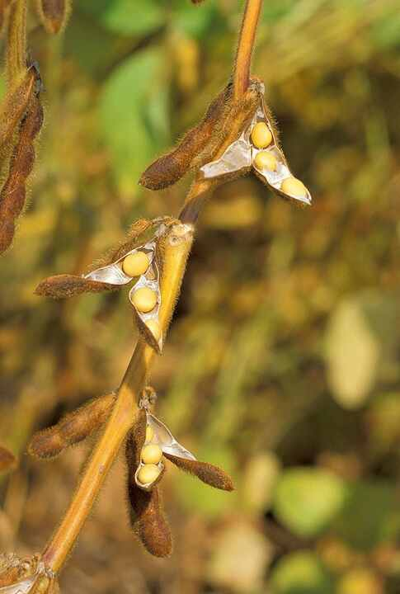
Source: Wikipedia — Soybean

Rice
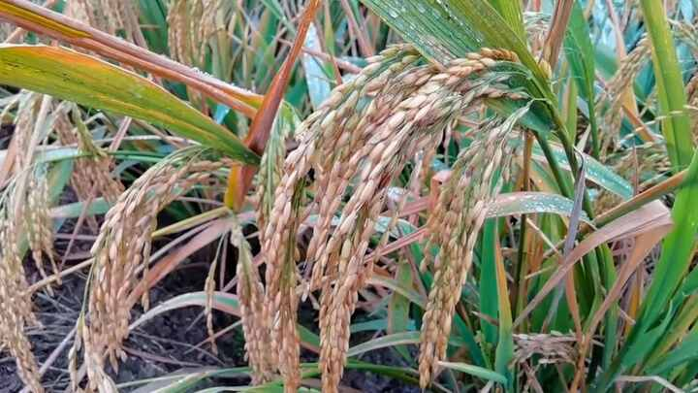
Source: Wikipedia — Rice

Wheat
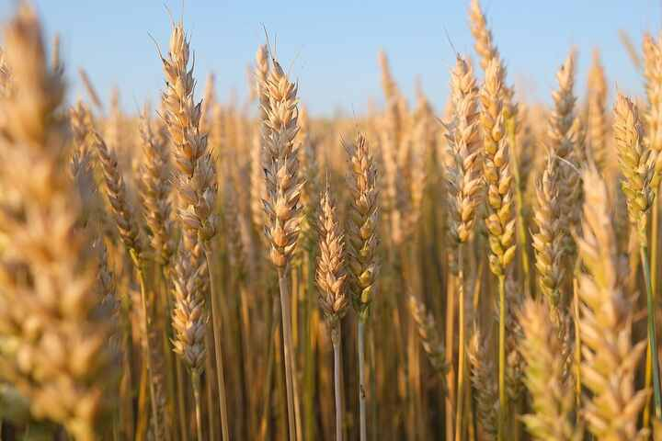
Source: Wikipedia — Wheat

Maize (Corn)
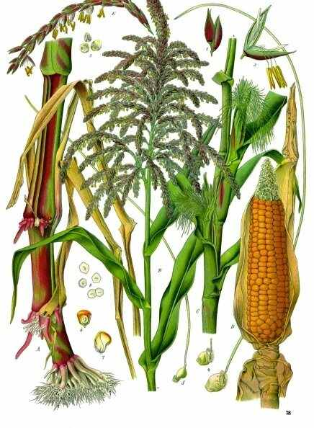
Source: Wikipedia — Maize

Sugarcane
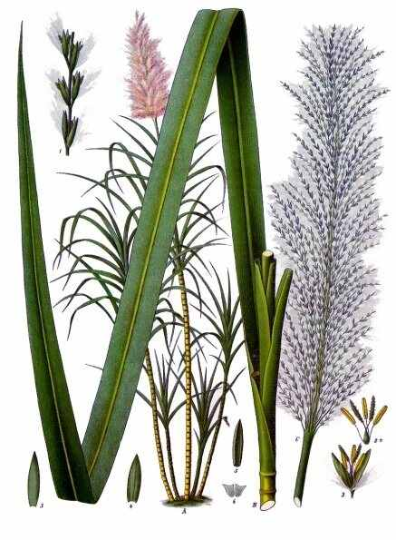
Source: Wikipedia — Sugarcane

Cotton
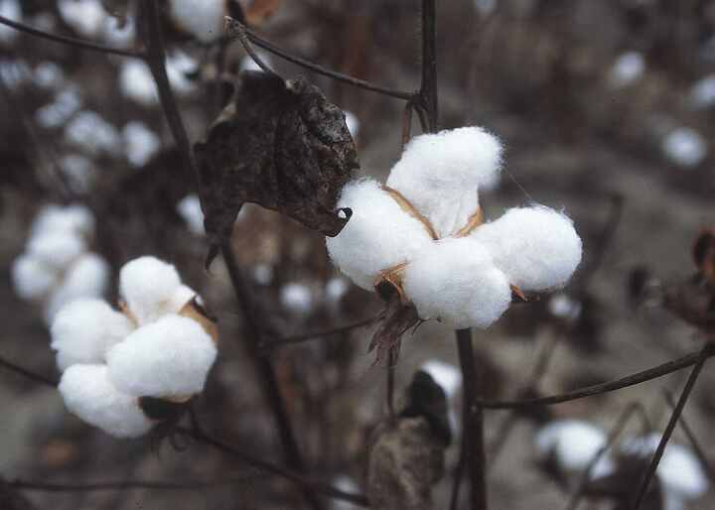
Source: Wikipedia — Cotton

Tea plant
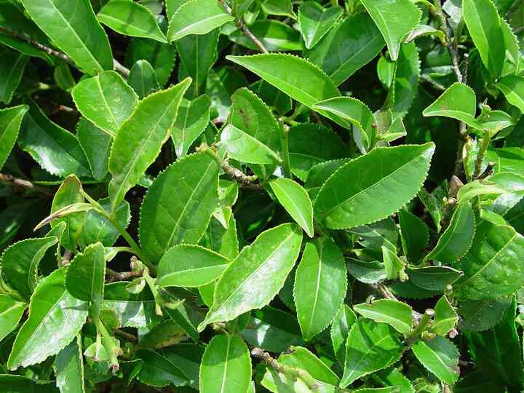
Source: Wikipedia — Camellia sinensis

Coffee plant
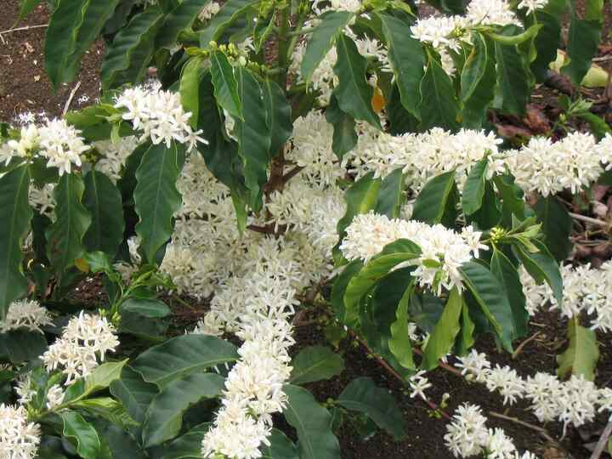
Source: Wikipedia — Coffea

Bamboo
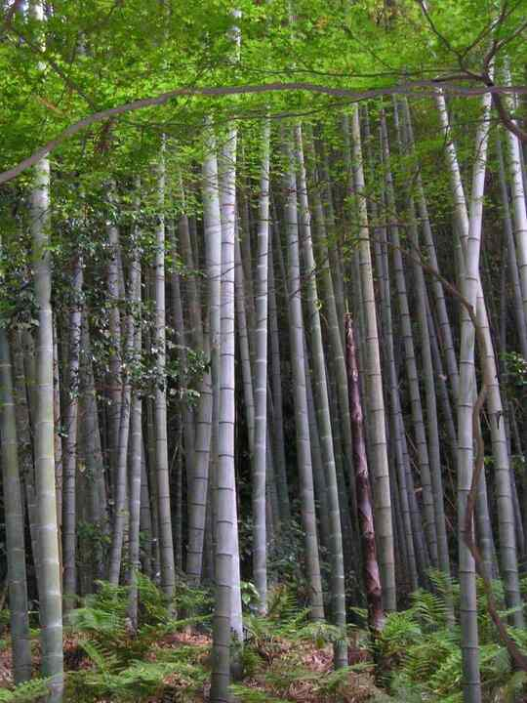
Source: Wikipedia — Bamboo

Eucalyptus
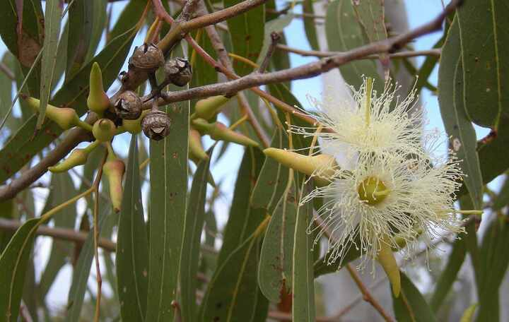
Source: Wikipedia — Eucalyptus

Teak
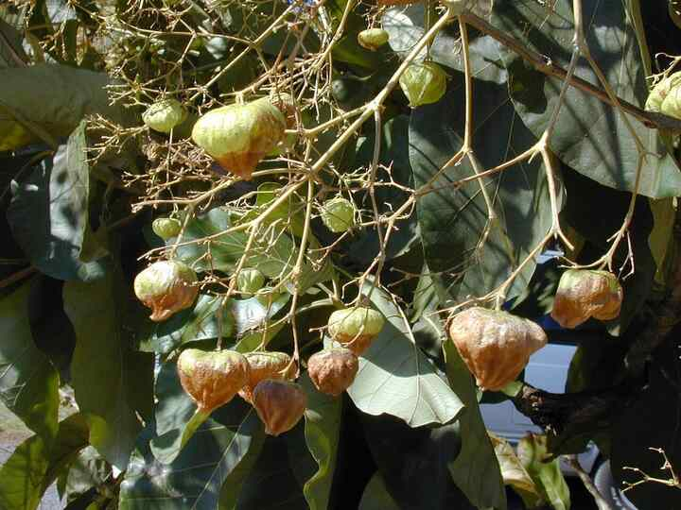
Source: Wikipedia — Teak

Sandalwood
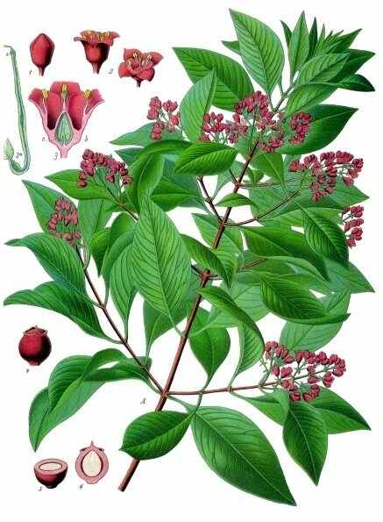
Source: Wikipedia — Santalum album

Money plant (Pothos)
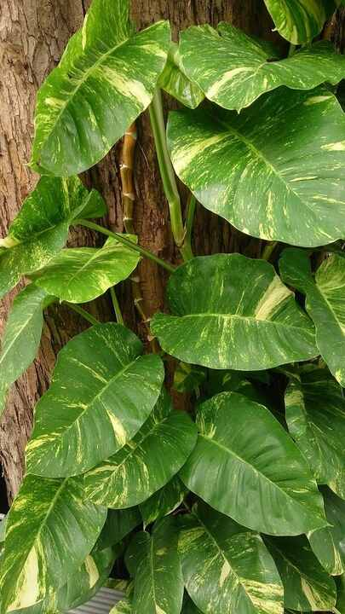
Source: Wikipedia — Epipremnum aureum

Snake plant
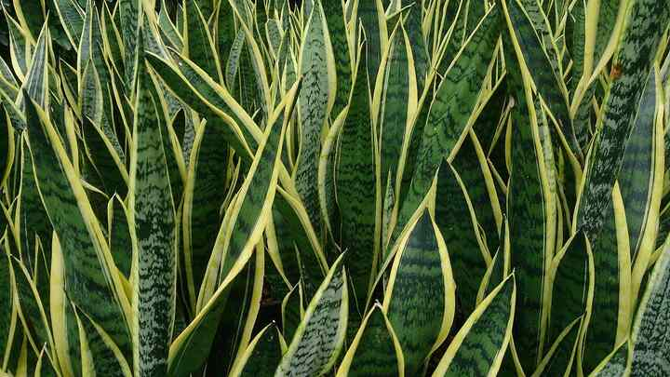
Source: Wikipedia — Dracaena trifasciata

